Tables

Category Table

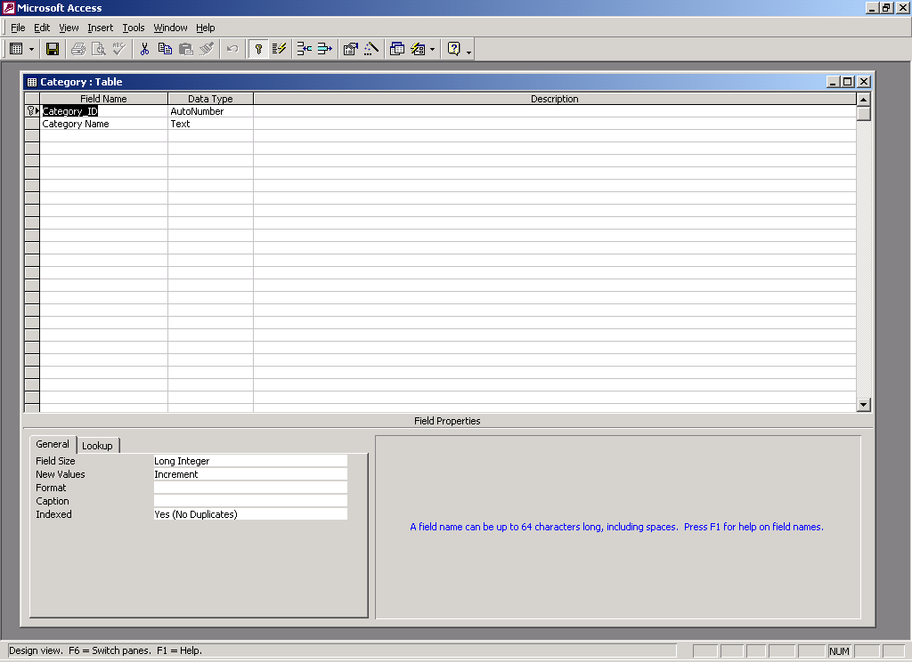

ClockinTimes Table

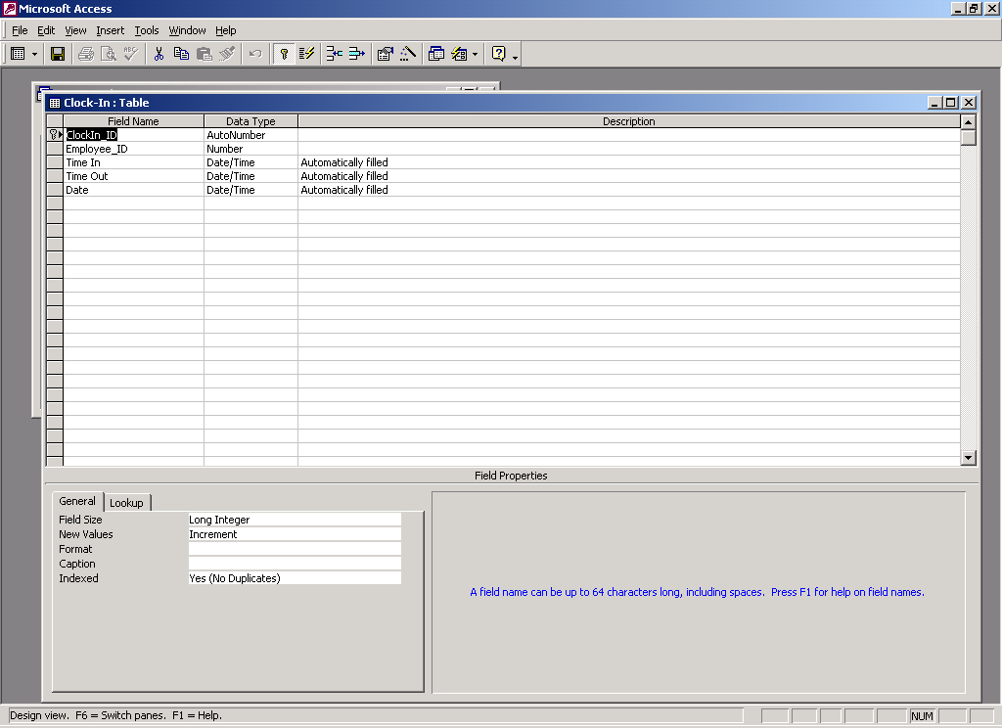

Customer Table

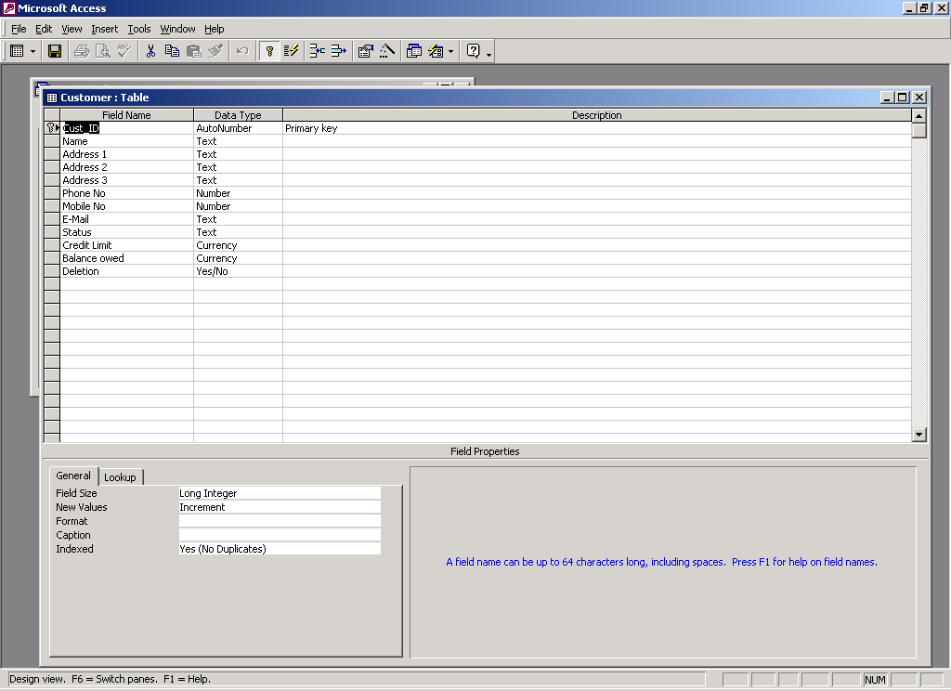

Employee Table

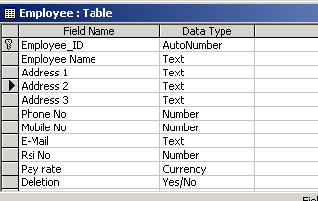

Equipment Table

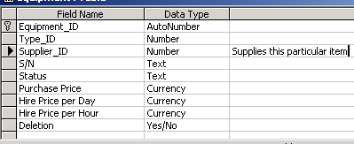

Equipment Type Table

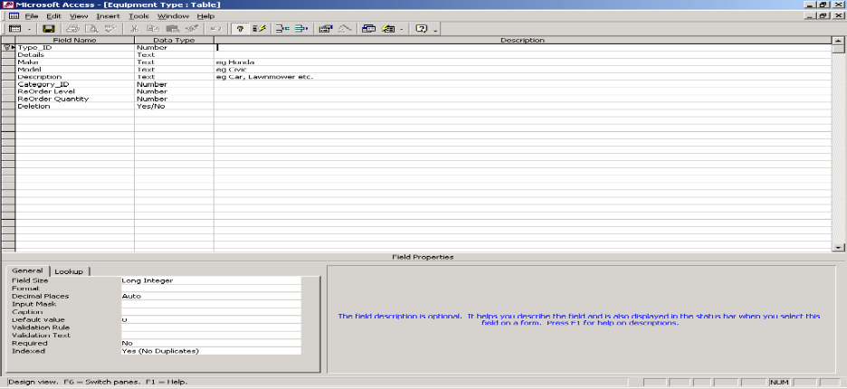

Order Table

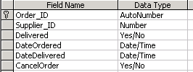

Order/Equipment Table

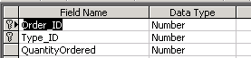

Password Table

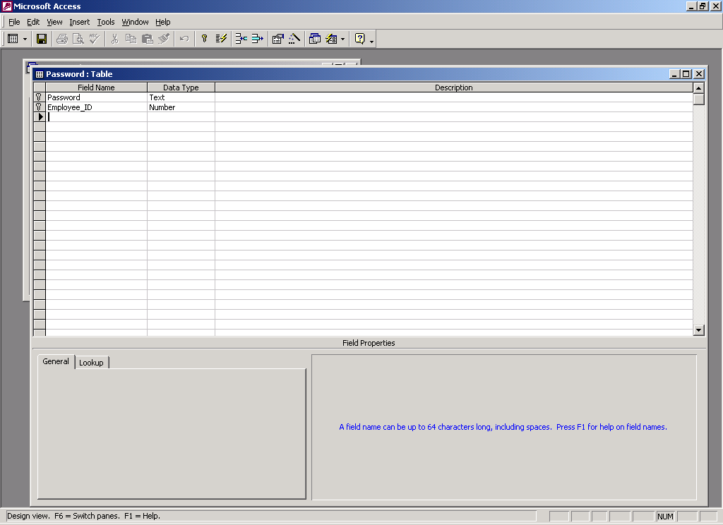

Payments Table

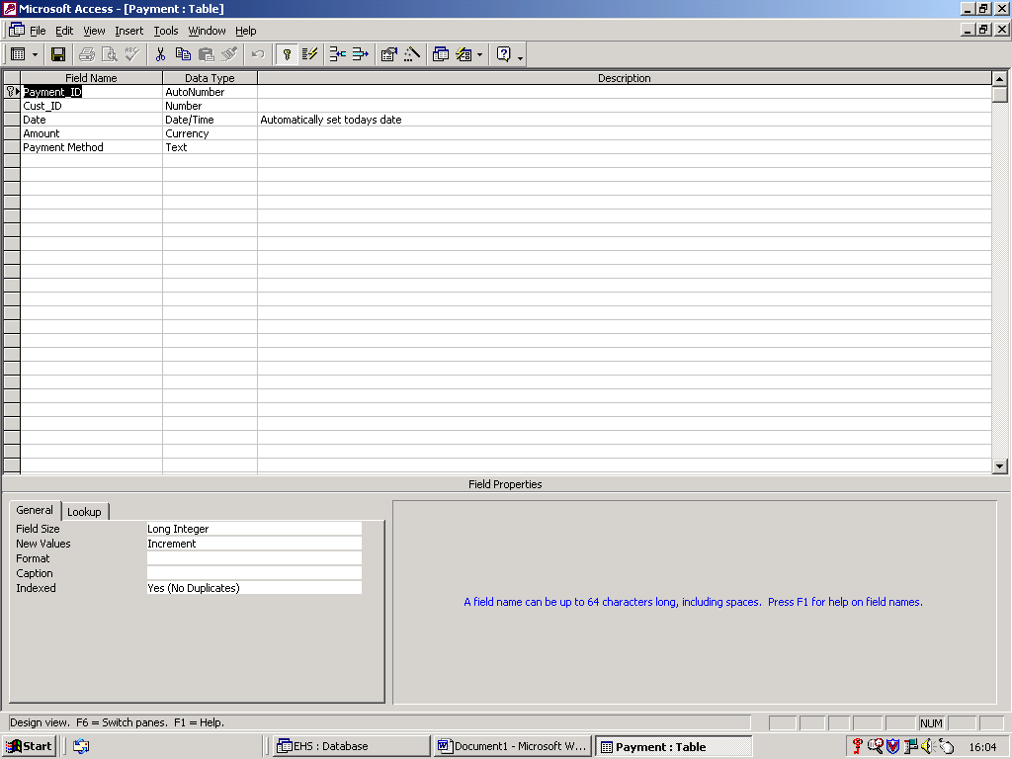

Supplier Table

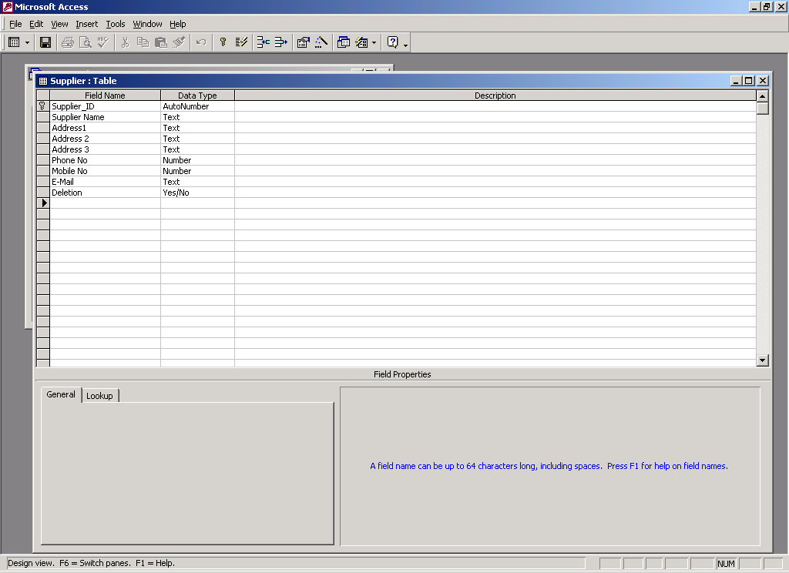

Rental/Returns Table

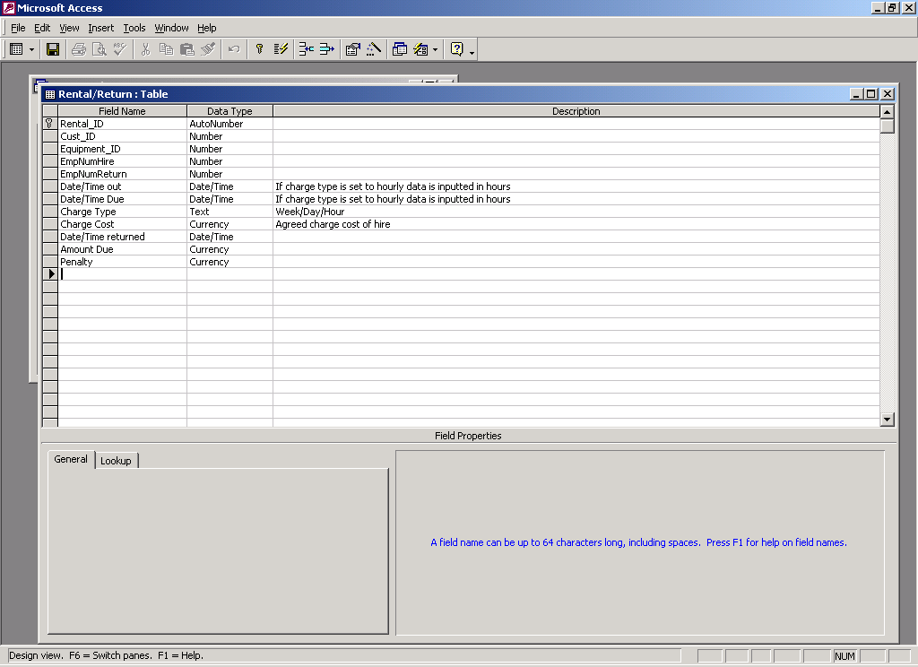

Supplier/Type Table

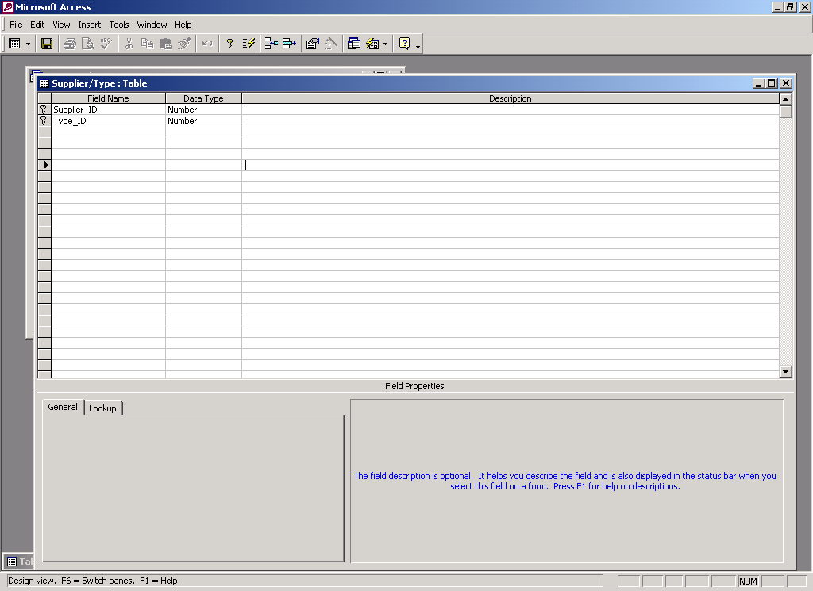

Hiring of equipment

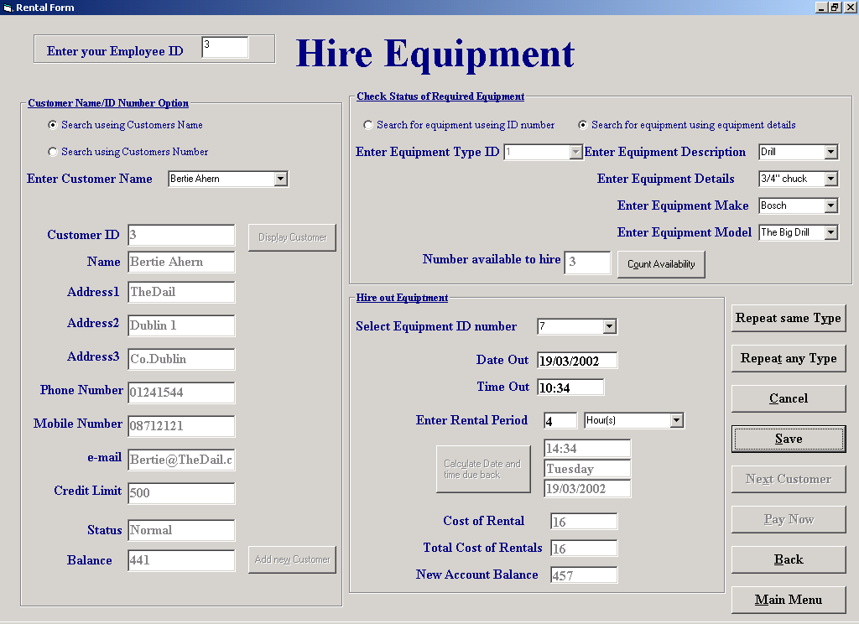

'Purpose This form allows the user to select a search for a Custemers details and
' then update his file with the details of a rental

'student David Hamilton
'StudentID Com2023
'Last Modified 15/3/02

'Variables used
'strMake String
'strModel String
'strDescription String
'strDetails String
'strAvailabilty String
'sqlDescription String
'strDate String
'sqlTime String
'sqlStatus String
'sqlEqptID String
'sqlCount String
'intID Integer
'intResponse Integer
'intResponse2 Integer
'intNumber Integer
'intCount Integer
'intIndex Integer
'intEqID Integer
'varCust Variant
'varID Variant
'varEmp Variant
'varDate Variant
'varPeriod Variant
'varIn Variant
'varCos Variant
'dteDateOut Date
'dteDueBack Date
'dblTime Double
'dblHour Double
'curRate Currancey

Option Explicit

Private Sub cboEquipDescription_KeyPress(KeyAscii As Integer)
If KeyAscii Then
If MsgBox("To ensure accurate selection from the equiptment in stock please select from the drop down list", vbOKOnly, "Accurate Input") = vbOK Then
cboEquipDescription.Text = ""
End If
cboEquipDescription.Text = ""
End If

End Sub

'This section is used to fill the Equipment Details drop down
'List with All the unique details of equiptment where the
'Description match those already chosen

Private Sub cboEquipDescription_Click()
Dim sqlDescription, strDescription As String

cboEquipDetails.Clear
cboEquipDetails.AddItem ("All")

strDescription = cboEquipDescription.Text
sqlDescription = "SELECT DISTINCT Details FROM [Equipment Type] WHERE Description = '" & strDescription & "'"

datSQL1.DatabaseName = "G:\EqpthireProject\EHS.mdb"
datSQL1.RecordSource = sqlDescription
datSQL1.Refresh

While Not datSQL1.Recordset.EOF
cboEquipDetails.AddItem datSQL1.Recordset("Details")
datSQL1.Recordset.MoveNext
Wend

End Sub

'This section is used to fill the Equipment Make drop down
'List with any make of equiptment where the Description
'and details match those already chosen

Private Sub cboEquipDetails_Click()

Dim sqlDetails, sqlMake, strDetails, sqlDescriptionAll As String

cboEquipMake.Clear
cboEquipMake.AddItem ("All")

strDescription = cboEquipDescription.Text
strDetails = cboEquipDetails.Text

If cboEquipDetails.Text = "All" Then
sqlDescription = "SELECT DISTINCT Make FROM [Equipment Type] WHERE Description = '" & strDescription & "'"
Else
sqlDescription = "SELECT DISTINCT Make FROM [Equipment Type] WHERE Details = '" & strDetails & "' AND Description = '" & strDescription & "'"
End If

datSQL1.DatabaseName = "G:\EqpthireProject\EHS.mdb"
datSQL1.RecordSource = sqlDescription
datSQL1.Refresh

While Not datSQL1.Recordset.EOF
cboEquipMake.AddItem datSQL1.Recordset("Make")
datSQL1.Recordset.MoveNext
Wend

'Using the infromation stored in the text part of the
'Equipment description,details,make and model comboboxes
'the unique Type ID can be queried from the equipment
'table this is then stored in the equipment number combo box
Private Sub cboEquipModel_Click()
Dim sqlDescription, strDescription, strModel, strMake, strDetails As String

cmdNewItem.Enabled = True

strDetails = cboEquipDetails.Text
strModel = cboEquipModel.Text
strMake = cboEquipMake.Text
strDescription = cboEquipDescription.Text

If strMake = "All" And strDetails = "All" Then
sqlDescription = "SELECT Type_ID FROM [Equipment Type] WHERE Model = '" & strModel & "' AND Description = '" & strDescription & "'"

ElseIf strMake = "All" Then
sqlDescription = "SELECT Type_ID FROM [Equipment Type] WHERE Model = '" & strModel & "' AND Details = '" & strDetails & "' AND Description = '" & strDescription & "'"

ElseIf strDetails = "All" Then
sqlDescription = "SELECT Type_ID FROM [Equipment Type] WHERE Model = '" & strModel & "' AND Make = '" & strMake & "' And Description = '" & strDescription & "'"

Else
sqlDescription = "SELECT Type_ID FROM [Equipment Type] WHERE Model = '" & strModel & "' AND Make = '" & strMake & "' And Description = '" & strDescription & "' AND Details = '" & strDetails & "'"
End If
datSQL1.DatabaseName = "G:\EqpthireProject\EHS.mdb"
datSQL1.RecordSource = sqlDescription
datSQL1.Refresh

While Not datSQL1.Recordset.EOF
cboTypeID.Text = datSQL1.Recordset("Type_ID")
datSQL1.Recordset.MoveNext
Wend
End Sub

'This section is used to fill the Equipment Make drop down
'List with any Model of equiptment where the Description
'details and make match those already chosen

Private Sub cboEquipMake_Click()
Dim strDescription, sqlDescription, strMake, strDetails As String

cboEquipModel.Clear
strDetails = cboEquipDetails.Text
strDescription = cboEquipDescription.Text
strMake = cboEquipMake.Text

If cboEquipMake.Text = "All" And cboEquipDetails = "All" Then
sqlDescription = "SELECT Model FROM [Equipment Type] WHERE Description = '" & strDescription & "'"

ElseIf cboEquipMake.Text = "All" Then
sqlDescription = "SELECT Model FROM [Equipment Type] WHERE Description = '" & strDescription & "' AND Details = '" & strDetails & "'"

ElseIf cboEquipDetails.Text = "All" Then
sqlDescription = "SELECT Model FROM [Equipment Type] WHERE Description = '" & strDescription & "' AND Make = '" & strMake & "'"

Else
sqlDescription = "SELECT Model FROM [Equipment Type] WHERE Make = '" & strMake & "' AND Description = '" & strDescription & "' AND Details = '" & strDetails & "'"

End If

datSQL1.DatabaseName = "G:\EqpthireProject\EHS.mdb"
datSQL1.RecordSource = sqlDescription
datSQL1.Refresh

While Not datSQL1.Recordset.EOF
cboEquipModel.AddItem datSQL1.Recordset("Model")
datSQL1.Recordset.MoveNext
Wend
End Sub

'iniated when a new Equipment ID number is chosen automatically sets the date and time
'to now as a logical default it also enables the date and time text
'text input boxes to allow the user to change them if necessary
Private Sub cboID_Click()
Dim strDate, strTime As String
txtDateOut = FormatDateTime(Now, vbShortDate)
txtTimeOut = FormatDateTime(Now, vbShortTime)
txtDateOut.Enabled = True
txtTimeOut.Enabled = True
txtRentPeriod.Enabled = True
cboPeriod.Enabled = True
txtRentPeriod.SetFocus

End Sub

Private Sub cboName_Change()
cboName_Click
fmeMove.Visible = False
End Sub

Private Sub cboName_Click()
fmeMove.Visible = False
cmdSeekCustomer.Enabled = True
End Sub

'Uses the validate procedure to check if the name of the supplier has been input
'before the user can proceed
Private Sub cboName_Validate(Cancel As Boolean)
Dim intResponse As Integer
If Len(cboName.Text) = 0 Then
Cancel = True
intResponse = MsgBox("You must enter data into this field", vbOKOnly, "Please Enter Data")
If intResponse = 1 Then
cboName.SetFocus
End If

End If
End Sub

Private Sub cboNumber_Change()
cboNumber_Click
End Sub

Private Sub cboNumber_Click()
fmeMove.Visible = False
cmdSeekCustomer.Enabled = True

End Sub

'Uses the validate procedure to check if the number of the supplier has been input
'before the user can proceed
Private Sub cboNumber_Validate(Cancel As Boolean)
Dim intResponse As Integer
If Len(cboNumber.Text) = 0 Then
Cancel = True
intResponse = MsgBox("You must enter data into this field", vbOKOnly, "Please Enter Data")
If intResponse = 1 Then
cboNumber.SetFocus
End If

End If
End Sub

Private Sub cboPeriod_Click()
cmdDateDue.Enabled = True
End Sub

Private Sub cboPeriod_Validate(Cancel As Boolean)
Dim intResponse As Integer
'A validation check to ensure that the user has filled in the rental period
'before trying to calculate the return time
If Len(cboPeriod.Text) = 0 Then
Cancel = True
intResponse = MsgBox("You must enter data into this field", vbOKOnly, "Please fill enter the Rental period")
If intResponse = 1 Then
cboPeriod.SetFocus
End If
End If
'A validation check for logical input ( as rental by the hour is
'more expensive the a maximum number of hours exceptable is set)
If Val(txtRentPeriod) > 8 And cboPeriod.Text = "Hour(s)" Then
Cancel = True
intResponse = MsgBox("It is not logical to enter more than 8 hours please use the day option", vbOKOnly, "Ilogical input")
If intResponse = 1 Then
cboPeriod.SetFocus
End If
End If

End Sub

Private Sub cboTypeID_Click()
cmdNewItem.Enabled = True
BlacklistCheck 'Procedure to check if a customer has been black listed
fmeMove.Visible = False
cmdSeekCustomer.Enabled = False
cmdAddCust.Enabled = False
End Sub

'Allows the user direct access to the the add customer screen where
'they can add a new customers details and then only return to this
'screen
Private Sub cmdAddCust_Click()

frmAddCustomer.Show
frmAddCustomer.Tag = "frmRental"
frmAddCustomer.cmdBack.Enabled = True
frmAddCustomer.cmdMainMenu.Enabled = False

End Sub

'Allows you to exit this screen and prompts you to save data before you exit also
'checks if you need to return to Main Menu or Hire Equiptment
Private Sub cmdBack_Click()
Dim intResponse As Integer

If txtTotal = "" Then
If frmRental.Tag <> "" Then
frmReturnEquipment.Show
Unload Me
frmHireEquipment.Tag = ""
Else
frmMainMenu.Show
Unload Me
End If
Else
intResponse = MsgBox("Do you wish to save details before you exit this screen", vbOKCancel, "Unsaved Input")
If intResponse = vbOK Then
cmdSave_Click
If frmHireEquipment.Tag <> "" Then
frmReturnEquipment.Show
Unload Me
frmHireEquipment.Tag = ""
Else
frmMainMenu.Show
Unload Me
End If
Else
cmdCancel_Click
If frmHireEquipment.Tag <> "" Then
frmReturnEquipment.Show
Unload Me
frmHireEquipment.Tag = ""
Else
frmMainMenu.Show
Unload Me
End If
End If
End If

End Sub

'The cancel button clears all the data stored in text boxes and also
'clears all the data stored in the tags of textboxes(Data has been saved
'in the relevent textbox tags so the tables can be updated at a later stage
'if the user selects the save button
Private Sub cmdCancel_Click()
Dim intIndex, intEqID As Integer
Dim varID As Variant 'varID is declared as a Varient as it is to
'be used in conjunction with the VB split function

'It has been necessary to mark a peice of equiptments record as out
'(Even though the the rental has not been saved) this is to allow the
'accurate searching of the Equiptment and equipment type tables. But
'if the rental has been canceled the status field of the relevent
'needs to be reset to available
If txtCustID.Tag <> "" And InStr(txtCustID.Tag, Chr(9)) <> 0 Then
'If anyone of the tags used to hold unsaved data contain
'a string and if that string contains a tab then there is more than
'one record saved to the tags so the tags need to be split back into
'values which then canbe used to identified the records altered
varID = Split(cboID.Tag, Chr(9))

For intIndex = 0 To (Val(lblHeader.Tag) - 1)
intEqID = Val(varID(intIndex))
datEquipment.Recordset.FindFirst "Equipment_ID = " & intEqID & ""

datEquipment.Recordset.Edit
datEquipment.Recordset("Status") = "Available"
datEquipment.Recordset.Update

Next intIndex

ElseIf txtCustID.Tag <> "" Then
'if the string contained in the tag is only one record
intEqID = Val(cboID.Tag)

datEquipment.Recordset.FindFirst "Equipment_ID = " & intEqID & ""

datEquipment.Recordset.Edit
datEquipment.Recordset("Status") = "Available"
datEquipment.Recordset.Update
End If

'Clear all the relevent input boxes
cboID.Clear
cboID.Text = ""
txtDateOut = ""
txtTimeOut = ""
txtRentPeriod = ""
cboPeriod.Text = ""
txtDateReturn = ""
txtDayDue = ""
txtTimeDue = ""
txtNoInStock = ""
cboEquipModel.Clear
cboEquipModel.Text = ""
cboEquipMake.Clear
cboEquipMake.Text = ""
cboEquipDetails.Clear
cboEquipDetails.Text = ""
cboEquipDescription.Text = ""
cboTypeID.Text = ""
cboID.Enabled = False
txtDateOut.Enabled = False
txtTimeOut.Enabled = False
txtRentPeriod.Enabled = False
cboPeriod.Enabled = False
txtDateReturn.Enabled = False
txtDayDue.Enabled = False
txtTimeDue.Enabled = False
txtNoInStock.Enabled = False
cmdNewItem.Enabled = False
cmdDateDue.Enabled = False
cboEquipDescription.Enabled = False
cmdSave.Enabled = False
cmdNumAvail.Enabled = False
cmdRepeatAny.Enabled = False
cmdPay.Enabled = False
cmdSave.Enabled = False
cmdCancel.Enabled = False
cmdPrevious.Enabled = False
cmdNext.Enabled = False
txtValueItem = ""
txtTotal = ""
txtNewBalance = ""
txtCustID.Tag = ""
cboID.Tag = ""
txtEmpID.Tag = ""
txtDateOut.Tag = ""
txtDateReturn.Tag = ""
cboPeriod.Tag = ""
txtValueItem.Tag = ""
lblHeader.Tag = ""
cmdNewCust.Enabled = True

End Sub
'The following code works out the date and time a peice of
'equipment should be returned. It takes the time out and
'date out and adds on the the rental period BUT
'-if the return day falls on a Sunday the the return day moves
' to the following Monday
'-if the return time falls outside opening Hours then the
' the amount of hours after closeing today(6:00 pm) are
' added on to opening time(9:00AM) tommorow
'The due back time does not effect the charge
Private Sub cmdDateDue_Click()
Dim dteDateOut, dteDueBack As Date
Dim intDateOut As Integer
Dim dblTime, dblHour As Double
Dim curRate As Currency
Dim intID As Integer

Const conWeek As Integer = 7

dteDateOut = txtDateOut

If Not cboPeriod = "Hour(s)" Then
If cboPeriod = "Week(s)" Then
dblTime = txtRentPeriod * conWeek
Else
dblTime = txtRentPeriod
End If

dteDueBack = DateAdd("d", dblTime, dteDateOut) 'Add rental period to Out Date
If Weekday(dteDueBack) = 1 Then 'Must presume that the business closes
dteDueBack = dteDueBack + 1 'On a Sunday so the due back date moves Monday
End If
txtDateReturn = dteDueBack
txtTimeDue = txtTimeOut
Else
dteDueBack = txtDateOut
dteTimeOut = txtTimeOut
dblHour = Val(txtRentPeriod)
dteTimeBack = DateAdd("H", dblHour, dteTimeOut) 'Add rental hours to Time out
If dteTimeBack > TimeSerial(18, 0, 0) Then 'if after closing time
dteTimeBack = DateAdd("H", 15, dteTimeBack) '15 hours between open and close
dteDueBack = DateAdd("D", 1, dteDueBack)
End If
If Weekday(dteDueBack) = 1 Then 'Must presume that the business closes
dteDueBack = dteDueBack + 1 'On a Sunday so the due back date moves Monday
End If
txtDateReturn = dteDueBack
txtTimeDue = FormatDateTime(dteTimeBack, vbShortTime)
End If

txtDayDue = WeekdayName(Weekday(dteDueBack - 1))

intID = Val(cboID.Text)
If cboPeriod.Text <> "Hour(s)" Then 'Querry the rental charge from the Equipment Table
SQLEqptID = "SELECT [Hire Price per Day] FROM Equipment WHERE Equipment_ID = " & intID & " ;"

DatSQL4.DatabaseName = "G:\EqpthireProject\EHS.mdb"
DatSQL4.RecordSource = SQLEqptID
DatSQL4.Refresh

With DatSQL4.Recordset
While Not .EOF
curRate = .Fields("Hire Price per Day")
.MoveNext
Wend
End With
Else
SQLEqptID = "SELECT [Hire Price per Hour] FROM Equipment WHERE Equipment_ID = " & intID & " ;"

DatSQL4.DatabaseName = "G:\EqpthireProject\EHS.mdb"
DatSQL4.RecordSource = SQLEqptID
DatSQL4.Refresh

With DatSQL4.Recordset
While Not .EOF
curRate = .Fields("Hire Price per Hour")
.MoveNext
Wend
End With
End If

If cboPeriod.Text = "Week(s)" Then
curRate = curRate * 7
End If

curRate = curRate * Val(txtRentPeriod)

txtValueItem = curRate
txtTotal = Val(txtTotal) + curRate
txtNewBalance = Val(txtBalance) + Val(txtTotal)

cmdCancel.Enabled = True

cmdRepeatAny.Enabled = True
cmdSave.Enabled = True
cmdDateDue.Enabled = False
cmdNumAvail.Enabled = True
If Val(txtNoInStock) < 2 Then
cmdNumAvail.Enabled = False
txtNoInStock = 0
End If

'Allows you to exit this screen and prompts you to save data before you exit
Private Sub cmdMainMenu_Click()
Dim intResponse As Integer

If cboID.Text = "" And cboID.Tag = "" Then
frmMainMenu.Show
Unload Me
Else
intResponse = MsgBox("Do you wish to save details before you exit this screen", vbOKCancel, "Unsaved Input")
If intResponse = vbOK Then
cmdSave_Click
frmMainMenu.Show
Unload Me
Else
cmdCancel_Click
frmMainMenu.Show
Unload Me
End If
End If

End Sub

'Count the number of peices of equipment that match the selected
'Type of equipment and the load their Equipment_ID numbers into
'a combo box to allow the user to select an available number
Private Sub cmdNewItem_Click()
Dim sqlCount As String
Dim intID As Integer
Dim intCount As Integer
Dim SQLEqptID As String

intID = Val(cboTypeID)
cboID.Clear

sqlCount = "SELECT Count(*)AS IDCount FROM Equipment WHERE Type_ID= " & intID & " AND Status = 'Available' AND Deletion = False;"
SQLEqptID = "SELECT Equipment_ID FROM Equipment WHERE Type_ID= " & intID & " AND Status = 'Available' AND Deletion = False;"

DatSQL4.DatabaseName = "G:\EqpthireProject\EHS.mdb"
DatSQL4.RecordSource = sqlCount
DatSQL4.Refresh

datSQL3.DatabaseName = "G:\EqpthireProject\EHS.mdb"
datSQL3.RecordSource = SQLEqptID
datSQL3.Refresh

intCount = DatSQL4.Recordset.Fields("IDCount")
txtNoInStock.Text = Str(intCount)

While Not datSQL3.Recordset.EOF
cboID.AddItem datSQL3.Recordset("Equipment_ID")
datSQL3.Recordset.MoveNext
Wend

cboID.Enabled = True
End Sub

'Clear the screen and reset initial settings
Private Sub cmdNewCust_Click()
cboID.Clear
cboID.Text = ""
txtDateOut = ""
txtTimeOut = ""
txtRentPeriod = ""
cboPeriod.Text = ""
txtDateReturn = ""
txtDayDue = ""
txtTimeDue = ""
txtNoInStock = ""
cboEquipModel.Clear
cboEquipModel.Text = ""
cboEquipMake.Clear
cboEquipMake.Text = ""
cboEquipDetails.Clear
cboEquipDetails.Text = ""
cboEquipDescription.Text = ""
cboTypeID.Text = ""
txtCustID = ""
txtNameFound = ""
txtAddress1 = ""
txtAddress2 = ""
txtAddress3 = ""
txtPhoneNo = ""
txtMobileNo = ""
txtEmail = ""
txtCreditLimit = ""
txtStatus = ""
txtBalance = ""
cboID.Enabled = False
txtDateOut.Enabled = False
txtTimeOut.Enabled = False
txtRentPeriod.Enabled = False
cboPeriod.Enabled = False
txtDateReturn.Enabled = False
txtDayDue.Enabled = False
txtTimeDue.Enabled = False
txtNoInStock.Enabled = False
cboEquipModel.Enabled = False
cboEquipMake.Enabled = False
cboEquipDetails.Enabled = False
cboEquipDescription.Enabled = False
cmdNewItem.Enabled = False
cmdDateDue.Enabled = False
cboTypeID.Enabled = False
optEqptNum.Enabled = False
optEquipName.Enabled = False
cboEquipDescription.Enabled = False
cboTypeID.Enabled = False
cmdSave.Enabled = False
cmdNumAvail.Enabled = False
cmdRepeatAny.Enabled = False
cmdPay.Enabled = False
cmdSave.Enabled = False
cmdCancel.Enabled = False
cmdPrevious.Enabled = False
cmdNext.Enabled = False
cboName.Text = ""
cboNumber.Text = ""
cmdSeekCustomer.Enabled = True
End Sub

Private Sub cmdNext_Click()
Dim strName As String

strName = cboName.Text
With datCustomer.Recordset
.FindNext ("Name like '*" & strName & "*'")

End With
txtCustID = datCustomer.Recordset("Cust_ID")
txtNameFound = datCustomer.Recordset("Name")
txtAddress1 = datCustomer.Recordset("Address 1")
txtAddress2 = datCustomer.Recordset("Address 2")
txtAddress3 = datCustomer.Recordset("Address 3")
txtPhoneNo = datCustomer.Recordset("Phone No")
txtMobileNo = datCustomer.Recordset("Mobile No")
txtEmail = datCustomer.Recordset("E-Mail")
txtCreditLimit = datCustomer.Recordset("Credit Limit")
txtStatus = datCustomer.Recordset("Status")
txtBalance = datCustomer.Recordset("Balance owed")

End Sub

'selecting this button allows you to select another item
'of equiptment where the Equipment type matches the type
'last selected. The inputs are not saved at this stage but
'instead moved to the tags of the relevent text boxes, the
'text boxes are then cleared to make way for the next inputs
Private Sub cmdNumAvail_Click()
Dim sqlCount As String
Static intID, intNumber As Integer
Dim intCount As Integer
Dim SQLEqptID As String
Dim intResponse As Integer
Dim intEqID As Integer

intEqID = Val(cboID.Text)

If cboID.Tag = "" Then
'If there is nothing stored in the tag the the contents of
'the text boxes is moved into the tag
lblHeader.Tag = 1
txtCustID.Tag = txtCustID
cboID.Tag = cboID.Text
txtEmpID.Tag = txtEmpID
txtDateOut.Tag = DateValue(txtDateOut) + TimeValue(txtTimeOut)
txtDateReturn.Tag = DateValue(txtDateReturn) + TimeValue(txtTimeDue)
cboPeriod.Tag = cboPeriod.Text
txtValueItem.Tag = Val(txtValueItem)

Else
'if there is something in the tag then the contents of the
'text boxes are concatinated on to the tag
lblHeader.Tag = Val(lblHeader.Tag) + 1
txtCustID.Tag = txtCustID.Tag & Chr(9) & txtCustID
cboID.Tag = cboID.Tag & Chr(9) & cboID.Text
txtEmpID.Tag = txtEmpID.Tag & Chr(9) & txtEmpID
txtDateOut.Tag = txtDateOut.Tag & Chr(9) & DateValue(txtDateOut) + TimeValue(txtTimeOut)
txtDateReturn.Tag = txtDateReturn.Tag & Chr(9) & DateValue(txtDateReturn) + TimeValue(txtTimeDue)
cboPeriod.Tag = cboPeriod.Tag & Chr(9) & cboPeriod.Text
txtValueItem.Tag = txtValueItem.Tag & Chr(9) & Val(txtValueItem)
End If
'The on screen view changes to reflect the fact that a peice
'of equipment has been selected and therefore can not be
'reselected. All relevent input boxes are cleared to allow
'the next input
txtNoInStock = Val(txtNoInStock) - 1
If txtNoInStock <> "0" Then
cboID.RemoveItem (cboID.ListIndex)
cboID.Text = ""
txtDateOut = ""
txtTimeOut = ""
txtDateReturn = ""
txtDayDue = ""
txtTimeDue = ""
cboID.SetFocus
cmdDateDue.Enabled = True
Else
'if there are no more of the selected peices of equipment
'left in stock amessage is sent to the screen to inform
'the user
intResponse = MsgBox("There are no further matching items left in stock", vbOKOnly, "You Can not use this option")
cboID.RemoveItem (cboID.ListIndex)
cboID.Text = ""
txtDateOut = ""
txtTimeOut = ""
txtRentPeriod = ""
cboPeriod.Text = ""
txtDateReturn = ""
txtDayDue = ""
txtTimeDue = ""
End If
cmdNumAvail.Enabled = False
cmdRepeatAny.Enabled = False
'But to allow any future searchs of equipment for the present customer
'The status field of the Equipment table nust be set to "OUT"
datEquipment.Recordset.FindFirst "Equipment_ID = " & intEqID & ""

datEquipment.Recordset.Edit
datEquipment.Recordset("Status") = "Out"
datEquipment.Recordset.Update

End Sub
'Opens the make a payment screen from this screen
Private Sub cmdPay_Click()
frmMakeAPayment.Show
frmMakeAPayment.Tag = txtCustID
End Sub

Private Sub cmdPrevious_Click()

'Allows the user to search through the
Dim strName As String

strName = cboName.Text
With datCustomer.Recordset
.FindPrevious ("Name like '*" & strName & "*'")

End With
txtCustID = datCustomer.Recordset("Cust_ID")
txtNameFound = datCustomer.Recordset("Name")
txtAddress1 = datCustomer.Recordset("Address 1")
txtAddress2 = datCustomer.Recordset("Address 2")
txtAddress3 = datCustomer.Recordset("Address 3")
txtPhoneNo = datCustomer.Recordset("Phone No")
txtMobileNo = datCustomer.Recordset("Mobile No")
txtEmail = datCustomer.Recordset("E-Mail")
txtCreditLimit = datCustomer.Recordset("Credit Limit")
txtStatus = datCustomer.Recordset("Status")
txtBalance = datCustomer.Recordset("Balance owed")
End Sub

'Allows the user to search for another peice of equipment
'where the Equipment type does not matche the type
'last selected. The inputs are not saved at this stage but
'instead moved to the tags of the relevent text boxes, the
'text boxes are then cleared to make way for the next inputs
Private Sub cmdRepeatAny_Click()
intEqID = Val(cboID.Text)

If cboID.Tag = "" Then
'If there is nothing stored in the tag the the contents of
'the text boxes is moved into the tag
lblHeader.Tag = 1
txtCustID.Tag = txtCustID
cboID.Tag = cboID.Text
txtEmpID.Tag = txtEmpID
txtDateOut.Tag = Str(DateValue(txtDateOut) + TimeValue(txtTimeOut))
txtDateReturn.Tag = Str(DateValue(txtDateReturn) + TimeValue(txtTimeDue))
cboPeriod.Tag = cboPeriod.Text
txtValueItem.Tag = Val(txtValueItem)

Else
'if there is something in the tag then the contents of the
'text boxes are concatinated on to the tag
lblHeader.Tag = Val(lblHeader.Tag) + 1
txtCustID.Tag = txtCustID.Tag & Chr(9) & txtCustID
cboID.Tag = cboID.Tag & Chr(9) & cboID.Text
txtEmpID.Tag = txtEmpID.Tag & Chr(9) & txtEmpID
txtDateOut.Tag = txtDateOut.Tag & Chr(9) & Str(DateValue(txtDateOut) + TimeValue(txtTimeOut))
txtDateReturn.Tag = txtDateReturn.Tag & Chr(9) & Str(DateValue(txtDateReturn) + TimeValue(txtTimeDue))
cboPeriod.Tag = cboPeriod.Tag & Chr(9) & cboPeriod.Text
txtValueItem.Tag = txtValueItem.Tag & Chr(9) & Val(txtValueItem)
End If

cboID.Clear
cboID.Text = ""
txtDateOut = ""
txtTimeOut = ""
txtRentPeriod = ""
cboPeriod.Text = ""
txtDateReturn = ""
txtDayDue = ""
txtTimeDue = ""
txtNoInStock = ""
cboEquipModel.Clear
cboEquipModel.Text = ""
cboEquipMake.Clear
cboEquipMake.Text = ""
cboEquipDetails.Clear
cboEquipDetails.Text = ""
cboEquipDescription.Text = ""
cboTypeID.Text = ""

cboID.Enabled = False
txtDateOut.Enabled = False
txtTimeOut.Enabled = False
txtRentPeriod.Enabled = False
cboPeriod.Enabled = False
txtDateReturn.Enabled = False
txtDayDue.Enabled = False
txtTimeDue.Enabled = False
txtNoInStock.Enabled = False
cboEquipModel.Enabled = False
cboEquipMake.Enabled = False
cboEquipDetails.Enabled = False
cboEquipDescription.Enabled = False
cmdNewItem.Enabled = False
cmdDateDue.Enabled = False
optEqptNum = True
cmdNumAvail.Enabled = False
cmdRepeatAny.Enabled = False
'But to allow any future searchs of equipment for the present customer
'The status field of the Equipment table nust be set to "OUT"

datEquipment.Recordset.FindFirst "Equipment_ID = " & intEqID & ""

datEquipment.Recordset.Edit
datEquipment.Recordset("Status") = "Out"
datEquipment.Recordset.Update

End Sub
'Saves the information presently displayed in the relevant
'input boxes as well as the information stored in the tags
'A new unique ID number is created for each new record
'added to the rental table. The total
Private Sub cmdSave_Click()

If Val(txtNewBalance) < Val(txtCreditLimit) Then
SaveAll 'Procedure to save all in tags and text boxes

Else
intResponse = MsgBox("Please inform the customer that he must be willing to bring the Balance of his account back in line with his credit limit, if he is willing to make a payment now select OK otherwise you must Cancel the Rental", vbOKCancel, "Credit limit exceeded")
If intResponse = vbOK Then
SaveAll
cmdPay_Click
Else
cmdCancel_Click
End If
End If
cmdNewCust.Enabled = True
End Sub

Private Sub SaveAll()
Dim sqlCount As String
Static intID, intNumber As Integer
Dim intCount, intIndex As Integer
Dim SQLEqptID As String
Dim intResponse, intResponse2 As Integer
Dim intEqID As Integer
Dim varCust, varID, varEmp, varDate, varPeriod, varIn, varCost As Variant

intEqID = Val(cboID.Text)
If Not datRent.Recordset.BOF Then
datRent.Recordset.MoveLast
If intID >= datRent.Recordset("Rental_ID") Then
intID = intID + 1
Else
intID = datRent.Recordset("Rental_ID")
intID = intID + 1
End If
Else
intID = 1
End If

intResponse2 = MsgBox("Click OK to save all inputted Data", vbOKCancel, "SAVE NOW")
If intResponse2 = 1 Then

If cboID.Text <> "" Then
datRent.Recordset.AddNew
datRent.Recordset("Rental_ID") = intID
datRent.Recordset("Cust_ID") = txtCustID
datRent.Recordset("Equipment_ID") = cboID.Text
datRent.Recordset("EmpNumHire") = txtEmpID
datRent.Recordset("Date/Time out") = DateValue(txtDateOut) + TimeValue(txtTimeOut)
datRent.Recordset("Date/Time Due") = DateValue(txtDateReturn) + TimeValue(txtTimeDue)
datRent.Recordset("Charge Type") = cboPeriod.Text
datRent.Recordset("Charge Cost") = Val(txtValueItem)
datRent.Recordset.Update
End If

If txtCustID.Tag <> "" And InStr(txtCustID.Tag, Chr(9)) <> 0 Then

varCust = Split(txtCustID.Tag, Chr(9))
varID = Split(cboID.Tag, Chr(9))
varEmp = Split(txtEmpID.Tag, Chr(9))
varDate = Split(txtDateOut.Tag, Chr(9))
varIn = Split(txtDateReturn.Tag, Chr(9))
varPeriod = Split(cboPeriod.Tag, Chr(9))
varCost = Split(txtValueItem.Tag, Chr(9))

For intIndex = 0 To (Val(lblHeader.Tag) - 1)
intID = intID + 1
datRent.Recordset.AddNew
datRent.Recordset("Rental_ID") = intID
datRent.Recordset("Cust_ID") = varCust(intIndex)
datRent.Recordset("Equipment_ID") = varID(intIndex)
datRent.Recordset("EmpNumHire") = varEmp(intIndex)
datRent.Recordset("Date/Time out") = varDate(intIndex)
datRent.Recordset("Date/Time Due") = varIn(intIndex)
datRent.Recordset("Charge Type") = varPeriod(intIndex)
datRent.Recordset("Charge Cost") = varCost(intIndex)
datRent.Recordset.Update

Next intIndex

ElseIf txtCustID.Tag <> "" Then
intID = intID + 1
datRent.Recordset.AddNew
datRent.Recordset("Rental_ID") = intID
datRent.Recordset("Cust_ID") = txtCustID.Tag
datRent.Recordset("Equipment_ID") = cboID.Tag
datRent.Recordset("EmpNumHire") = txtEmpID.Tag
datRent.Recordset("Date/Time out") = DateValue(txtDateOut.Tag)
datRent.Recordset("Date/Time Due") = DateValue(txtDateReturn.Tag)
datRent.Recordset("Charge Type") = cboPeriod.Tag
datRent.Recordset("Charge Cost") = Val(txtValueItem.Tag)
datRent.Recordset.Update
End If

If cboID.Text <> "" Then
datEquipment.Recordset.FindFirst "Equipment_ID = " & intEqID & ""

datEquipment.Recordset.Edit
datEquipment.Recordset("Status") = "Out"
datEquipment.Recordset.Update
End If

intNumber = Val(txtCustID)
datCustomer.Recordset.FindFirst "Cust_ID = " & intNumber & ""
datCustomer.Recordset.Edit
datCustomer.Recordset("Balance owed") = Val(txtNewBalance)
If Val(txtNewBalance) > Val(txtCreditLimit) Then
datCustomer.Recordset("Status") = "Blacklisted"
txtStatus = "Blacklisted"
End If
datCustomer.Recordset.Update

If txtCustID.Tag <> "" And InStr(txtCustID.Tag, Chr(9)) <> 0 Then
varID = Split(cboID.Tag, Chr(9))

For intIndex = 0 To (Val(lblHeader.Tag) - 1)
intEqID = Val(varID(intIndex))
datEquipment.Recordset.FindFirst "Equipment_ID = " & intEqID & ""

datEquipment.Recordset.Edit
datEquipment.Recordset("Status") = "Available"
datEquipment.Recordset.Update

Next intIndex

ElseIf txtCustID.Tag <> "" Then
intEqID = Val(cboID.Tag)

datEquipment.Recordset.FindFirst "Equipment_ID = " & intEqID & ""

datEquipment.Recordset.Edit
datEquipment.Recordset("Status") = "Available"
datEquipment.Recordset.Update
End If
End If
cmdCancel_Click
End Sub

'Using the Name/Number/letters entered a search is made of the
'Customer Table to return the first match, the coresponding
'record is then displayed. If a search is made using a name
'and their is more than one match, the user is then allowed
'step through the records of those with matching names
Private Sub cmdSeekCustomer_Click()
Dim strName, strID As String
Dim intNumber, intID As Integer

cmdPrevious.Enabled = True
cmdNext.Enabled = True
cboTypeID.Enabled = True
optEqptNum.Enabled = True
optEquipName.Enabled = True
cmdAddCust.Enabled = True

strID = cboName.Text

sqlCount = "SELECT Count(*)AS IDCount FROM Customer WHERE Name Like '*" & strID & "*';"

datSQL1.DatabaseName = "G:\EqpthireProject\EHS.mdb"
datSQL1.RecordSource = sqlCount
datSQL1.Refresh

intCount = datSQL1.Recordset.Fields("IDCount")

If intCount > 1 And cboName.Visible = True Then 'Displays matching records if their is more than 1
fmeMove.Visible = True
txtMatches = intCount
cmdPrevious.Enabled = True
cmdNext.Enabled = True
End If
If optName = True Then
strName = cboName.Text
If Not Len(strName) = 0 Then
datCustomer.Recordset.FindFirst "Name like '*" & strName & "*'"

txtCustID = datCustomer.Recordset("Cust_ID")
txtNameFound = datCustomer.Recordset("Name")
txtAddress1 = datCustomer.Recordset("Address 1")
txtAddress2 = datCustomer.Recordset("Address 2")
txtAddress3 = datCustomer.Recordset("Address 3")
txtPhoneNo = datCustomer.Recordset("Phone No")
txtMobileNo = datCustomer.Recordset("Mobile No")
txtEmail = datCustomer.Recordset("E-Mail")
txtCreditLimit = datCustomer.Recordset("Credit Limit")
txtStatus = datCustomer.Recordset("Status")
txtBalance = datCustomer.Recordset("Balance owed")
End If
Else
intNumber = Int(Val(cboNumber.Text))

datCustomer.Recordset.FindFirst "Cust_ID = " & intNumber & ""

txtCustID = datCustomer.Recordset("Cust_ID")
txtNameFound = datCustomer.Recordset("Name")
txtAddress1 = datCustomer.Recordset("Address 1")
txtAddress2 = datCustomer.Recordset("Address 2")
txtAddress3 = datCustomer.Recordset("Address 3")
txtPhoneNo = "" & datCustomer.Recordset("Phone No")
txtMobileNo = "" & datCustomer.Recordset("Mobile No")
txtEmail = "" & datCustomer.Recordset("E-Mail")
txtCreditLimit = datCustomer.Recordset("Credit Limit")
txtStatus = datCustomer.Recordset("Status")
txtBalance = "" & datCustomer.Recordset("Balance owed")

End If
BlacklistCheck 'Procedure to check if a customer has been black listed

End Sub

'If a customer has been black listed then a message is displayed to the screen
'and his record is removed from the screen
Private Sub BlacklistCheck()

If txtStatus = "Blacklisted" Then
If MsgBox("This Customer has been BlackListed and the company has discontinued doing business with him", vbOKOnly, "Important message") = vbOK Then
txtCustID = ""
txtNameFound = ""
txtAddress1 = ""
txtAddress2 = ""
txtAddress3 = ""
txtPhoneNo = ""
txtMobileNo = ""
txtEmail = ""
txtCreditLimit = ""
txtStatus = ""
txtBalance = ""
End If
End If
End Sub

'When the form is loaded 4 combo boxes lists are loaded
Private Sub Form_Load()

datCustomer.DatabaseName = "G:\EqpthireProject\EHS.mdb"
datCustomer.RecordSource = "Customer"
datCustomer.Refresh

datEquipment.DatabaseName = "G:\EqpthireProject\EHS.mdb"
datEquipment.RecordSource = "Equipment"
datEquipment.Refresh

datType.DatabaseName = "G:\EqpthireProject\EHS.mdb"
datType.RecordSource = "Equipment Type"
datType.Refresh

datRent.DatabaseName = "G:\EqpthireProject\EHS.mdb"
datRent.RecordSource = "Rental/Return"
datRent.Refresh

datEmp.DatabaseName = "G:\EqpthireProject\EHS.mdb"
datEmp.RecordSource = "Employee"
datEmp.Refresh

While Not datCustomer.Recordset.EOF
cboName.AddItem datCustomer.Recordset("Name")
cboNumber.AddItem datCustomer.Recordset("Cust_ID")
datCustomer.Recordset.MoveNext
Wend

While Not datType.Recordset.EOF
cboTypeID.AddItem datType.Recordset("Type_ID")
datType.Recordset.MoveNext
Wend

Dim sqlDescription As String

sqlDescription = "SELECT DISTINCT Description FROM [Equipment Type]"

datSQL1.DatabaseName = "G:\EqpthireProject\EHS.mdb"
datSQL1.RecordSource = sqlDescription
datSQL1.Refresh

While Not datSQL1.Recordset.EOF
cboEquipDescription.AddItem datSQL1.Recordset("Description")
datSQL1.Recordset.MoveNext
Wend

End Sub

Private Sub optEqptNum_Click()

cboTypeID.Enabled = True
cboEquipDescription.Enabled = False
cboEquipMake.Enabled = False
cboEquipModel.Enabled = False
cboEquipDetails.Enabled = False

End Sub

Private Sub optEquipName_Click()

cboTypeID.Enabled = False
cboEquipDescription.Enabled = True
cboEquipMake.Enabled = True
cboEquipModel.Enabled = True
cboEquipDetails.Enabled = True
BlacklistCheck 'Procedure to check if a customer has been black listed
fmeMove.Visible = False
cmdSeekCustomer.Enabled = False
cmdAddCust.Enabled = False
End Sub

Private Sub optName_Click()
fmeMove.Visible = False
lblNameNumber = "Enter Customers Name"
cboName = ""
cboName.Visible = True
cboNumber.Visible = False
cboName.SetFocus
fmeMove.Visible = False
End Sub

Private Sub optNumber_Click()
fmeMove.Visible = False
lblNameNumber = "Enter Customers ID Number"
cboName.Visible = False
cboNumber.Visible = True
cboNumber = ""
cboNumber.Enabled = True
fmeMove.Visible = False
End Sub
'Ensures that this feild is filled before the user moves on with a date of a correct format
Private Sub txtDateOut_Validate(Cancel As Boolean)
Dim intResponse As Integer
If Len(txtDateOut) = 0 Then
Cancel = True
intResponse = MsgBox("You must enter data into this field", vbOKOnly, "Please fill enter the Rental period")
If intResponse = 1 Then
txtDateOut.SetFocus
End If
ElseIf Not IsDate(txtDateOut) Then
Cancel = True
intResponse = MsgBox("You must enter a Valid date in this text box in the format dd/mm/yyyy", vbOKOnly, "Incorrect data format")
If intResponse = 1 Then
txtDateOut.SetFocus
txtDateOut = ""
End If
End If

End Sub

'Ensures that the user fills in his employee number before
'the form can be filled
Private Sub txtEmpID_Validate(Cancel As Boolean)
Dim intResponse, intID, intCount As Integer

intID = Val(txtEmpID)

sqlCount = "SELECT Count(*)AS IDCount FROM Employee WHERE Employee_ID= " & intID & ";"

datEmp.DatabaseName = "G:\EqpthireProject\EHS.mdb"
datEmp.RecordSource = sqlCount
datEmp.Refresh

intCount = datEmp.Recordset.Fields("IDCount")

If intCount = 0 Then
Cancel = True
intResponse = MsgBox("You have entered a invalid ID", vbOKOnly, "Incorect Data Entry")
If intResponse = 1 Then
txtEmpID.SetFocus
End If
cmdAddCust.Enabled = True
End If
End Sub
'Ensures that this feild is filled before the user moves on
Private Sub txtRentPeriod_Validate(Cancel As Boolean)
Dim intResponse As Integer
If Len(txtRentPeriod) = 0 Then
Cancel = True
intResponse = MsgBox("You must enter data into this field", vbOKOnly, "Please fill enter the Rental period")
If intResponse = 1 Then
txtRentPeriod.SetFocus
End If
ElseIf Not IsNumeric(txtRentPeriod) Then
Cancel = True
intResponse = MsgBox("You must enter a number in this box", vbOKOnly, "Numders only")
If intResponse = 1 Then
txtRentPeriod.SetFocus
End If
End If
End Sub
'Ensures that this feild is filled before the user moves on
Private Sub txtTimeOut_Validate(Cancel As Boolean)
Dim intResponse As Integer
If Len(txtTimeOut) = 0 Then
Cancel = True
intResponse = MsgBox("You must enter data into this field", vbOKOnly, "Please fill enter the Rental period")
If intResponse = 1 Then
txtTimeOut.SetFocus
ElseIf Not IsDate(txtDateOut) Then
Cancel = True
intResponse = MsgBox("You must enter a Valid Time in this text box in the format hh:mm", vbOKOnly, "Incorrect data format")
If intResponse = 1 Then
txtTimeOut.SetFocus
txtTimeOut = ""
End If
End If
End If
End Sub

Delete equipment

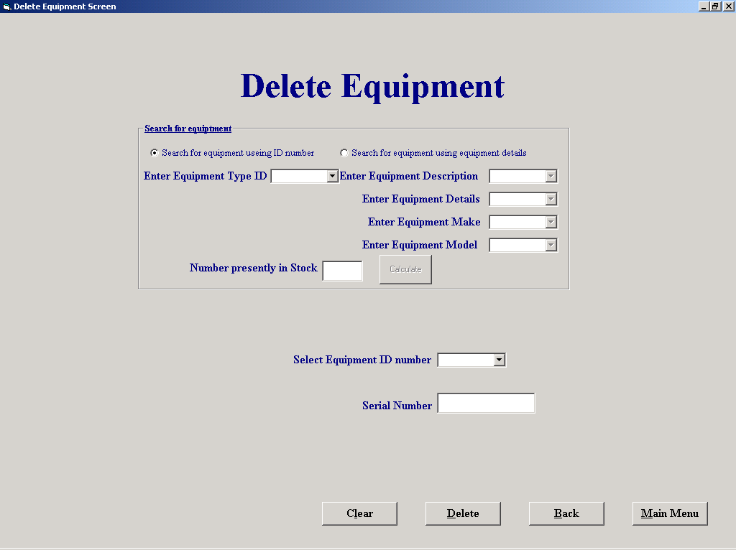

'Purpose This form allows the user to select a peice of equiptment for
' and mark its record for deletion. If the user knows the equipments
' ID number he can input it in a text box and then confirm it's
' serial number and then delete it (If the peice of equipment is
' out on hire then it should not be deleted)
' Alternatively you can search for the ID numbers of all stock
' by selecting either their Type ID number or working your way down
' a number of selection steps to search the a unique type. Each step
' You take reduces the scope of your search. When you have chosen the
' type you require you can calculate the number in stock and add the
' ID numbers to drop down list of a combo box
'Student David Hamilton
'StudentID Com2023
'Last Modified 15/3/02

'Variables used
'strMake String
'strModel String
'strDescription String
'strDetails String
'strAvailabilty String
'sqlDescription String
'strMess String
'sqlSN String
'sqlStatus String
'sqlEqptID String
'sqlCount String
'intID Integer
'intResponse Integer
'intNumber Integer
'intCount Integer

Option Explicit

'Checks if a valid "Equipment_ID" has been entered and if so it then checks
'If the equipment is on hire
Private Sub cboID_Click()
Dim intID, intResponse As Integer
Dim sqlSN, strMess, sqlStatus, strAvailabilty As String

intID = Val(cboID.Text)
sqlSN = "SELECT [S/N],Status FROM Equipment WHERE Equipment_ID = " & intID & " "

datSQL2.DatabaseName = "G:\EqpthireProject\EHS.mdb"
datSQL2.RecordSource = sqlSN
datSQL2.Refresh

On Error GoTo NoIDError
txtSN = datSQL2.Recordset.Fields("S/N")
strAvailabilty = datSQL2.Recordset.Fields("Status")
If strAvailability = "Out" Then
strMess = "This item of equipment is curently on hire and should not be Deleted"
intResponse = MsgBox(strMess, vbOKOnly, "Equipment on hire")
If intResponse = vbOK Then
txtSN = ""
cboID.Text = ""
cboID.SetFocus
End If
End If
Exit Sub

NoIDError:
If Err.Number = 3021 Then 'If an ID is entered that is not in the Table
If Len(txtSN) > 0 Then
strMess = "There is no matching ID"
intResponse = MsgBox(strMess, vbOKOnly, "Inncorect input")
If intResponse = vbOK Then
txtSN = ""
cboID.Text = ""
cboID.SetFocus
End If
End If
On Error GoTo 0
End If

'Resets screen to original settings

Private Sub cmdClear_Click()
cboEquipDescription.Text = ""
cboEquipDetails.Text = ""
cboEquipMake.Text = ""
cboEquipModel.Text = ""
cboTypeID.Text = ""
cboID.Text = ""
txtSN = ""
txtNoInStock = ""

End Sub

'Deletes the record curently shown
Private Sub cmdDelete_Click()
Dim intNumber As Integer

intResponse = MsgBox("Click OK to Delete all inputted Data", vbOKCancel, "Delete NOW")
If intResponse = 1 Then

datType.DatabaseName = "G:\EqpthireProject\EHS.mdb"
datType.RecordSource = "Equipment"
datType.Refresh

intNumber = Val(cboID.Text)
datType.Recordset.FindFirst " Equipment_ID = " & intNumber & ""

datType.Recordset.Edit
datType.Recordset("Deletion") = True
datType.Recordset.Update

cmdClear_Click
Else
cmdClear_Click
End If

Private Sub Command4_Click()
frmEquipmentFileProcessing
Unload Me
End Sub

Private Sub Command6_Click()
frmMainMenu.Show
Unload Me
End Sub

'When the form is loaded 2 combo boxes lists are loaded, cboTypeID contains
'a list of all the Equipment ID numbers, and the cboEquipDescription contains
'a list of Equipment descriptions (the first subset that a Type is devided into)
Private Sub Form_Load()
Dim sqlDescription As String

datType.DatabaseName = "G:\EqpthireProject\EHS.mdb"
datType.RecordSource = "Equipment Type"
datType.Refresh

While Not datType.Recordset.EOF
cboTypeID.AddItem datType.Recordset("Type_ID")
datType.Recordset.MoveNext
Wend

sqlDescription = "SELECT DISTINCT Description FROM [Equipment Type]"

datSQL1.DatabaseName = "G:\EqpthireProject\EHS.mdb"
datSQL1.RecordSource = sqlDescription
datSQL1.Refresh

While Not datSQL1.Recordset.EOF
cboEquipDescription.AddItem datSQL1.Recordset("Description")
datSQL1.Recordset.MoveNext
Wend
End Sub

Private Sub optEqptNum_Click()

cboTypeID.Enabled = True
cboEquipDescription.Enabled = False
cboEquipMake.Enabled = False
cboEquipModel.Enabled = False
cboEquipDetails.Enabled = False

End Sub

Private Sub optEquipName_Click()

cboTypeID.Enabled = False
cboEquipDescription.Enabled = True
cboEquipMake.Enabled = True
cboEquipModel.Enabled = True
cboEquipDetails.Enabled = True

End Sub

Private Sub cboTypeID_Click()
cmdNewItem.Enabled = True
End Sub

'calculate the number in stock and add the ID numbers to drop down list of
'a combo box
Private Sub cmdNewItem_Click()
Dim sqlCount As String
Dim intID As Integer
Dim intCount As Integer
Dim SQLEqptID As String

intID = Val(cboTypeID)
cboID.Clear

sqlCount = "SELECT Count(*)AS IDCount FROM Equipment WHERE Type_ID= " & intID & " AND Status = 'Available' AND Deletion = False ;"
SQLEqptID = "SELECT Equipment_ID FROM Equipment WHERE Type_ID= " & intID & " AND Status = 'Available' AND Deletion = False;"

datSQL1.DatabaseName = "G:\EqpthireProject\EHS.mdb"
datSQL1.RecordSource = sqlCount
datSQL1.Refresh

datSQL2.DatabaseName = "G:\EqpthireProject\EHS.mdb"
datSQL2.RecordSource = SQLEqptID
datSQL2.Refresh

intCount = datSQL1.Recordset.Fields("IDCount")
txtNoInStock.Text = Str(intCount)

While Not datSQL2.Recordset.EOF
cboID.AddItem datSQL2.Recordset("Equipment_ID")
datSQL2.Recordset.MoveNext
Wend

cboID.Enabled = True
End Sub

'This section is used to fill the Equipment Details drop down
'List with All the unique details of equiptment where the
'Description match those already chosen

Private Sub cboEquipDescription_Click()
Dim sqlDescription, strDescription As String

cboEquipDetails.Clear
cboEquipDetails.AddItem ("All")

strDescription = cboEquipDescription.Text
sqlDescription = "SELECT DISTINCT Details FROM [Equipment Type] WHERE Description = '" & strDescription & "'"

datSQL1.DatabaseName = "G:\EqpthireProject\EHS.mdb"
datSQL1.RecordSource = sqlDescription
datSQL1.Refresh

While Not datSQL1.Recordset.EOF
cboEquipDetails.AddItem datSQL1.Recordset("Details")
datSQL1.Recordset.MoveNext
Wend

End Sub

'This section is used to fill the Equipment Make drop down
'List with any make of equiptment where the Description
'and details match those already chosen

Private Sub cboEquipDetails_Click()

Dim sqlDetails, sqlMake, strDetails, sqlDescriptionAll As String

cboEquipMake.Clear
cboEquipMake.AddItem ("All")

strDescription = cboEquipDescription.Text
strDetails = cboEquipDetails.Text

If cboEquipDetails.Text = "All" Then
sqlDescription = "SELECT DISTINCT Make FROM [Equipment Type] WHERE Description = '" & strDescription & "'"
Else
sqlDescription = "SELECT DISTINCT Make FROM [Equipment Type] WHERE Details = '" & strDetails & "' AND Description = '" & strDescription & "'"
End If

datSQL1.DatabaseName = "G:\EqpthireProject\EHS.mdb"
datSQL1.RecordSource = sqlDescription
datSQL1.Refresh

While Not datSQL1.Recordset.EOF
cboEquipMake.AddItem datSQL1.Recordset("Make")
datSQL1.Recordset.MoveNext
Wend

'Using the infromation stored in the text part of the
'Equipment description,details,make and model comboboxes
'the unique Type ID can be queried from the equipment
'table this is then stored in the equipment number combo box
Private Sub cboEquipModel_Click()
Dim sqlDescription, strDescription, strModel, strMake, strDetails As String

cmdNewItem.Enabled = True

strDetails = cboEquipDetails.Text
strModel = cboEquipModel.Text
strMake = cboEquipMake.Text
strDescription = cboEquipDescription.Text

If strMake = "All" And strDetails = "All" Then
sqlDescription = "SELECT Type_ID FROM [Equipment Type] WHERE Model = '" & strModel & "' AND Description = '" & strDescription & "'"

ElseIf strMake = "All" Then
sqlDescription = "SELECT Type_ID FROM [Equipment Type] WHERE Model = '" & strModel & "' AND Details = '" & strDetails & "' AND Description = '" & strDescription & "'"

ElseIf strDetails = "All" Then
sqlDescription = "SELECT Type_ID FROM [Equipment Type] WHERE Model = '" & strModel & "' AND Make = '" & strMake & "' And Description = '" & strDescription & "'"

Else
sqlDescription = "SELECT Type_ID FROM [Equipment Type] WHERE Model = '" & strModel & "' AND Make = '" & strMake & "' And Description = '" & strDescription & "' AND Details = '" & strDetails & "'"
End If
datSQL1.DatabaseName = "G:\EqpthireProject\EHS.mdb"
datSQL1.RecordSource = sqlDescription
datSQL1.Refresh

While Not datSQL1.Recordset.EOF
cboTypeID.Text = datSQL1.Recordset("Type_ID")
datSQL1.Recordset.MoveNext
Wend
End Sub

'This section is used to fill the Equipment Make drop down
'List with any Model of equiptment where the Description
'details and make match those already chosen

Private Sub cboEquipMake_Click()
Dim strDescription, sqlDescription, strMake, strDetails As String

cboEquipModel.Clear
strDetails = cboEquipDetails.Text
strDescription = cboEquipDescription.Text
strMake = cboEquipMake.Text

If cboEquipMake.Text = "All" And cboEquipDetails = "All" Then
sqlDescription = "SELECT Model FROM [Equipment Type] WHERE Description = '" & strDescription & "'"

ElseIf cboEquipMake.Text = "All" Then
sqlDescription = "SELECT Model FROM [Equipment Type] WHERE Description = '" & strDescription & "' AND Details = '" & strDetails & "'"

ElseIf cboEquipDetails.Text = "All" Then
sqlDescription = "SELECT Model FROM [Equipment Type] WHERE Description = '" & strDescription & "' AND Make = '" & strMake & "'"

Else
sqlDescription = "SELECT Model FROM [Equipment Type] WHERE Make = '" & strMake & "' AND Description = '" & strDescription & "' AND Details = '" & strDetails & "'"

End If

datSQL1.DatabaseName = "G:\EqpthireProject\EHS.mdb"
datSQL1.RecordSource = sqlDescription
datSQL1.Refresh

While Not datSQL1.Recordset.EOF
cboEquipModel.AddItem datSQL1.Recordset("Model")
datSQL1.Recordset.MoveNext
Wend
End Sub

Amend\View a Customer

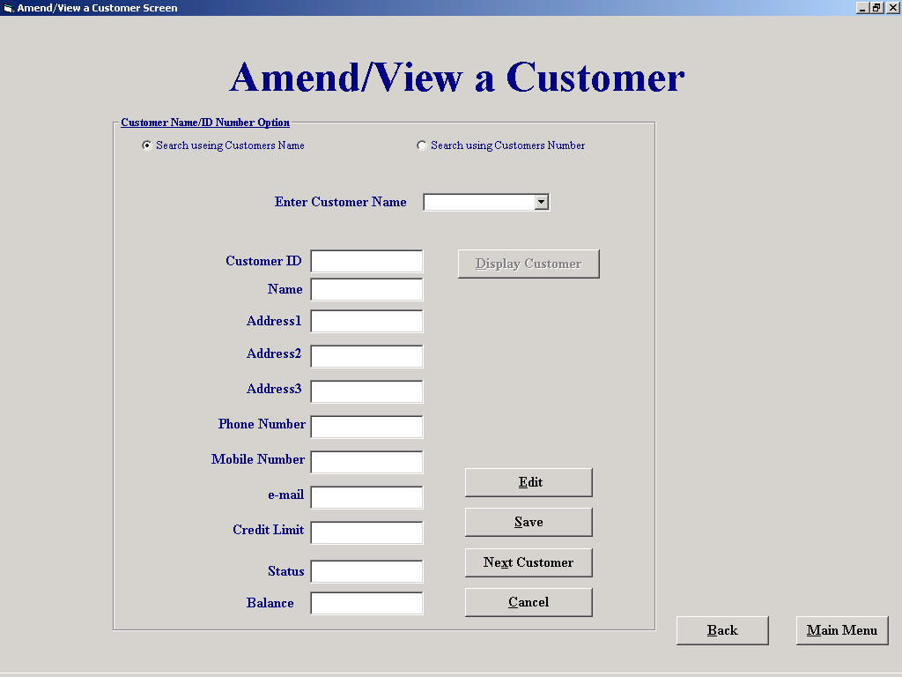

'Purpose This form allows the user to select a customer either by
' picking a customer ID from a drop down list,picking a
' customer name from a drop down list or by entering part of
' a name and searching through any names that match the criteria
' The Customers details can then be saved or ammended. If a
' customers details are amended they will be temperarly stored
' in the associated tag of the relevent text box until the save
' comand is selected. If the cancel comand is selected then all
' amendments not saved will be deleted
'Student David Hamilton
'StudentID Com2023
'Last Modified 15/3/02

'Variables used
'varName Variant
'varAdd1 Variant
'varAdd2 Variant
'varAdd3 Variant
'varPhone Variant (Declared as a varant because they are being
'varMob Variant used with the split Function)
'varEmail Variant
'varCrLim Variant
'varNum Variant
'strName String
'strID String
'intID Integer
'intNumber Integer
'intSaveCount Integer(Form level)

Option Explicit

Dim intSaveCount As Integer
'Clears the screen, clears the tags and resets the form level variabl
'intSaveCount to 0

Private Sub cmdBack_Click()
frmCustomerFileProcessing.Show
Unload Me
End Sub

Private Sub cmdCancel_Click()

ClearAll 'Procedure to clear Input boxes

If txtNameFound.Tag <> "" Then
txtNameFound.Tag = ""
txtAddress1.Tag = ""
txtAddress2.Tag = ""
txtAddress3.Tag = ""
txtPhoneNo.Tag = ""
txtMobileNo.Tag = ""
txtEmail.Tag = ""
txtCreditLimit.Tag = ""
intSaveCount = 0
End If
End Sub

'Enables relevent text boxes to allow editing
Private Sub cmdEdit_Click()

txtNameFound.Enabled = True
txtAddress1.Enabled = True
txtAddress2.Enabled = True
txtAddress3.Enabled = True
txtPhoneNo.Enabled = True
txtMobileNo.Enabled = True
txtEmail.Enabled = True
txtCreditLimit.Enabled = True

End Sub

Private Sub cmdMainMenu_Click()
frmMainMenu.Show
Unload Me

'selecting this button allows you to display another Customer
'The inputs are not saved at this stage but
'instead moved to the tags of the relevent text boxes, the
'text boxes are then cleared to make way for the next inputs
Private Sub cmdNextCustomer_Click()
If txtNameFound.Tag = "" Then
txtCustID.Tag = txtCustID
txtNameFound.Tag = txtNameFound
txtAddress1.Tag = txtAddress1
txtAddress2.Tag = txtAddress2
txtAddress3.Tag = txtAddress3
txtPhoneNo.Tag = txtPhoneNo
txtMobileNo.Tag = txtMobileNo
txtEmail.Tag = txtEmail
txtCreditLimit.Tag = txtCreditLimit
intSaveCount = 1
Else
txtCustID.Tag = txtCustID.Tag & Chr(9) & txtCustID
txtNameFound.Tag = txtNameFound.Tag & Chr(9) & txtNameFound
txtAddress1.Tag = txtAddress1.Tag & Chr(9) & txtAddress1
txtAddress2.Tag = txtAddress2.Tag & Chr(9) & txtAddress2
txtAddress3.Tag = txtAddress3.Tag & Chr(9) & txtAddress3
txtPhoneNo.Tag = txtPhoneNo.Tag & Chr(9) & txtPhoneNo
txtMobileNo.Tag = txtMobileNo.Tag & Chr(9) & txtMobileNo
txtEmail.Tag = txtEmail.Tag & Chr(9) & txtEmail
txtCreditLimit.Tag = txtCreditLimit.Tag & Chr(9) & txtCreditLimit
intSaveCount = intSaveCount + 1
End If

ClearAll 'Procedure to clear Input boxes
End Sub

'Allows the user to search through all records which match the initial criteria
Private Sub cmdPrevious_Click()

Dim strName As String

strName = cboName.Text
datCustomer.Recordset.FindPrevious ("Name like '*" & strName & "*'")

DisplayCustomer ' Displays the customer that relates to the above criteria
End Sub

'clears the text boxes and sets the "Enabled" settings of relevent input boxes
Private Sub ClearAll()
txtCustID = ""
txtNameFound = ""
txtAddress1 = ""
txtAddress2 = ""
txtAddress3 = ""
txtPhoneNo = ""
txtMobileNo = ""
txtEmail = ""
txtCreditLimit = ""
txtStatus = ""
txtBalance = ""

fmeMove.Visible = False
optName = True
cboName.Text = ""
cboNumber.Text = ""
optName.Enabled = True
optNumber.Enabled = True
cboName.Enabled = True
cmdSeekCustomer.Enabled = True
cboName.SetFocus
End Sub

'Allows the user to search through all records which match the initial criteria

Private Sub cmdNext_Click()
Dim strName As String

strName = cboName.Text
datCustomer.Recordset.FindNext ("Name like '*" & strName & "*'")

DisplayCustomer ' Displays the customer that relates to the above criteria

End Sub

'Saves the information presently displayed in the relevant
'input boxes as well as the information stored in their associated tags
Private Sub cmdSave_Click()
Dim intNumber As Integer
Dim varName, varAdd1, varAdd2, varAdd3, varPhone, varMob, varEmail, varCrLim, varNum As Variant

intResponse = MsgBox("Click OK to save all inputted Data", vbOKCancel, "SAVE NOW")
If intResponse = 1 Then

If txtCustID.Text <> "" Then
intNumber = Int(Val(txtCustID.Text))
datCustomer.Recordset.FindFirst "Cust_ID = " & intNumber & ""
datCustomer.Recordset.Edit
datCustomer.Recordset("Name") = txtNameFound
datCustomer.Recordset("Address 1") = txtAddress1
datCustomer.Recordset("Address 2") = txtAddress2
datCustomer.Recordset("Address 3") = txtAddress3
datCustomer.Recordset("Phone No") = txtPhoneNo
datCustomer.Recordset("Mobile No") = txtMobileNo
datCustomer.Recordset("E-Mail") = txtEmail
datCustomer.Recordset("Credit Limit") = txtCreditLimit
datCustomer.Recordset.Update

ClearAll 'Procedure to clear Input boxes

End If

If txtNameFound.Tag <> "" Then
If InStr(txtNameFound.Tag, Chr(9)) <> 0 Then
varNum = Split(txtCustID.Tag, Chr(9))
varName = Split(txtNameFound.Tag, Chr(9))
varAdd1 = Split(txtAddress1.Tag, Chr(9))
varAdd2 = Split(txtAddress2.Tag, Chr(9))
varAdd3 = Split(txtAddress3.Tag, Chr(9))
varPhone = Split(txtPhoneNo.Tag, Chr(9))
varMob = Split(txtMobileNo.Tag, Chr(9))
varEmail = Split(txtEmail.Tag, Chr(9))
varCrLim = Split(txtCreditLimit.Tag, Chr(9))

For intIndex = 0 To intSaveCount - 1
intNumber = Val(varNum(intIndex))
datCustomer.Recordset.FindFirst "Cust_ID = " & intNumber & ""
datCustomer.Recordset.Edit
datCustomer.Recordset("Name") = varName(intIndex)
datCustomer.Recordset("Address 1") = varAdd1(intIndex)
datCustomer.Recordset("Address 2") = varAdd2(intIndex)
datCustomer.Recordset("Address 3") = varAdd3(intIndex)
datCustomer.Recordset("Phone No") = varPhone(intIndex)
datCustomer.Recordset("Mobile No") = varMob(intIndex)
datCustomer.Recordset("E-Mail") = varEmail(intIndex)
datCustomer.Recordset("Credit Limit") = Val(varCrLim(intIndex))
datCustomer.Recordset.Update
Next intIndex
cmdCancel_Click

Else
intNumber = Val(txtCustID.Tag)
datCustomer.Recordset.FindFirst "Cust_ID = " & intNumber & ""
datCustomer.Recordset.Edit
datCustomer.Recordset("Name") = txtNameFound.Tag
datCustomer.Recordset("Address 1") = txtAddress1.Tag
datCustomer.Recordset("Address 2") = txtAddress2.Tag
datCustomer.Recordset("Address 3") = txtAddress3.Tag
datCustomer.Recordset("Phone No") = txtPhoneNo.Tag
datCustomer.Recordset("Mobile No") = txtMobileNo.Tag
datCustomer.Recordset("E-Mail") = txtEmail.Tag
datCustomer.Recordset("Credit Limit") = txtCreditLimit.Tag
datCustomer.Recordset.Update
cmdCancel_Click
End If
End If
Else
cmdCancel_Click
End If

End Sub

'When the form is loaded drop down lists of both cboName and cboNumber are
'filled from the customer table
Private Sub Form_Load()
datCustomer.DatabaseName = "G:\EqpthireProject\EHS.mdb"
datCustomer.RecordSource = "Customer"
datCustomer.Refresh

While Not datCustomer.Recordset.EOF
cboName.AddItem datCustomer.Recordset("Name")
cboNumber.AddItem datCustomer.Recordset("Cust_ID")
datCustomer.Recordset.MoveNext
Wend

End Sub

Private Sub optName_Click()

lblNameNumber = "Enter Customers Name"
cboName = ""
cboName.Visible = True
cboNumber.Visible = False
cboName.Enabled = True
cboName.SetFocus

Private Sub optNumber_Click()

lblNameNumber = "Enter Customers ID Number"
cboName.Visible = False
cboNumber.Visible = True
cboNumber = ""
cboNumber.Enabled = True
cboNumber.SetFocus

End Sub

Private Sub cboName_Change()
cmdSeekCustomer.Enabled = True
End Sub

Private Sub cboName_Click()
cmdSeekCustomer.Enabled = True
End Sub

Private Sub cboNumber_Change()
cmdSeekCustomer.Enabled = True
End Sub

Private Sub cboNumber_Click()
cmdSeekCustomer.Enabled = True

End Sub

'Using the Name/Number/letters entered a search is made of the
'Customer Table to return the first match, the coresponding
'record is then displayed. If a search is made using a name
'and their is more than one match, the user is then allowed
'step through the records of those with matching names
Private Sub cmdSeekCustomer_Click()
Dim strName, strID As String
Dim intNumber, intID As Integer

cmdPrevious.Enabled = True
cmdNext.Enabled = True

strID = cboName.Text

sqlCount = "SELECT Count(*)AS IDCount FROM Customer WHERE Name Like '*" & strID & "*';"

datSQL1.DatabaseName = "G:\EqpthireProject\EHS.mdb"
datSQL1.RecordSource = sqlCount
datSQL1.Refresh

intCount = datSQL1.Recordset.Fields("IDCount")

If intCount > 1 And cboName.Visible = True Then 'Displays matching records if their is more than 1
fmeMove.Visible = True
txtMatches = intCount
cmdPrevious.Enabled = True
cmdNext.Enabled = True
End If
If optName = True Then
strName = cboName.Text
If Not Len(strName) = 0 Then
datCustomer.Recordset.FindFirst "Name like '*" & strName & "*'"

txtCustID = datCustomer.Recordset("Cust_ID")
txtNameFound = datCustomer.Recordset("Name")
txtAddress1 = datCustomer.Recordset("Address 1")
txtAddress2 = datCustomer.Recordset("Address 2")
txtAddress3 = datCustomer.Recordset("Address 3")
txtPhoneNo = datCustomer.Recordset("Phone No")
txtMobileNo = datCustomer.Recordset("Mobile No")
txtEmail = datCustomer.Recordset("E-Mail")
txtCreditLimit = datCustomer.Recordset("Credit Limit")
txtStatus = datCustomer.Recordset("Status")
txtBalance = datCustomer.Recordset("Balance owed")
End If
Else
intNumber = Int(Val(cboNumber.Text))

datCustomer.Recordset.FindFirst "Cust_ID = " & intNumber & ""

txtCustID = datCustomer.Recordset("Cust_ID")
txtNameFound = datCustomer.Recordset("Name")
txtAddress1 = datCustomer.Recordset("Address 1")
txtAddress2 = datCustomer.Recordset("Address 2")
txtAddress3 = datCustomer.Recordset("Address 3")
txtPhoneNo = "" & datCustomer.Recordset("Phone No")
txtMobileNo = "" & datCustomer.Recordset("Mobile No")
txtEmail = "" & datCustomer.Recordset("E-Mail")
txtCreditLimit = datCustomer.Recordset("Credit Limit")
txtStatus = datCustomer.Recordset("Status")
txtBalance = "" & datCustomer.Recordset("Balance owed")

End If

End Sub

'A procedure the contents of a related record
Private Sub DisplayCustomer()

txtCustID = datCustomer.Recordset("Cust_ID")
txtNameFound = datCustomer.Recordset("Name")
txtAddress1 = datCustomer.Recordset("Address 1")
txtAddress2 = datCustomer.Recordset("Address 2")
txtAddress3 = datCustomer.Recordset("Address 3")
txtPhoneNo = "" & datCustomer.Recordset("Phone No")
txtMobileNo = "" & datCustomer.Recordset("Mobile No")
txtEmail = "" & datCustomer.Recordset("E-Mail")
txtCreditLimit = datCustomer.Recordset("Credit Limit")
txtStatus = datCustomer.Recordset("Status")
txtBalance = "" & datCustomer.Recordset("Balance owed")

End Sub

Private Sub SetScreen()
fmeMove.Visible = False
optName = True
cboName.Text = ""
cboNumber.Text = ""
optName.Enabled = False
optNumber.Enabled = False
cboName.Enabled = False
cmdSeekCustomer.Enabled = False
End Sub

Add a Customer

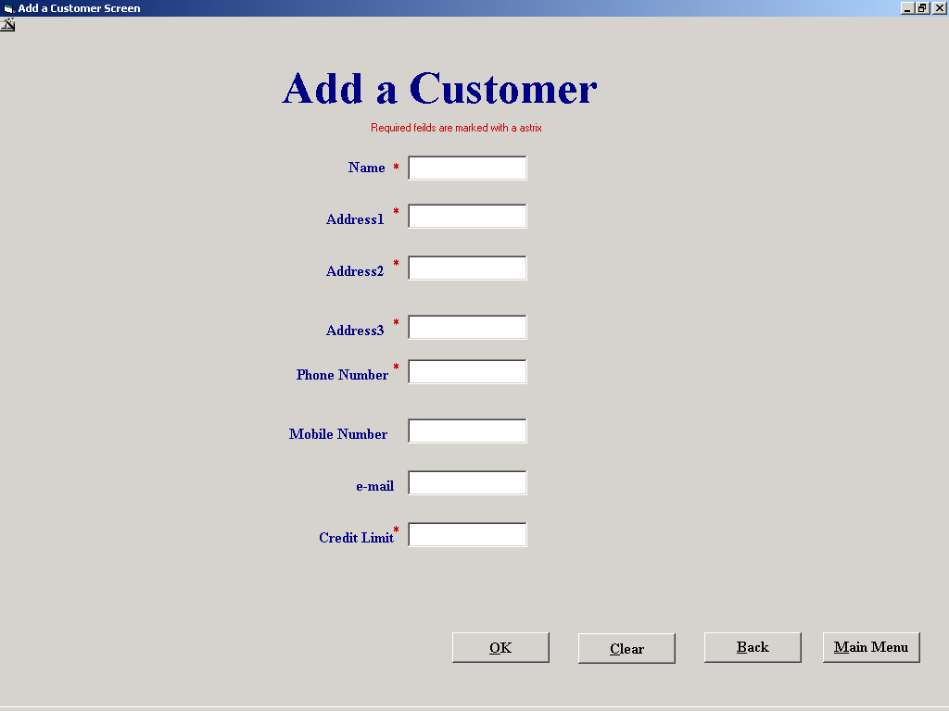

'Purpose This form allows the user to Display a add a new customer to the
' Customer table
'Student David Hamilton
'StudentID Com2023
'Last Modified 15/3/02

'Variables used
'intID Integer
'intResponse Integer

Option Explicit

'If the this form was opened from the Equipment Hire screen then a string
'will have been placed in the form tag else this form must have been opened
'from the Main Menu so return their
Private Sub cmdBack_Click()
If frmAddCustomer.Tag <> "" Then
frmRental.optNumber = False
frmRental.optName = True
frmRental.cboName.Visible = True
frmRental.cboNumber.Visible = False
frmRental.optNumber.Enabled = False
frmRental.optName.Enabled = False
frmRental.cboName.Enabled = False
frmRental.cboNumber.Visible = False
frmRental.cmdAddCust.Enabled = False
frmRental.lblNameNumber = "New Customers Name"
frmRental.cboName = txtName
frmRental.txtCustID = ""
frmRental.txtNameFound = ""
frmRental.txtAddress1 = ""
frmRental.txtAddress2 = ""
frmRental.txtAddress3 = ""
frmRental.txtPhoneNo = ""
frmRental.txtMobileNo = ""
frmRental.txtEmail = ""
frmRental.txtCreditLimit = ""
frmRental.txtStatus = ""
frmRental.txtBalance = ""
frmRental.datCustomer.Refresh
Else
frmCustomerFileProcessing.Show
End If

Unload Me
End Sub

'Empties text boxes
Private Sub cmdClear_Click()
txtName = ""
txtAddress1 = ""
txtAddress2 = ""
txtAddress3 = ""
txtPhoneNo = ""
txtMobileNo = ""
txtEmail = ""
txtCreditLimit = ""
txtName.SetFocus
cmdSave.Enabled = False
End Sub

Private Sub cmdMainMenu_Click()
If Len(txtCreditLimit) > 0 Then
intResponse = MsgBox("Do you wish to save before you Exit", vbYesNo, "Save Now")
If intResponse = vbYes Then
cmdSave_Click
Else
cmdClear_Click
End If
End If
frmMainMenu.Show
Unload Me
End Sub

'Create a new customers ID then save the contents the screen to a table then
'Clear out the text boxes
Private Sub cmdSave_Click()

Dim intID As Integer
Dim intResponse As Integer

If Not datCustomer.Recordset.BOF Then
datCustomer.Recordset.MoveLast
If intID >= datCustomer.Recordset("Cust_ID") Then
intID = intID + 1
Else
intID = datCustomer.Recordset("Cust_ID")
intID = intID + 1
End If
Else
intID = 1
End If

intResponse = MsgBox("Click OK to save inputted Data", vbOKCancel, "SAVE NOW")
If intResponse = 1 Then
datCustomer.Recordset.AddNew
datCustomer.Recordset("Cust_ID") = intID
datCustomer.Recordset("Name") = txtName
datCustomer.Recordset("Address 1") = txtAddress1
datCustomer.Recordset("Address 2") = txtAddress2
datCustomer.Recordset("Address 3") = txtAddress3
datCustomer.Recordset("Phone No") = txtPhoneNo
datCustomer.Recordset("Mobile No") = txtMobileNo
datCustomer.Recordset("E-Mail") = txtEmail
datCustomer.Recordset("Credit Limit") = txtCreditLimit
datCustomer.Recordset("Status") = "Normal"
datCustomer.Recordset("Balance owed") = 0
datCustomer.Recordset.Update

Else
cmdClear_Click
End If
cmdSave.Enabled = False

End Sub

Private Sub Form_Activate()
txtName.SetFocus
End Sub

Private Sub Form_Load()

datCustomer.DatabaseName = "G:\EqpthireProject\EHS.mdb"
datCustomer.RecordSource = "Customer"
datCustomer.Refresh
End Sub

'uses the validate function to ensure esential data is taken in

Private Sub txtAddress1_Validate(Cancel As Boolean)
Dim intResponse As Integer
If Len(txtAddress1) = 0 Then
Cancel = True
intResponse = MsgBox("You must enter data into this field", vbOKOnly, "Please fill out the form properaly")
If intResponse = 1 Then
txtAddress1.SetFocus
End If

End If

End Sub

Private Sub txtAddress2_Validate(Cancel As Boolean)
Dim intResponse As Integer
If Len(txtAddress2) = 0 Then
Cancel = True
intResponse = MsgBox("You must enter data into this field", vbOKOnly, "Please fill out the form properaly")
If intResponse = 1 Then
txtAddress2.SetFocus
End If
End If
End Sub

Private Sub txtCreditLimit_Validate(Cancel As Boolean)
Dim intResponse As Integer
If Len(txtCreditLimit) = 0 Then
Cancel = True
intResponse = MsgBox("You must enter data into this field", vbOKOnly, "Please fill out the form properaly")
If intResponse = 1 Then
txtCreditLimit.SetFocus
End If
ElseIf Not IsNumeric(txtCreditLimit) Then
Cancel = True
intResponse = MsgBox("You must enter a number in this box", vbOKOnly, "Numders only")
If intResponse = 1 Then
txtCreditLimit.SetFocus
End If
End If
cmdSave.Enabled = True
End Sub

Private Sub txtName_Validate(Cancel As Boolean)
Dim intResponse As Integer
If Len(txtName) = 0 Then
Cancel = True
intResponse = MsgBox("You must enter data into this field", vbOKOnly, "Please fill out the form properaly")
If intResponse = 1 Then
txtName.SetFocus
End If
End If
End Sub

Private Sub txtAddress3_Validate(Cancel As Boolean)
Dim intResponse As Integer
If Len(txtAddress3) = 0 Then
Cancel = True
intResponse = MsgBox("You must enter data into this field", vbOKOnly, "Please fill out the form properaly")
If intResponse = 1 Then
txtAddress1.SetFocus
End If
End If
End Sub
Private Sub txtPhoneNo_Change()
Dim intResponse As Integer
If Len(txtPhoneNo) = 0 Then
Cancel = True
intResponse = MsgBox("You must enter data into this field", vbOKOnly, "Please fill out the form properaly")
If intResponse = 1 Then
txtPhoneNo.SetFocus
End If
End If
End Sub

Payments Received report

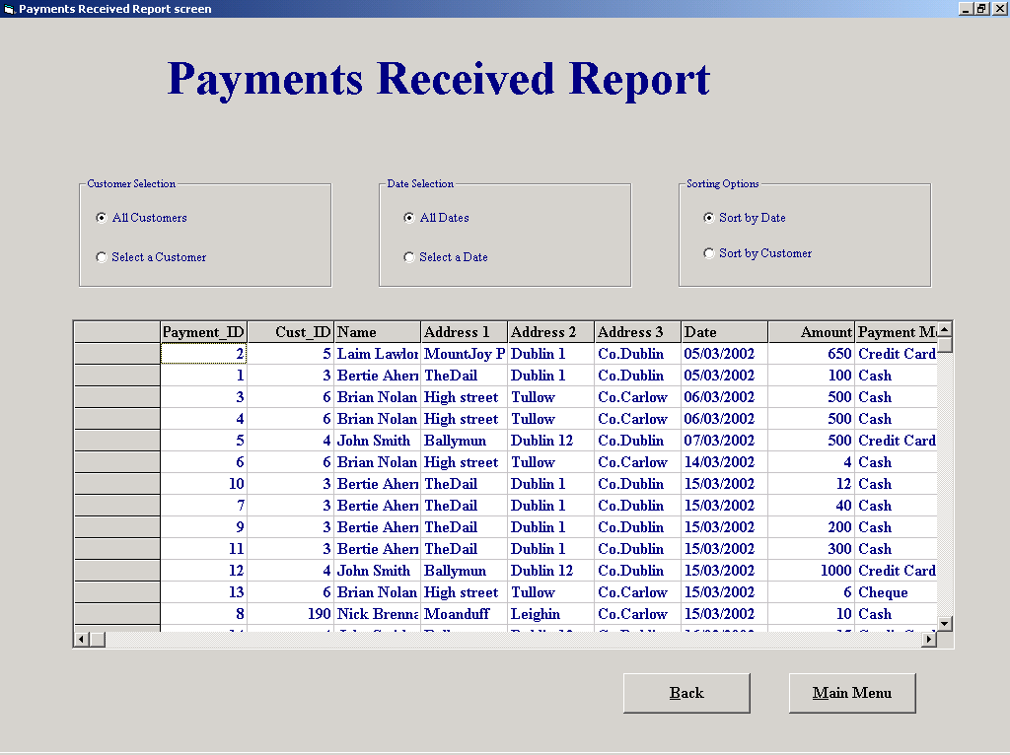

'Purpose This form allows the user to Display a number of different Reports
' depending on the options selected
'Student David Hamilton
'StudentID Com2023
'Last Modified 15/3/02

'Variables used
'strName String
'strID String
'intNumber Integer
'intID Integer
'intResponse Integer
'dateDate Date
'sqlDescription String

Option Explicit

Private Sub cboName_Click()
cmdSeekCustomer.Enabled = True

End Sub

'Returns to the reports menu
Private Sub cmdBack_Click()
frmReportsMenu.Show
Unload Me
End Sub

'Runs the function "functSQL" which selects the appropiate sql statement
'and returns the value to the data grid
Private Sub cmdConfirm_Click()

datGrid.RecordSource = functSQL
datGrid.Refresh
EnableOptions
fmeName.Visible = False
frmConfirm.Visible = False

End Sub

'A function to enable the select and sort option buttons
Private Sub EnableOptions()

optAllDates.Enabled = True
optAllCust.Enabled = True
optSelectCust.Enabled = True
optDateSort.Enabled = True
optCustomerSort.Enabled = True
optSelectDate.Enabled = True
End Sub
'Runs the function "functSQL" which selects the appropiate sql statement
'and returns the value to the data grid

Private Sub cmdConfirmDate_Click()

datGrid.RecordSource = functSQL
datGrid.Refresh
EnableOptions
fmeDate.Visible = False

End Sub

Private Sub cmdMainMenu_Click()
frmMainMenu.Show
Unload Me
End Sub

'Runs the function "functSQL" which selects the appropiate sql statement
'and returns the value to the data grid
Private Sub optAllCust_Click()

datGrid.RecordSource = functSQL
datGrid.Refresh
End Sub
'Runs the function "functSQL" which selects the appropiate sql statement
'and returns the value to the data grid
Private Sub optAllDates_Click()

datGrid.RecordSource = functSQL
datGrid.Refresh
End Sub

'Runs the function "functSQL" which selects the appropiate sql statement
'and returns the value to the data grid
Private Sub optCustomerSort_Click()

datGrid.RecordSource = functSQL
datGrid.Refresh
End Sub

'Runs the function "functSQL" which selects the appropiate sql statement
'and returns the value to the data grid
Private Sub optDateSort_Click()

datGrid.RecordSource = functSQL
datGrid.Refresh
End Sub

Private Sub optName_Click()

lblNameNumber = "Enter Customers Name"
cboName = ""
cboName.Visible = True
cboNumber.Visible = False
cboName.SetFocus

End Sub

Private Sub optNumber_Click()

cboNumber.Text = cboNumber.List(0)
lblNameNumber = "Enter Customers ID Number"
cboName.Visible = False
cboNumber.Visible = True
cboNumber = ""
cboNumber.Enabled = True

End Sub

Private Sub cboName_Change()
cboName_Click
End Sub

'This function checks to see which search and sort options have been selected
'then selects the correct SQL querry
Private Function functSQL() As String
Dim dateDate As Date
Dim intID As Integer

If Not optAllDates Then
dateDate = Format(calCalander.Value, "mm dd yyyy")
End If
If Len(cboNumber.Text) <> 0 Then
intID = Val(cboNumber.Text)
End If

If optAllCust = True And optAllDates = True And optDateSort = True Then
functSQL = "SELECT Payment.Payment_ID, Customer.Cust_ID, Customer.Name, Customer.[Address 1], Customer.[Address 2], Customer.[Address 3], Payment.Date, Payment.Amount, Payment.[Payment Method] FROM Customer INNER JOIN Payment ON Customer.Cust_ID = Payment.Cust_ID ORDER BY Payment.Date;"
ElseIf optAllCust = False And optAllDates = True And optDateSort = True Then
functSQL = "SELECT Payment.Payment_ID, Customer.Cust_ID, Customer.Name, Customer.[Address 1], Customer.[Address 2], Customer.[Address 3], Payment.Date, Payment.Amount, Payment.[Payment Method] FROM Customer INNER JOIN Payment ON Customer.Cust_ID = Payment.Cust_ID WHERE Customer.Cust_ID = " & intID & " ORDER BY Payment.Date;"
ElseIf optAllCust = False And optAllDates = False And optDateSort = True Then
functSQL = "SELECT Payment.Payment_ID, Customer.Cust_ID, Customer.Name, Customer.[Address 1], Customer.[Address 2], Customer.[Address 3], Payment.Date, Payment.Amount, Payment.[Payment Method] FROM Customer INNER JOIN Payment ON Customer.Cust_ID = Payment.Cust_ID WHERE Customer.Cust_ID = " & intID & " AND Payment.Date = #" & dateDate & "# ORDER BY Payment.Date;"
ElseIf optAllCust = False And optAllDates = False And optDateSort = False Then
functSQL = "SELECT Payment.Payment_ID, Customer.Cust_ID, Customer.Name, Customer.[Address 1], Customer.[Address 2], Customer.[Address 3], Payment.Date, Payment.Amount, Payment.[Payment Method] FROM Customer INNER JOIN Payment ON Customer.Cust_ID = Payment.Cust_ID WHERE Customer.Cust_ID = " & intID & " AND Payment.Date = #" & dateDate & "# ORDER BY Customer.Name;"
ElseIf optAllCust = False And optAllDates = True And optDateSort = False Then
functSQL = "SELECT Payment.Payment_ID, Customer.Cust_ID, Customer.Name, Customer.[Address 1], Customer.[Address 2], Customer.[Address 3], Payment.Date, Payment.Amount, Payment.[Payment Method] FROM Customer INNER JOIN Payment ON Customer.Cust_ID = Payment.Cust_ID WHERE Customer.Cust_ID = " & intID & " ORDER BY Customer.Name;"
ElseIf optAllCust = True And optAllDates = True And optDateSort = False Then
functSQL = "SELECT Payment.Payment_ID, Customer.Cust_ID, Customer.Name, Customer.[Address 1], Customer.[Address 2], Customer.[Address 3], Payment.Date, Payment.Amount, Payment.[Payment Method] FROM Customer INNER JOIN Payment ON Customer.Cust_ID = Payment.Cust_ID ORDER BY Customer.Name;"
ElseIf optAllCust = True And optAllDates = False And optDateSort = True Then
functSQL = "SELECT Payment.Payment_ID, Customer.Cust_ID, Customer.Name, Customer.[Address 1], Customer.[Address 2], Customer.[Address 3], Payment.Date, Payment.Amount, Payment.[Payment Method] FROM Customer INNER JOIN Payment ON Customer.Cust_ID = Payment.Cust_ID WHERE Payment.Date = #" & dateDate & "# ORDER BY Payment.Date;"
Else
functSQL = "SELECT Payment.Payment_ID, Customer.Cust_ID, Customer.Name, Customer.[Address 1], Customer.[Address 2], Customer.[Address 3], Payment.Date, Payment.Amount, Payment.[Payment Method] FROM Customer INNER JOIN Payment ON Customer.Cust_ID = Payment.Cust_ID WHERE Payment.Date = #" & dateDate & "# ORDER BY Customer.Name;"
End If
End Function
'Ensures that the cboName input section has been filled

Private Sub cboName_Validate(Cancel As Boolean)
Dim intResponse As Integer

If Len(cboName.Text) = 0 Then
Cancel = True
intResponse = MsgBox("You must enter data into this field", vbOKOnly, "Please Enter Data")
If intResponse = 1 Then
cboName.SetFocus
End If

End If
End Sub

Private Sub cboNumber_Change()
cmdSeekCustomer.Enabled = True
End Sub

Private Sub cboNumber_Click()
cmdSeekCustomer.Enabled = True

End Sub

'Using the Name/Number/letters entered a search is made of the
'Customer Table to return the first match, the coresponding
'record is then displayed. If a search is made using a name
'and their is more than one match, the user is then allowed
'step through the records of those with matching names
Private Sub cmdSeekCustomer_Click()
Dim strName, strID As String
Dim intNumber, intID As Integer

cmdPrevious.Enabled = True
cmdNext.Enabled = True

strID = cboName.Text

sqlCount = "SELECT Count(*)AS IDCount FROM Customer WHERE Name Like '*" & strID & "*';"

datSQL1.DatabaseName = "G:\EqpthireProject\EHS.mdb"
datSQL1.RecordSource = sqlCount
datSQL1.Refresh

intCount = datSQL1.Recordset.Fields("IDCount")

If intCount > 1 Then 'Displays matching records if their is more than 1
fmeMove.Visible = True
txtMatches = intCount
cmdPrevious.Enabled = True
cmdNext.Enabled = True
End If
If optName = True Then
strName = cboName.Text
If Not Len(strName) = 0 Then
datCustomer.Recordset.FindFirst "Name like '*" & strName & "*'"

cboNumber.Text = datCustomer.Recordset("Cust_ID")
txtNameFound = datCustomer.Recordset("Name")
txtAddress1 = datCustomer.Recordset("Address 1")
txtAddress2 = datCustomer.Recordset("Address 2")
txtAddress3 = datCustomer.Recordset("Address 3")

End If
Else
intNumber = Int(Val(cboNumber.Text))

datCustomer.Recordset.FindFirst "Cust_ID = " & intNumber & ""

txtNameFound = datCustomer.Recordset("Name")
txtAddress1 = datCustomer.Recordset("Address 1")
txtAddress2 = datCustomer.Recordset("Address 2")
txtAddress3 = datCustomer.Recordset("Address 3")

End If
frmConfirm.Visible = True 'A confirm option is used to ensure that the correct
'information has been selected

End Sub

'This only becomes visable if there is a match in names selected and allows you to
'move forward through each possible customer until you can confirm you have
'the correct one from the extra details shown
Private Sub cmdNext_Click()
Dim strName As String

strName = cboName.Text
With datCustomer.Recordset
.FindNext ("Name like '*" & strName & "*'")

End With
cboNumber.Text = datCustomer.Recordset("Cust_ID")
txtNameFound = datCustomer.Recordset("Name")
txtAddress1 = datCustomer.Recordset("Address 1")
txtAddress2 = datCustomer.Recordset("Address 2")
txtAddress3 = datCustomer.Recordset("Address 3")

End Sub
'This only becomes visable if there is a match in names selected and allows you to
'move backwards through each possible customer until you can confirm you have
'the correct one from the extra details shown
Private Sub cmdPrevious_Click()
Dim strName As String

strName = cboName.Text
With datCustomer.Recordset
.FindPrevious ("Name like '*" & strName & "*'")

End With
cboNumber.Text = datCustomer.Recordset("Cust_ID")
txtNameFound = datCustomer.Recordset("Name")
txtAddress1 = datCustomer.Recordset("Address 1")
txtAddress2 = datCustomer.Recordset("Address 2")
txtAddress3 = datCustomer.Recordset("Address 3")

End Sub
'Fills the customer name and id number combo box's with information stored in the
'Customer table also an SQL query which is correct for the initial set up of
'the option buttons is run and the Data Grid is filled

Private Sub Form_Load()
Dim sqlDescription As String
cboName.Text = cboName.List(0)
datCustomer.DatabaseName = "G:\EqpthireProject\EHS.mdb"
datCustomer.RecordSource = "Customer"
datCustomer.Refresh

While Not datCustomer.Recordset.EOF
cboName.AddItem datCustomer.Recordset("Name")
cboNumber.AddItem datCustomer.Recordset("Cust_ID")
datCustomer.Recordset.MoveNext
Wend

sqlDescription = "SELECT Payment.Payment_ID, Customer.Cust_ID, Customer.Name, Customer.[Address 1], Customer.[Address 2], Customer.[Address 3], Payment.Date, Payment.Amount, Payment.[Payment Method] FROM Customer INNER JOIN Payment ON Customer.Cust_ID = Payment.Cust_ID ORDER BY Payment.Date;"

datGrid.DatabaseName = "G:\EqpthireProject\EHS.mdb"
datGrid.RecordSource = sqlDescription
datGrid.Refresh

datGrid.Refresh
End Sub
'Disables all the options while a selection process is taking place
Private Sub DisableOptions()

optAllDates.Enabled = False
optAllCust.Enabled = False
optSelectDate.Enabled = False
optSelectCust.Enabled = False
optDateSort.Enabled = False
optCustomerSort.Enabled = False

End Sub

Private Sub optSelectCust_Click()

DisableOptions
fmeName.Visible = True

End Sub

Private Sub optSelectDate_Click()

DisableOptions
fmeDate.Visible = True

End Sub

Reports Menu

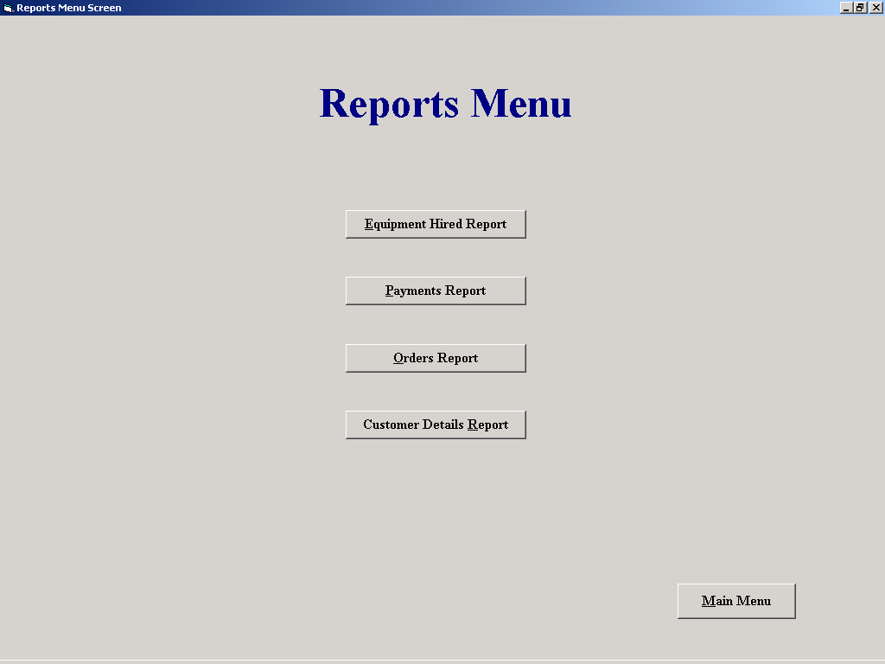

'Purpose This form allows the user to select and open any one of 4
' Report screens

'Student David Hamilton
'StudentID Com2023
'Last Modified 15/3/02

Option Explicit

Private Sub cmdCustDetails_Click()

frmCustReport.Show
Unload Me

End Sub

Private Sub cmdEqptHired_Click()

frmEquipmentHiredReport.Show
Unload Me

End Sub

Private Sub cmdMainMenu_Click()
frmMainMenu.Show
Unload Me
End Sub

Private Sub cmdOrders_Click()

frmOrdersReport.Show
Unload Me

End Sub

Private Sub cmdPayments_Click()

frmPaymentsReport.Show
Unload Me

End Sub

Add Equipment

Screen Shot:

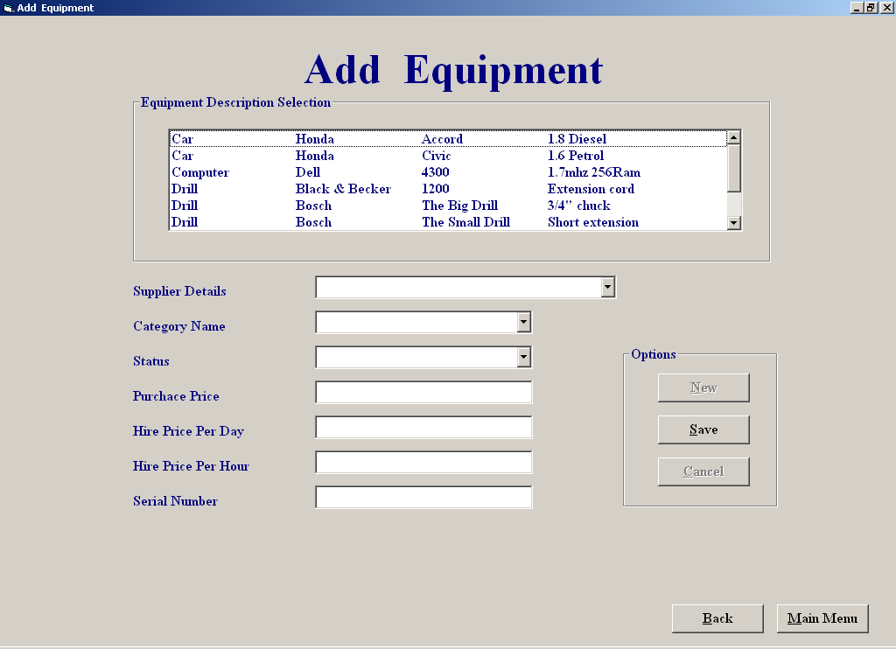

Code:

'Purpose of screen:

'the purpose of this screen is to allow the user to add in new equipment
'to the database,the user can enter in the new equipment details by selecting
'on some of the listed details such as equipment type description
'supplier of the equipment and category of the equipment, the rest of the
'details are then manually entered in, when all the details are entered
'the user has two options exit without saving the new equipment
'details to the database or he/she can save the details to the database
'and he/she can then cancel/delete the record just entered from
'the database
,the user can then add another new record to the database
'by clicking the add new button

'Author: Derek Stafford com2026
'15/03/2002

'variables used purpose
'strMake string; holds make fields from the equipment type table
'strModel, string; holds model fields from the equipment type table
'strDetails string; holds details fields from the equipment type table
'strSQL string; holds SQL query result
'strDescription string; holds description fields form the equipment type table
'curHirePDay currency; stores a tempary currency value from the hire per day textbox
'strStatus, currency; stores a tempary currency value from the status textbox
'strDescription currency; stores a tempary currency value from the descrption textbox
'intindex integer; used as a counter variable in loops etc
'intTempEquipTypeID integer; holds equipment type ID value
'intEmpSupplierID integer; holds supplier ID
'intcategoryID integer; holds category id
'intResult integer; holds result of answer from message box
'
'objects used
'
'datEquipmentType datacontrol; holds data from the equipment type table
'datEquipment datacontrol; holds data from the equipment table
'datSupplier datacontrol; holds data from the supplier table
'datCategory datacontrol; holds data from the category table

'Author: Derek Stafford com2026
'15/03/2002

Option Explicit

Dim intEquipTypeID, intCategoryID, intSupplierID As Integer

Private Sub cmbCategory_Click()
intCategoryID = cmbCategory.ItemData(cmbCategory.ListIndex)
datCategory.Recordset.FindFirst "Category_ID = " & intCategoryID & ""
End Sub
=============================================================
Private Sub cmdAddNew_Click()
cmbEquipType.Text = ""
cmbCategory.Text = ""
cmbSupplier.Text = ""
txtSerialNumber = ""
txtStatus = ""
txtPurchasePrice = ""
txtHireDay = ""
txtHireHour = ""
End Sub
============================================================
Private Sub cmdCancel_Click()

Dim intResult As Integer
intResult = MsgBox("Are you sure you want to cancel,if you click yes you will delete the new record from the database", vbYesNo, "Cancel")
If intResult = vbYes Then
With datEquipment
.Recordset.MoveLast
.Recordset.Delete
End With

End If
Cmdcancel.Enabled = False
cmdNew.Enabled = True
End Sub
=============================================================
Private Sub cmdNew_Click()

cmdSave.Enabled = True
Cmdcancel.Enabled = False
cmbSupplier = ""
cmbCategory = ""
cmbStatus = ""
txtPurchasePrice = ""
txtHireDay = ""
txtHireHour = ""
txtSerialNumber = ""
lstEquipmentType.SetFocus
End Sub
=============================================================
Private Sub cmdSave_Click()

Dim intindex As Integer
If intEquipTypeID = "" Then
Call MsgBox("An equipment description has not been selected", vbCritical, "Empty Field")
cmdSave.Enabled = True
cmbSupplier.SetFocus
Else
If cmbCategory.ListIndex = -1 Or cmbSupplier.ListIndex = -1 Or txtPurchasePrice = "" Or cmbStatus.ListIndex = -1 Or txtHireDay = "" Or txtHireHour = "" Then
Call MsgBox("All/Some Of The Equipment Details Have Not Been Filled In ", vbCritical, "Details InComplete")
cmdSave.Enabled = True
Else
datEquipment.Recordset.MoveLast
intindex = datEquipment.Recordset("Equipment_ID") + 1
With datEquipment
.Recordset.AddNew
.Recordset("Equipment_ID") = intindex
.Recordset("Type_ID") = intEquipTypeID
.Recordset("Supplier_ID") = intSupplierID
.Recordset("S/N") = Val(txtSerialNumber.Text)
.Recordset("Status") = cmbStatus.Text
.Recordset("[Purchase Price]") = CCur(Val(txtPurchasePrice.Text))
.Recordset("[Hire Price Per Day]") = CCur(Val(txtHireDay.Text))
.Recordset("[Hire Price Per Hour]") = CCur(Val(txtHireHour))
.Recordset.Update

End With
cmdSave.Enabled = False
Cmdcancel.Enabled = True
cmdNew.Enabled = True

End If
End If
End Sub
=============================================================
Private Sub cmbStatus_DropDown()
cmbStatus.Clear
cmbStatus.AddItem ("Available")
cmbStatus.AddItem ("Broke")
cmbStatus.AddItem ("Out")
End Sub
=============================================================
Private Sub cmbcategory_DropDown()
'Fills the supplier combo box
While Not datCategory.Recordset.EOF
cmbCategory.AddItem (datCategory.Recordset("Category Name"))
cmbCategory.ItemData(cmbCategory.NewIndex) = datCategory.Recordset("Category_ID")
datCategory.Recordset.MoveNext
Wend
End Sub
=============================================================
Private Sub cmbSupplier_DropDown()
cmbSupplier.Clear
datSupplier.Recordset.MoveFirst
While Not datSupplier.Recordset.EOF
cmbSupplier.AddItem datSupplier.Recordset("Supplier Name") + ", " + datSupplier.Recordset("Address 1") + ", " + datSupplier.Recordset("Address 2")
cmbSupplier.ItemData(cmbSupplier.NewIndex) = datSupplier.Recordset("Supplier_ID")
datSupplier.Recordset.MoveNext
Wend
End Sub
=============================================================

'Stores the selected supplier id number
Private Sub cmbSupplier_Click()
intSupplierID = cmbSupplier.ItemData(cmbSupplier.ListIndex)
End Sub
=============================================================
Private Sub cmdMainMenu_Click()
frmMainMenu.Show
Unload Me
End Sub
=============================================================
'Loads Equipmentfileprocessing screen and unloads the amend/view equipment screen

Private Sub cmdBack_Click()
frmEquipmentFileProcessing.Show
Unload Me
End Sub
=============================================================
'Fills the two listboxes and sets up screen layout

Private Sub Form_Activate()
Dim srtDescription, strMake, strModel, strDetails As String, intindex As Integer
cmdNew.Enabled = False
lstEquipmentType.SetFocus
cmdSave.Enabled = True

datEquipmentType.Recordset.MoveFirst
While Not datEquipmentType.Recordset.EOF
With datEquipmentType
srtDescription = .Recordset("Description")
strMake = .Recordset("Make")
strModel = .Recordset("Model")
strDetails = .Recordset("Details")
For intindex = Len(.Recordset("Description")) To 20
srtDescription = srtDescription + " "
Next intindex
For intindex = Len(.Recordset("Make")) To 20
strMake = strMake + " "
Next intindex
For intindex = Len(.Recordset("Model")) To 20
strModel = strModel + " "
Next intindex
For intindex = Len(.Recordset("Details")) To 20
strDetails = strDetails + " "
Next intindex

lstEquipmentType.AddItem (srtDescription + vbTab + strMake + vbTab + strModel + vbTab + strDetails)
lstEquipmentType.ItemData(lstEquipmentType.NewIndex) = .Recordset("Type_ID")
.Recordset.MoveNext
End With
Wend
End Sub
=============================================================
Private Sub Form_Load()
Cmdcancel.Enabled = False
cmdAMend.Enabled = False

cmdSave.Enabled = False
datEquipmentType.DatabaseName = "c:/EHS.mdb"
datEquipmentType.RecordSource = "Equipment Type"
datEquipment.DatabaseName = "c:/EHS.mdb"
datEquipment.RecordSource = "Equipment"
datCategory.DatabaseName = "c:/EHS.mdb"
datCategory.RecordSource = "Category"
datSupplier.DatabaseName = "c:/EHS.mdb"
datSupplier.RecordSource = "Supplier"

End Sub
=============================================================
Private Sub lstEquipmentType_Click()
Dim strmySQl As String

intEquipTypeID = lstEquipmentType.ItemData(lstEquipmentType.ListIndex)
End Sub
=============================================================
'Checks that serial number entered is valid
Private Sub txtSerialNumber_Validate(Cancel As Boolean)
If IsNumeric(txtSerialNumber.Text) Then
Cancel = False
Else
Call MsgBox("Sorry invalid data", vbOKOnly, "Warning")
txtSerialNumber.SetFocus
Cancel = True
End If
End Sub
=============================================================
Private Sub txtPurchasePrice_Validate(Cancel As Boolean)
If IsNumeric(txtPurchasePrice.Text) Then
Cancel = False
Else
Call MsgBox("Sorry invalid data", vbOKOnly, "Warning")
txtHireDay.SetFocus
Cancel = True
End If
End Sub
=============================================================
'Checks that hire day number entered is valid
Private Sub txtHireDay_Validate(Cancel As Boolean)

If IsNumeric(txtHireDay.Text) Then
Cancel = False
Else
Call MsgBox("Sorry invalid data", vbOKOnly, "Warning")
txtHireDay.SetFocus
Cancel = True
End If
End Sub
=============================================================
'Checks that hire hour number entered is valid
Private Sub txtHireHour_Validate(Cancel As Boolean)
If IsNumeric(txtHireHour.Text) Then
Cancel = False
Else
Call MsgBox("Sorry invalid data", vbOKOnly, "Warning")
txtHireHour.SetFocus
Cancel = True
End If
End Sub
=============================================================

Amend/View Equipment

Screen Shot:

Code:

'Purpose of screen:

'the purpose of this screen is to allow the user to to select an item of
'equipment either by entering the equipment id number or by browsing threw
'equipment details until the item is found ,when the item is found the user
'can 'make changes to the equipment details by clicking on the amend button
'to which allows the user to to select the listed details any manually enter
'the rest,when the changes have been made the user has two options,either
'save or cancel the changes made to the equipment details,if the details
'are saved the relevant tables are updated ie the equipment type table and
'the equipment.
'
'
'Author: Derek Stafford com2026
'15/03/2002

'Variables Used Purpose of string

'strSerialNumb string stores a tempary string value from the serial number textbox
'strStatus, string stores a tempary string value from the status textbox
'strDescription string stores a tempary string value from the descrption textbox
'strmySQL string stores the SQL queries
'curHirePDay currency stores a tempary currency value from the hire per day textbox
'strStatus, currency stores a tempary currency value from the status textbox
'strDescription currency stores a tempary currency value from the descrption textbox
'intindex integer used as a counter variable in loops etc
'intTempEquipTypeID integer stores a tempary equipment type ID value
'intEmpSupplierID integer stores supplier ID

'objects used

'datEquipmentType datacontrol Retrieves info from equipmentType table
'datEquipment datacontrol retrieves info from equipment table
'datSupplier datacontrol retrieves info from supplier table
'datSupplier datacontrol retrieves info from category table
'datCategory

Option Explicit

Dim strSerialNumb, strStatus, strDescription As String
Dim curHirePDay, curHirePHour, curPurchPrice As Currency
Dim intTempEquipTypeID, intTempSupplierID, intTempEquipmentID As Integer
Dim intEquipTypeID, intEquipTypeID2, intSupplierID, intEquipmentID As Integer

'Empties textboxes on the screen

Private Sub Cleartextboxes()
cmbSupplier = ""
txtSerialNumber = ""
cmbStatus = ""
txtPurchasePrice = ""
txtHireDay = ""
txtHireHour = ""
txtDescription = ""
End Sub
=============================================================
'Fills combo box with serial numbers of the equipment type

Private Sub cmbSerialNumb_click()
Dim strmySQl As String
lstEquipmentType2.Enabled = False
cmdAMend.Enabled = True
cmbSerialNumb.Enabled = False
strSerialNumb = cmbSerialNumb.ItemData(cmbSerialNumb.ListIndex)
If intEquipTypeID = "" Then
Call MsgBox("you have not selected an item", vbCritical, "Equipment Not Selected")

Else
cmdAMend.Enabled = True
strmySQl = "SELECT Equipment.* From Equipment WHERE (((Equipment.Type_ID)=" & intEquipTypeID & ") AND ((Equipment.[S/N])='" & strSerialNumb & "'));"
datEquipment.RecordSource = strmySQl
datEquipment.Refresh
intEquipmentID = datEquipment.Recordset("Equipment_ID")
display
End If
End Sub
=============================================================
'Puts data into combobox

Private Sub cmbStatus_DropDown()
cmbStatus.Clear
cmbStatus.AddItem ("Available")
cmbStatus.AddItem ("Broke")
cmbStatus.AddItem ("Out")
End Sub
=============================================================
'Fills the supplier combo box
Private Sub cmbSupplier_DropDown()
cmbSupplier.Clear
datSupplier.Recordset.MoveFirst
While Not datSupplier.Recordset.EOF
cmbSupplier.AddItem (datSupplier.Recordset("Supplier Name")) + ", " + (datSupplier.Recordset("Address 1")) + ", " + (datSupplier.Recordset("Address 2"))
cmbSupplier.ItemData(cmbSupplier.NewIndex) = datSupplier.Recordset("Supplier_ID")
datSupplier.Recordset.MoveNext
Wend
End Sub
=============================================================
'Stores the selected supplier id number

Private Sub cmbSupplier_Click()
intSupplierID = cmbSupplier.ItemData(cmbSupplier.ListIndex)
End Sub

'Stores the textbox data into variables for retieval if changes are cancelled
'and also resets screen layout

Private Sub cmdAMend_Click()
cmdAMend.Enabled = False
lstEquipmentType.Enabled = False
lstEquipmentType.Visible = False
lstEquipmentType.Visible = False
lstEquipmentType2.Visible = True
lstEquipmentType2.Enabled = False
lstEquipmentType2.Enabled = True
cmbSupplier.Enabled = True
cmbSupplier.SetFocus
txtSerialNumber.Enabled = True
txtSerialNumber.SetFocus
cmbStatus.Enabled = True
txtPurchasePrice.Enabled = True
txtHireDay.Enabled = True
txtHireHour.Enabled = True
cmdSave.Enabled = True
Cmdcancel.Enabled = True

intTempEquipmentID = datEquipment.Recordset("Equipment_ID")
If intEquipTypeID2 = "" Then
intTempEquipTypeID = intEquipmentID
Else
intTempEquipTypeID = intEquipTypeID2
End If
intTempEquipTypeID = datEquipment.Recordset("Type_ID")
intTempSupplierID = intSupplierID
strSerialNumb = txtSerialNumber
strStatus = cmbStatus.Text
curPurchPrice = txtPurchasePrice
curHirePDay = txtHireDay
curHirePHour = txtHireHour
strDescription = txtDescription
End Sub
=============================================================
'Puts back the orignal data back into textboxes before changes were made

Private Sub cmdCancel_Click()
cmdAMend.Enabled = True
intSupplierID = datEquipment.Recordset("Supplier_ID")
datSupplier.Recordset.FindFirst "Supplier_ID =" & intTempSupplierID & ""
cmbSupplier.Text = datSupplier.Recordset("Supplier Name")

txtSerialNumber = strSerialNumb
cmbStatus = strStatus
txtPurchasePrice = curPurchPrice
txtHireDay = curHirePDay
txtHireHour = curHirePHour
lstEquipmentType.Visible = True
lstEquipmentType.Enabled = True
txtDescription = strDescription
Disabletextboxes
End Sub
=============================================================
'Check for valid number

Function IsValid(StrEQID As Variant) As Boolean
Dim intindex As Integer, temp As Variant, blnValid As Boolean
blnValid = False
For intindex = 1 To Len(StrEQID)
temp = Mid(StrEQID, intindex, 1)
If (temp > 0 And temp < 9) Then
blnValid = True
Else
intindex = Len(StrEQID)
blnValid = False

End If
Next
IsValid = blnValid
End Function
=============================================================
'Check if equipment id entered is valid and if so it finds the info to be diplayed
'if not a an error message is displayed

Private Sub cmdDisplay_Click()
If IsValid(txtEquipmentID.Text) = False Then
Call MsgBox("You have entered invalid data or no data ,you must enter a number", vbCritical, "Invalid Data Entry")
txtEquipmentID = ""
txtEquipmentID.SetFocus
Else
If txtEquipmentID > 9999 Then
Call MsgBox("The highest entry is 9999", vbCritical, "Entry Exceeds Limit")
txtEquipmentID.Text = ""
txtEquipmentID.SetFocus
Else
intEquipmentID = txtEquipmentID
cmdAMend.Enabled = True
datEquipment.RecordSource = "Equipment"
datEquipment.Refresh
datEquipment.Recordset.FindFirst "Equipment_ID=" & intEquipmentID & ""
If datEquipment.Recordset.NoMatch Then
Call MsgBox("This ID is not listed ", vbInformation, "Not Listed")
txtEquipmentID.Text = ""
txtEquipmentID.SetFocus
Else
intEquipTypeID = datEquipment.Recordset("Type_ID")
cmdAMend.Enabled = True
lstEquipmentType.Visible = False
lstEquipmentType2.Visible = True
lstEquipmentType.Enabled = False
lstEquipmentType2.Enabled = False
display
End If
End If
End If
End Sub
=============================================================
'Checks if valid info was entered and if so searches for the the correct
'record in the equipment table record to save the amended info to

Private Sub cmdSave_Click()
cmdAMend.Enabled = True
Dim intindex As Integer, blnInvalid As Boolean

If IsValid(txtSerialNumber) = False Then
Call MsgBox("You have entered invalid serial number ,you must enter a number", vbCritical, "Invalid Data Entry")
txtSerialNumber = ""
txtSerialNumber.SetFocus
Else
Disabletextboxes
datEquipmentType.RecordSource = "Equipment Type"
datEquipmentType.Refresh
blnInvalid = False
If ((cmbStatus.Text = "Broke") Or (cmbStatus.Text = "Out") Or (cmbStatus.Text = "Available")) = False Then
blnInvalid = True
Else
blnInvalid = False
End If
If txtSerialNumber = "" Or txtPurchasePrice = "" Or txtHireDay = "" Or txtHireHour = "" Or (blnInvalid = True) Then
Call MsgBox("All The Equipment Details Have Not Been Filled In Or The Status Entry Has Been Written in Not Selected", vbCritical, "Details InComplete")
cmdAMend.Enabled = True
Else
datEquipment.Recordset.MoveFirst
datEquipment.Recordset.FindFirst "Equipment_ID=" & intEquipmentID & ""
intTempEquipmentID = intEquipmentID
With datEquipment
.Recordset.Edit
If intEquipTypeID2 = "" Then
.Recordset("Type_ID") = intEquipTypeID
datEquipmentType.Recordset.FindFirst "Type_ID = " & intEquipTypeID & ""
txtDescription = datEquipmentType.Recordset("Make") + " " + datEquipmentType.Recordset("Model") & _
" " + datEquipmentType.Recordset("Description") + " " + datEquipmentType.Recordset("Details")
Else
.Recordset("Type_ID") = intEquipTypeID2
datEquipmentType.Recordset.FindFirst "Type_ID = " & intEquipTypeID2 & ""
txtDescription = datEquipmentType.Recordset("Make") + " " + datEquipmentType.Recordset("Model") & _
" " + datEquipmentType.Recordset("Description") + " " + datEquipmentType.Recordset("Details")
End If

.Recordset("Supplier_ID") = intSupplierID
.Recordset("S/N") = Val(txtSerialNumber.Text)
.Recordset("Status") = cmbStatus
.Recordset("[Purchase Price]") = CCur(Val(txtPurchasePrice.Text))
.Recordset("[Hire Price Per Day]") = CCur(Val(txtHireDay.Text))
.Recordset("[Hire Price Per Hour]") = CCur(Val(txtHireHour))
.Recordset.Update

End With
optEquipmentType.Value = False
optEquipmentID.Value = False
lstEquipmentType.Enabled = False
lstEquipmentType2.Enabled = False
End If
End If
End Sub
=============================================================
'Disables textboxes and combo boxes on the screen

Private Sub Disabletextboxes()
txtSerialNumber.Enabled = False
cmbSupplier.Enabled = False
cmbStatus.Enabled = False
txtPurchasePrice.Enabled = False
txtHireDay.Enabled = False
txtHireHour.Enabled = False
cmdSave.Enabled = False
Cmdcancel.Enabled = False
End Sub

'Loads main menu screen and unloads the amend/view equipment screen

Private Sub cmdMainMenu_Click()
frmMainMenu.Show
Unload Me
End Sub
=============================================================
'Loads Equipmentfileprocessing screen and unloads the amend/view equipment screen

Private Sub cmdBack_Click()
frmEquipmentFileProcessing.Show
Unload Me
End Sub

'Fills the two listboxes and sets up screen layout

Private Sub Form_Activate()
Dim srtDescription, strMake, strModel, strDetails As String, intindex As Integer
txtEquipmentID.Visible = True
cmdDisplay.Visible = False
cmbSerialNumb.Visible = False
optEquipmentType.SetFocus
lblSerialNo.Visible = False
lblEqID.Visible = False

cmbSerialNumb.Visible = False
lstEquipmentType.Visible = True
lstEquipmentType2.Visible = False
lstEquipmentType.Enabled = False
txtEquipmentID.Enabled = False
Disabletextboxes
cmdDisplay.Enabled = False
lblSerialNo.Visible = False
lstEquipmentType.Clear
lstEquipmentType2.Clear
datEquipmentType.Recordset.MoveFirst

‘Sets layout and fills two list boxes

While Not datEquipmentType.Recordset.EOF
With datEquipmentType
srtDescription = .Recordset("Description")
strMake = .Recordset("Make")
strModel = .Recordset("Model")
strDetails = .Recordset("Details")
For intindex = Len(.Recordset("Description")) To 20
srtDescription = srtDescription + " "
Next intindex
For intindex = Len(.Recordset("Make")) To 20
strMake = strMake + " "
Next intindex
For intindex = Len(.Recordset("Model")) To 20
strModel = strModel + " "
Next intindex
For intindex = Len(.Recordset("Details")) To 20
strDetails = strDetails + " "
Next intindex

lstEquipmentType.AddItem (srtDescription + vbTab + strMake + vbTab + strModel + vbTab + strDetails)
lstEquipmentType.ItemData(lstEquipmentType.NewIndex) = .Recordset("Type_ID")
lstEquipmentType2.AddItem (srtDescription + vbTab + strMake + vbTab + strModel + vbTab + strDetails)
lstEquipmentType2.ItemData(lstEquipmentType2.NewIndex) = .Recordset("Type_ID")
.Recordset.MoveNext
End With
Wend
End Sub
=============================================================
'Displays the selected item details to the screen

Private Sub display()
intSupplierID = datEquipment.Recordset("Supplier_ID")
datEquipmentType.RecordSource = "Equipment Type"
datEquipmentType.Refresh
datEquipmentType.Recordset.FindFirst "Type_ID = " & intEquipTypeID & ""
txtDescription = datEquipmentType.Recordset("Make") + " " + datEquipmentType.Recordset("Model") & _
" " + datEquipmentType.Recordset("Description") + " " + datEquipmentType.Recordset("Details")

txtSerialNumber = datEquipment.Recordset("S/N")
cmbStatus = datEquipment.Recordset("Status")
txtPurchasePrice = datEquipment.Recordset("Purchase Price")
txtHireDay = datEquipment.Recordset("Hire Price Per Day")
txtHireHour = datEquipment.Recordset("Hire Price Per Hour")
datEquipmentType.RecordSource = "Equipment Type"
datEquipmentType.Refresh

datSupplier.Recordset.MoveFirst
datSupplier.Recordset.FindFirst "Supplier_ID =" & intSupplierID & ""
cmbSupplier.Text = datSupplier.Recordset("Supplier Name") + ", " + datSupplier.Recordset("Address 1") + ", " + datSupplier.Recordset("Address 2")

End Sub
============================================================
'Assigns the record sources to the datacontrols,from the selected database

Private Sub Form_Load()
Cmdcancel.Enabled = False
cmdAMend.Enabled = False

cmdSave.Enabled = False
datEquipmentType.DatabaseName = "c:/EHS.mdb"
datEquipmentType.RecordSource = "Equipment Type"
datEquipment.DatabaseName = "c:/EHS.mdb"
datEquipment.RecordSource = "Equipment"
datCategory.DatabaseName = "c:/EHS.mdb"
datCategory.RecordSource = "Category"
datSupplier.DatabaseName = "c:/EHS.mdb"
datSupplier.RecordSource = "Supplier"

End Sub
=============================================================
'Takes in the selected equipment type details and gives out the and fills a combo box
'of all the serial numbers stored on that equipment type

Private Sub lstEquipmentType_Click()
Dim strmySQl As String

optEquipmentType.Value = False
cmbSerialNumb.Visible = True
cmbSerialNumb.Enabled = True
cmbSerialNumb.Visible = True
lblSerialNo.Visible = True

cmbSerialNumb.SetFocus
lblSerialNo.Visible = True
lstEquipmentType.Enabled = False
cmbSerialNumb.Enabled = True

intEquipTypeID = lstEquipmentType.ItemData(lstEquipmentType.ListIndex)
strmySQl = "SELECT Equipment.Type_ID, [Equipment Type].Type_ID, [Equipment Type].Model, Equipment.[S/N]" & _
"FROM [Equipment Type] INNER JOIN Equipment ON [Equipment Type].Type_ID = Equipment.Type_ID " & _
"WHERE ((([Equipment Type].Type_ID)=" & intEquipTypeID & "));"
datEquipmentType.RecordSource = strmySQl

datEquipmentType.Refresh
cmbSerialNumb.Clear
If datEquipmentType.Recordset.EOF Then
Call MsgBox("There is no Items matching this Description stored", vbCritical, "No Match")
lstEquipmentType.Enabled = True
Else
cmbSerialNumb.Clear
While Not datEquipmentType.Recordset.EOF
cmbSerialNumb.AddItem (datEquipmentType.Recordset("S/N"))
cmbSerialNumb.ItemData(cmbSerialNumb.NewIndex) = datEquipmentType.Recordset("S/N")
datEquipmentType.Recordset.MoveNext
Wend
End If
End Sub
=============================================================
'Holds the new equipment type id that has been selected by the user

Private Sub lstEquipmentType2_Click()
intEquipTypeID2 = lstEquipmentType.ItemData(lstEquipmentType2.ListIndex)
End Sub
=============================================================
'Sets up the screen layout for the enter equipment id option

Private Sub optEquipmentID_Click()
txtEquipmentID.Visible = True
cmdDisplay.Visible = True
cmbSerialNumb.Visible = False

Cleartextboxes
cmdAMend.Enabled = False
txtEquipmentID.Enabled = True
txtEquipmentID.Text = ""
cmdSave.Enabled = False
txtEquipmentID.Enabled = True
Cmdcancel.Enabled = False
intEquipTypeID = ""
intEquipTypeID2 = ""
Disabletextboxes
cmbSerialNumb.Visible = False
lblSerialNo.Visible = False
lblEqID.Visible = True
cmdDisplay.Enabled = True
txtEquipmentID.Enabled = True
txtEquipmentID.SetFocus
End Sub
=============================================================
'Sets up the screen layout for the enter equipment browse option

Private Sub optEquipmentType_Click()
cmdAMend.Enabled = False

txtEquipmentID.Visible = False
cmdDisplay.Visible = False

'lblSerialNo.Visible = True
txtEquipmentID.Enabled = False
txtEquipmentID.Text = ""
Cleartextboxes
intEquipTypeID = ""
intEquipTypeID2 = ""
Disabletextboxes
cmdSave.Enabled = False
Cmdcancel.Enabled = False
lblEqID.Visible = False
lstEquipmentType.Visible = True
lstEquipmentType2.Visible = False
lstEquipmentType.Enabled = True
lstEquipmentType2.Enabled = False
End Sub

'Checks that serial number is valid

Private Sub txtSerialNumber_Validate(Cancel As Boolean)
If IsNumeric(txtSerialNumber.Text) Then
Cancel = False
Else
Call MsgBox("Sorry invalid data", vbOKOnly, "Warning")
txtSerialNumber.SetFocus
Cancel = True
End If
End Sub
=============================================================

'Checks that serial number entered is valid

Private Sub txtPurchasePrice_Validate(Cancel As Boolean)
If IsNumeric(txtPurchasePrice.Text) Then
Cancel = False
Else
Call MsgBox("Sorry invalid data", vbOKOnly, "Warning")
txtHireDay.SetFocus
Cancel = True
End If
End Sub
=============================================================
'Checks that hire day number entered is valid

Private Sub txtHireDay_Validate(Cancel As Boolean)
If IsNumeric(txtHireDay.Text) Then
Cancel = False
Else
Call MsgBox("Sorry invalid data", vbOKOnly, "Warning")
txtHireDay.SetFocus
Cancel = True
End If
End Sub
=============================================================
'Checks that hire hour number entered is valid

Private Sub txtHireHour_Validate(Cancel As Boolean)
If IsNumeric(txtHireHour.Text) Then
Cancel = False
Else
Call MsgBox("Sorry invalid data", vbOKOnly, "Warning")
txtHireHour.SetFocus
Cancel = True
End If
End Sub
=============================================================

e Customer:

Screen Shot:

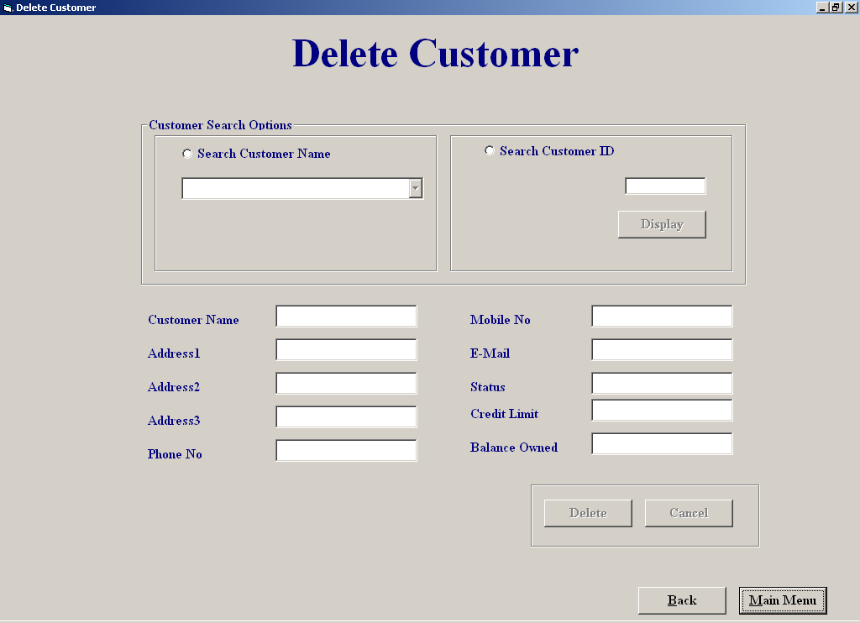

Code:

'Purpose of screen:

'This screen allows the user to delete an existing customer from the database
'the user can select the customer from a list or enter in the customer id number,
'when a customer is selected the rest of the customer details are displayed
'on the screen,the user can delete the cutomer from the screen by clicking the
'"Delete" button or they can cancel'the deletion or return to the main menu without
'deleting,if the user presses the "cancel" button all the deletios are undeleted

'Author Derek Stafford
'Date 015/03/2002

'varibales used Purpose
'intMaxoption integer; sores a count for exception deletion
'intCustID integer; store customer id number
'intCounter integer; stores counter in for loop for entrycode to exception deletion
'intResult integer; stores result of an answer
'strmySQl string; store sql string
'strTempName string; stores name of customer
'strTempAdd1 string; stores address1 of customer
'strTempAdd2 string; stores address2 of customer
'Delete boolean; stores true/false value
'Enterycode const; stores the exception entry code
'ainCustID Array of Integers hold all deleted customer ids

'Objects used

'datCustomer; Datacontrol retrieves data from customer table
'datRentalReturn; Datacontrol retrieves data from rental/return table

Option Explicit
Dim intCustID, intindex, aintCustIDs(1 To 30) As Integer
Private Sub cmdCancel_Click()
'find the last record entered into the cutomer table and deletes it
Dim intAmount, intResult, intDelCust As Integer

datCustomer.RecordSource = "Customer"
datCustomer.Refresh
intResult = MsgBox("Are you sure you want to undelete the " & intindex - 1 & " customer(s) you deleted ", vbYesNo, "System response")
If intResult = vbYes Then
For intAmount = 1 To intindex
intDelCust = aintCustIDs(intAmount)
datCustomer.Recordset.FindFirst "Cust_ID = " & intDelCust & ""
datCustomer.Recordset.Edit
datCustomer.Recordset("Deletion") = "False"
datCustomer.Recordset.Update
datCustomer.Recordset.MoveNext
Next intAmount
intindex = 1
Cmdcancel.Enabled = False
End If
End Sub
=============================================================
Private Sub cmdDisplay_Click()
'Searchs for the a customer based on the customer id entered, if found it calls display procedure 'if not found it returns an error
Dim strmySQl, Result As String

intCustID = Val(txtCustNumber)

strmySQl = "SELECT Customer.Cust_ID, Customer.Name,Customer.[Address 1], Customer.[Address 2], Customer.Deletion " & _
"From Customer " & _
"WHERE (((Customer.Deletion)=False));"
datCustomer.RecordSource = strmySQl
datCustomer.Refresh
datCustomer.Recordset.FindFirst "Cust_ID = " & intCustID & ""
If datCustomer.Recordset.NoMatch Then
Call MsgBox("This customer migth not be listed or is already deleted", vbInformation, "Not Found")
Else
display
Cmdcancel.Enabled = True
End If
End Sub
=============================================================
Private Sub cmdMainMenu_Click()
Unload Me
frmMainMenu.Show
End Sub
============================================================
Private Sub txtCustNumber_change()
cmdDisplay.Enabled = True
End Sub
=============================================================
Private Sub txtCustNumber_Validate(Cancel As Boolean)
'Checks for valid id was entered
If IsNumeric(txtCustNumber.Text) Then
Cancel = False
Else
Call MsgBox("Sorry invalid data", vbOKOnly, "Warning")
txtCustNumber.SetFocus
Cancel = True
End If
End Sub
=============================================================
Private Sub optCustName_Click()
'Resets screen layout
lblID.Visible = False
cmdDisplay.Enabled = False
txtCustNumber = ""
cmbCustomer.Enabled = True
txtCustNumber.Enabled = False
Clear
End Sub
=============================================================
Private Sub Clear()
'Empties all textboxes
txtCustomerName = ""
txtAddress1 = ""
txtAddress2 = ""
txtAddress3 = ""
txtPhoneNo = ""
txtMobileNo = ""
txtEmail = ""
txtStatus = ""
txtCreditLimit = ""
txtBalanceowned = ""
End Sub
Private Sub optCustID_Click()
'Resets screen

txtCustNumber = ""
lblID.Visible = True
cmbCustomer.Enabled = False
txtCustNumber.Enabled = True
txtCustNumber.SetFocus
cmbCustomer.Text = ""
Clear
End Sub
=============================================================
Private Sub cmbCustomer_Click()
'Stores the cutomer id selected

intCustID = cmbCustomer.ItemData(cmbCustomer.ListIndex)
datCustomer.Recordset.FindFirst "Cust_ID = " & intCustID & ""
cmdDelCust.Enabled = True
display
End Sub
=============================================================
Private Sub cmbCustomer_DropDown()
'Fills the customer combo box based on result of SQL
Dim strmySQl As String
strmySQl = "SELECT Customer.Cust_ID, Customer.Name,Customer.[Address 1], Customer.[Address 2], Customer.Deletion " & _
"From Customer " & _
"WHERE (((Customer.Deletion)=False));"
cmbCustomer.Clear
datCustomer.RecordSource = strmySQl
datCustomer.Refresh
While Not datCustomer.Recordset.EOF
cmbCustomer.AddItem (datCustomer.Recordset("Name")) + ", " + (datCustomer.Recordset("Address 1")) + ", " + (datCustomer.Recordset("Address 2"))
cmbCustomer.ItemData(cmbCustomer.NewIndex) = datCustomer.Recordset("Cust_ID")
datCustomer.Recordset.MoveNext
Wend
End Sub
=============================================================
Private Sub cmdDelCust_Click()
'Search for the selected customer record and finds out if that customer can be
'deleted or not based on having equipment still on hire or having an outstanding
'balance

Dim ccurID As Currency, intReturnValue As Integer, BalanceOwed As Currency
Dim strmySQl, strTempCustName, strTempAdd1, strTempAdd2 As String, Delete As Boolean
Delete = False

strmySQl = "SELECT Customer.Cust_ID, Customer.Name, Customer.[Address 1],Customer.[Address 2], [Rental/Return].[Date/Time returned],Customer.[Balance owed], [Rental/Return].Equipment_ID, Customer.Deletion " & _
"From Customer, [Rental/Return]" & _
"WHERE (((Customer.Cust_ID)= " & intCustID & "));"

datCustomer.RecordSource = strmySQl
datCustomer.Refresh
datCustomer.Recordset.MoveFirst
datCustomer.Recordset.FindFirst "Cust_ID = " & intCustID & ""

'Checks if customer has an outstanding balance or still has equipment on hire
If datCustomer.Recordset("Balance Owed") > 0 Or datCustomer.Recordset("Date/Time returned") = "" Then
strTempCustName = datCustomer.Recordset("Name")
strTempAdd1 = datCustomer.Recordset("Address 1")
strTempAdd2 = datCustomer.Recordset("Address 2")
If datCustomer.Recordset("Deletion") = True Then
Call MsgBox(strTempCustName & " From " & strTempAdd1 & ", " & strTempAdd2 & " Has Already Been Deleted ", vbInformation, "Information")
Else
Call MsgBox(strTempCustName & " From " & strTempAdd1 & ", " & strTempAdd2 & " Cannot Be Deleted As He/She Still Has An Equipment On Hire OR Has An OutStanding Balance ", vbInformation, "Information")
intReturnValue = MsgBox("If You Wish To Delete " & strTempCustName & " From " & strTempAdd1 & ", " & strTempAdd2 & " Anyway Press Yes ", vbYesNo, "Exception Deletion")
If intReturnValue = vbYes Then
ExceptionDeletion
Cmdcancel.Enabled = True
End If
End If
Else
While Not datCustomer.Recordset.EOF
datCustomer.Recordset.FindNext "Cust_ID = " & intCustID & ""
If datCustomer.Recordset("Date/Time returned") = "" Then
If datCustomer.Recordset("Deletion") = False Then
Delete = True
End If
End If
datCustomer.Recordset.MoveNext
Wend
If Delete Then
Call MsgBox(strTempCustName & " From " & strTempAdd1 & "," & strTempAdd2 & " Has Already Been Deleted", vbInformation, "Information")
Else
Cmdcancel.Enabled = True
Deletion
End If
End If
End Sub
=============================================================
Private Sub ExceptionDeletion()
'Allows the user to make exception deletions
Dim intCounter, intMaxoption, intResult As Integer
Const intEntrycode As Integer = 1111, intMax As Integer = 3
For intCounter = 1 To intMax
If intEntrycode = Val(InputBox("Please Enter Security Code", "Security")) Then
intCounter = intMax
Deletion
Else
Call MsgBox("Incorrect Code! You Have " & intMax - intCounter & " Changes Left", vbCritical, "System Response")
intMaxoption = intMax - intCounter
If intMaxoption > 0 Then
intResult = MsgBox("Do You Want To Try Again ", vbYesNo, "System Response")
If intResult = vbNo Then
intCounter = intMax
End If
End If
End If
Next intCounter
End Sub
=============================================================
Private Sub cmdBack_Click()
Dim intAmount, intResult, intDelCust As Integer
'Asks user to confirm deletion and shows another form
datCustomer.RecordSource = "Customer"
datCustomer.Refresh
If intindex > 1 Then
intResult = MsgBox("Are you Sure you want to save the deletions made ", vbYesNo, "System response")
If intResult = vbNo Then
For intAmount = 1 To intindex
intDelCust = aintCustIDs(intAmount)
datCustomer.Recordset.FindFirst "Cust_ID = " & intDelCust & ""
datCustomer.Recordset.Edit
datCustomer.Recordset("Deletion") = "False"
datCustomer.Recordset.Update
datCustomer.Recordset.MoveNext
Next intAmount
intindex = 1
End If
End If
frmCustomerFileProcessing.Show
Unload Me
End Sub
=============================================================
Private Sub Deletion()
'This procedure deletes the selected customer from the customer table
Dim strTempCustName, strTempAdd1, strTempAdd2 As String
Dim intReturnValue, integ As Integer

datCustomer.RecordSource = "Customer"
datCustomer.Refresh
datCustomer.Recordset.FindFirst "Cust_ID = " & intCustID & ""
strTempCustName = datCustomer.Recordset("Name")
strTempAdd1 = datCustomer.Recordset("Address 1")
strTempAdd2 = datCustomer.Recordset("Address 2")
intReturnValue = MsgBox("Are You Sure You Want To Delete" & strTempCustName & " From " & strTempAdd1 & "," & strTempAdd2 & " From The System ", vbYesNo, "Response Required")
If intReturnValue = vbYes Then
datCustomer.Recordset.Edit
datCustomer.Recordset("Deletion") = "True" 'marks the customer for deletion
datCustomer.Recordset.Update
Call MsgBox(strTempCustName & ", From " & strTempAdd1 & ", " & strTempAdd2 & " Has Sucessfully Been Deleted", vbInformation, "Sucessful Deletion")
aintCustIDs(intindex) = intCustID
intindex = intindex + 1
End If
End Sub
=============================================================
Private Sub Form_Activate()
'Sets screen when form is activated
lblID.Visible = False
cmbCustomer.Enabled = False
txtCustNumber.Enabled = False
cmdDelCust.Enabled = False
cmdDisplay.Enabled = False
Cmdcancel.Enabled = False
intindex = 1
End Sub
=============================================================
Private Sub Form_Load()
'Assigns tables to data controls

datCustomer.DatabaseName = "c:/EHS.mdb"
datCustomer.RecordSource = "Customer"
datRentalReturn.RecordSource = "EHS.mdb"
datRentalReturn.RecordSource = "Rental/Return"

End Sub
=============================================================
Private Sub display()
'Fill all the textboxes with the selected customer details
Dim AmountDue, Cost, ChargeType As Currency
datCustomer.RecordSource = "Customer"
datCustomer.Refresh
datCustomer.Recordset.FindFirst "Cust_ID = " & intCustID & ""
txtCustomerName.Text = datCustomer.Recordset("Name")
txtAddress1.Text = datCustomer.Recordset("Address 1")
txtAddress2.Text = datCustomer.Recordset("Address 2")
txtAddress3.Text = datCustomer.Recordset("Address 3")
txtPhoneNo.Text = datCustomer.Recordset("Phone No")
txtMobileNo.Text = datCustomer.Recordset("Mobile No")
txtEmail.Text = datCustomer.Recordset("E-Mail")
txtStatus.Text = datCustomer.Recordset("Status")
txtCreditLimit.Text = datCustomer.Recordset("Credit Limit")
txtBalanceowned.Text = datCustomer.Recordset("Balance owed")

End Sub
=============================================================
Private Sub txtCustomerName_Change()

cmdDelCust.Enabled = True
End Sub
=============================================================

Equipment Hired Report:

Screen Shot

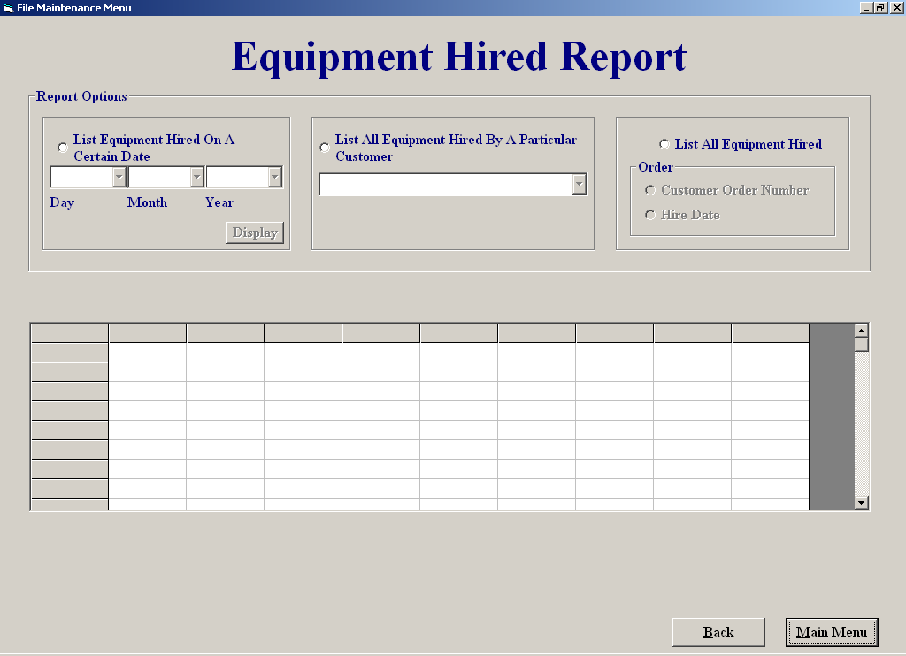

Code:

'Purpose of screen:

'The purpose of this screen is to display equipment hired in different
'formats such as:
'1listing equipment hired on a certain date
'2listing equipment hired by a particular customer
'3listing all equipment presently on hire which the user can display either
'by date ored or customer number order

'Author: Derek Stafford com2026
'15/03/2002

'variable used purpose

'Inindex integer; used to control for loops
'intCustID integer; store customer id number
'srtTime1 string; used to hold date
'srtTime2 string; used to hold date

'objects used

'datRental datacontrol; used to retrieve info from rental/return table
'datCustomer datacontrol; used to retrieve info from customer table
'thegrid flexigrid ; bound to the datRental datacontrol

Option Explicit
Dim intCustID As Integer
Private Sub CmbEqCust_click()

Dim strmySQl As String
'List equipment hired by a certain customer

intCustID = CmbEqCust.ItemData(CmbEqCust.ListIndex)

strmySQl = "SELECT [Rental/Return].[Date/Time out] as [Hire Date],Customer.Cust_ID as [Customer No], " & _
"Customer.Name,Customer.[Address 1],Customer.[Address 2], [Rental/Return].Equipment_ID as [Equipment ID], " & _
"[Rental/Return].Rental_ID as [Rental ID No],[Rental/Return].[Date/Time returned]as [Return Date] " & _
"FROM Customer INNER JOIN [Rental/Return] ON Customer.Cust_ID = [Rental/Return].Cust_ID " & _
"Where (((Customer.Cust_ID) = " & intCustID & "))" & _
"ORDER BY Customer.Cust_ID;"
datRental.RecordSource = strmySQl
datRental.Refresh
End Sub
=============================================================
Private Sub CmbEqCust_DropDown()
datCustomer.RecordSource = "Customer"

'Put customer details into combo box

CmbEqCust.Clear

datCustomer.Recordset.MoveFirst
While Not datCustomer.Recordset.EOF
CmbEqCust.AddItem (datCustomer.Recordset("Name")) + " ," + (datCustomer.Recordset("Address 1")) + ", " + (datCustomer.Recordset("Address 2"))
CmbEqCust.ItemData(CmbEqCust.NewIndex) = datCustomer.Recordset("Cust_ID")
datCustomer.Recordset.MoveNext
Wend
End Sub
=============================================================
Private Sub cmbmonth_DropDown()
'Fills combo box with month of year

Dim intindex As Integer
cmbmonth.Clear
For intindex = 1 To 12
cmbmonth.AddItem (intindex)
Next intindex
End Sub
=============================================================
Private Sub cmbDate_DropDown()
'Fills combo box with days of month

Dim intindex As Integer
CmbDate.Clear
For intindex = 1 To 31
CmbDate.AddItem (intindex)
Next intindex
End Sub
=============================================================
Private Sub cmbyear_DropDown()
'Fills combo box with yaers 2001-2009

Dim intindex As Integer

For intindex = 2001 To 2009
cmbyear.AddItem (intindex)
Next intindex
End Sub
=============================================================
Private Sub cmdBack_Click()
frmReportsMenu.Show
Unload Me
End Sub
=============================================================
Private Sub cmdDisplayDate_Click()
'Lists equipment hired on a particular date

Dim strTime1, strTime2, strmySQl As String

If CmbDate.ListIndex = -1 Or cmbyear.ListIndex = -1 Or cmbmonth.ListIndex = -1 Then
Call MsgBox("The date entry is not complete or not valid ", vbCritical, "Entry Not Complete")
Else
strTime1 = "#" & CmbDate & "/" & cmbmonth & "/" & cmbyear & "#"
strTime2 = "#" & CmbDate + 1 & "/" & cmbmonth & "/" & cmbyear & "#"

strmySQl = "SELECT [Rental/Return].[Date/Time out] as [Hire Date],Customer.Cust_ID as [Customer No], " & _
"Customer.Name,Customer.[Address 1],Customer.[Address 2], [Rental/Return].Equipment_ID as [Equipment ID], " & _
"[Rental/Return].Rental_ID as [Rental ID No],[Rental/Return].[Date/Time returned]as [Return Date] " & _
"FROM Customer INNER JOIN [Rental/Return] ON Customer.Cust_ID = [Rental/Return].Cust_ID " & _
"Where ((([Rental/Return].[Date/Time out]) >= " & strTime1 & " And ([Rental/Return].[Date/Time out]) <" & strTime2 & "))" & _
"ORDER BY Customer.Cust_ID;"

datRental.RecordSource = strmySQl
datRental.Refresh

End If
End Sub
=============================================================
Private Sub cmdMainMenu_Click()
frmMainMenu.Show
Unload Me
End Sub
=============================================================
Private Sub Form_Activate()
Optorderbydate.Enabled = False
optOrdebyrCust.Enabled = False
CmbEqCust.Enabled = False
CmbDate.Enabled = False
cmbyear.Enabled = False
cmbmonth.Enabled = False
cmdDisplayDate.Enabled = False
cmdDisplayDate.ToolTipText = "Displays the equipment hire on the choosen date"
thegrid.Clear
End Sub
=============================================================
Private Sub Form_Load()
'Assigns the tables of the data base to the controls

datRental.DatabaseName = "c:/EHS.mdb"
datRental.RecordSource = "Equipment"
datCustomer.DatabaseName = "c:/EHS.mdb"
datCustomer.RecordSource = "Customer"

End Sub
=============================================================
Private Sub optDate_Click()
'If date option is clicked
CmbDate.Text = ""
cmbmonth.Text = ""
cmbyear.Text = ""
thegrid.Clear
CmbDate.Enabled = True
cmbmonth.Enabled = True
cmbyear.Enabled = True
cmdDisplayDate.Enabled = True
CmbEqCust.Text = ""
CmbEqCust.Enabled = False
Optorderbydate.Enabled = False
optOrdebyrCust.Enabled = False
End Sub
=============================================================
Private Sub OptEqCust_Click()
cmbmonth.Clear
CmbDate.Clear
cmbyear.Clear

Optorderbydate.Enabled = False
optOrdebyrCust.Enabled = False
CmbEqCust.Enabled = True
CmbDate.Enabled = False
cmbyear.Enabled = False
cmbmonth.Enabled = False
cmdDisplayDate.Enabled = False
End Sub
=============================================================
Private Sub OptEQHired_Click()
Dim strmySQl As String
'Lists all the equipment hired
cmbmonth.Clear
CmbDate.Clear
cmbyear.Clear

CmbEqCust.Text = ""
CmbEqCust.Enabled = False
CmbDate.Enabled = False
cmbyear.Enabled = False
cmbmonth.Enabled = False
cmdDisplayDate.Enabled = False
Optorderbydate.Enabled = True
optOrdebyrCust.Enabled = True

strmySQl = "SELECT [Rental/Return].[Date/Time out] as [Hire Date],Customer.Cust_ID as [Customer No], " & _
"Customer.Name,Customer.[Address 1],Customer.[Address 2], [Rental/Return].Equipment_ID as [Equipment ID], " & _
"[Rental/Return].Rental_ID as [Rental ID No],[Rental/Return].[Date/Time returned]as [Return Date] " & _
"FROM [Rental/Return] INNER JOIN Customer ON [Rental/Return].Cust_ID = Customer.Cust_ID " & _
"Where ((([Rental/Return].[Date/Time returned]) Is Null)) " & _
"ORDER BY [Rental/Return].[Date/Time out];"

Optorderbydate.Value = True
datRental.RecordSource = strmySQl
datRental.Refresh
End Sub
=============================================================
Private Sub Optorderbydate_Click()
'Order all equipment hired by date

Dim strmySQl As String, intEquipID, intEquipType As Integer

strmySQl = "SELECT [Rental/Return].[Date/Time out] as [Hire Date],Customer.Cust_ID as [Customer No], " & _
"Customer.Name,Customer.[Address 1],Customer.[Address 2],[Rental/Return].Equipment_ID as [Equipment ID], " & _
"[Rental/Return].Rental_ID as [Rental ID No],[Rental/Return].[Date/Time returned]as [Return Date] " & _
"FROM [Rental/Return] INNER JOIN Customer ON [Rental/Return].Cust_ID = Customer.Cust_ID " & _
"Where ((([Rental/Return].[Date/Time returned]) Is Null)) " & _
"ORDER BY [Rental/Return].[Date/Time out];"

datRental.RecordSource = strmySQl
datRental.Refresh

End Sub
=============================================================
Private Sub optOrdebyrCust_Click()
'Order all equipment hired by customer id

Dim strmySQl As String

strmySQl = "SELECT [Rental/Return].[Date/Time out] as [Hire Date],Customer.Cust_ID as [Customer No], " & _
"Customer.Name,Customer.[Address 1],Customer.[Address 2], [Rental/Return].Equipment_ID as [Equipment ID], " & _
"[Rental/Return].Rental_ID as [Rental ID No],[Rental/Return].[Date/Time returned]as [Return Date] " & _
"FROM Customer INNER JOIN [Rental/Return] ON Customer.Cust_ID = [Rental/Return].Cust_ID " & _
"Where ((([Rental/Return].[Date/Time returned]) Is Null))" & _
"ORDER BY [Rental/Return].Rental_ID;"

datRental.RecordSource = strmySQl
datRental.Refresh

End Sub
=============================================================

File Maintenance Menu:

Screen Shot:

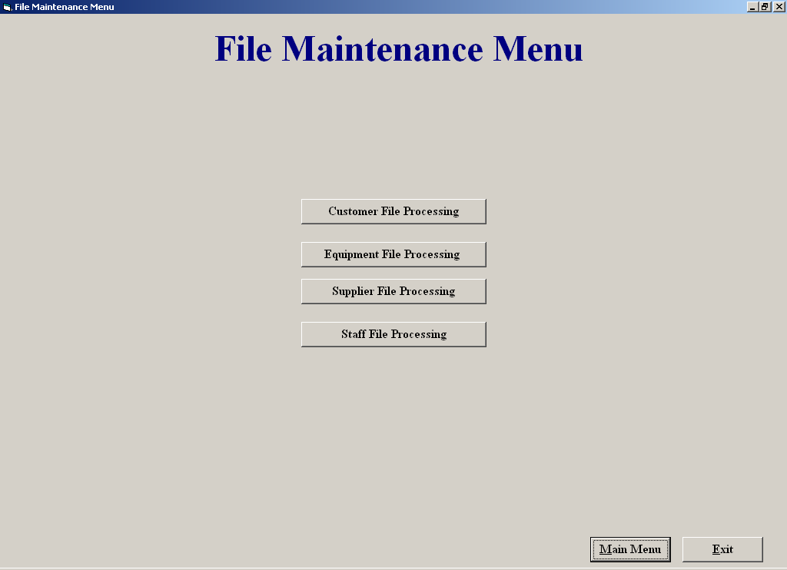

Code:

'Purpose of Screen

'The file maintenance menu is used to allow the user access to the :

'1 Customer Maintenance Menu screen
'2 Equipment Maintenance Menu screen
'3 Staff Maintenance Menu screen
'4 Supplier Maintenance Menu screen

'Author Derek Stafford com2026

Private Sub cmdCustomerFP_Click()
frmCustomerFileProcessing.Show
Unload Me
End Sub

Private Sub cmdEquipmentFP_Click()
frmEquipmentFileProcessing.Show
Unload Me
End Sub
=============================================================
Private Sub cmdExit_Click()
End
End Sub
=============================================================
Private Sub cmdMainMenu_Click()
frmMainMenu.Show
Unload Me
End Sub
=============================================================
Private Sub cmdStaffFP_Click()
frmStaffMenu.Show
Unload Me
End Sub
=============================================================
Private Sub cmdSupplierFP_Click()
frmSupplierMaintenanceMenu.Show
Unload Me
End Sub
=============================================================

Return Equipment

Screen Shot

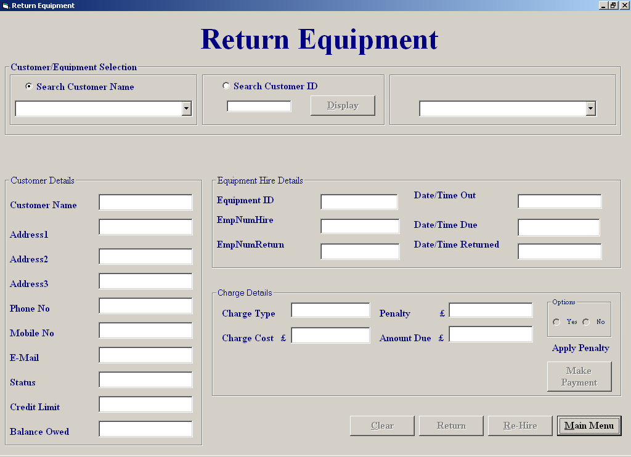

Code:

'Purpose of screen:

'The purose of this scren is to allow the user to add back returned equipment
'to the sytem in order for it to be rehired again.
'when the equipment is returned by the customer the user can select
'the the customer from a list of customer ofr by simmply entering the customers
'id number and clicking display,once the customer is selected the user can
'see all the equipment on hire by that particular customer,the user can than select the
'on the equipment being returned by that customer,when selected all the relevant
'details on that piece of equipment are displayed,the user also has the option
'of appling penanties for late returns which the system has calculated,in this
'screen it is also possible for the user to rehire the equipment back out to the
'customer, also the user can deal with payments from this by press the make payment
'button.

'Author: Derek Stafford com2026
'15/03/2002

'vaiables used Purpose

'strSQL string; holds SQL query result
'dtTime String; Holds the time part of a date split
'dtDate String; holds the date part of a date split
'strReturnTime string; temperarty holds date
'Isvalid Boolean; used to see if entry number is valid
'HourDiff integer; holds the different in hours for penalty calulations
'WeekDiff integer; holds the different in weeks for penalty calulations
'DayDiff integer; holds the different in days for penalty calulations
'intindex integer; used as a counter variable in loops etc
'intResult integer; holds result of answer from message box
'intEmpReturn integer; holds employee id number returning equipment
'intEmpHire integer; holds employee id number who rented out the item
'IntCustID integer; holds the selected customer id
'intRentalID integer; holds the selected rental id
'
'objects used
'
'datEquipmentType datacontrol retrieves data from the equipment type table
'datEquipment datacontrol retrieves data from the equipment table
'datEquip2 datacontrol retrieves data from the equipment table
'datcustomer datacontrol retrieves data from customer table
'datEmpNumReturn datacontrol retrieves data from find employees table
'datEquipment datacontrol retrieves data fom equipment table
'datReturn datacontrol retrieves locate rented table

Option Explicit

Dim counter, intRentalID, intCustID, index, intEquipID, intEmpReturn, intEmpHire As Integer, HourlyRate, DailyRate As Currency
Private Sub CheckRental()

Dim strmySQl As String 'query which checks current rentals

datCustomer.Recordset.FindFirst "Cust_ID = " & intCustID & ""
strmySQl = "SELECT Customer.Cust_ID, [Rental/Return].Equipment_ID, [Rental/Return].[Date/Time returned], [Rental/Return].Rental_ID " & _
"FROM Customer INNER JOIN [Rental/Return] ON Customer.Cust_ID = [Rental/Return].Cust_ID " & _
"WHERE (((Customer.Cust_ID)= " & intCustID & ") AND (([Rental/Return].[Date/Time returned])is Null));"
datReturn.RecordSource = strmySQl
datReturn.Refresh

End Sub
Private Sub cmbCustomer_Click()
‘Empties unneeded data from selected textboxes and suplies new customer details details
intCustID = cmbCustomer.ItemData(cmbCustomer.ListIndex)
cmdmakePayment.Enabled = True
CheckRental
display
If datReturn.Recordset.EOF Then
Call MsgBox("The selected customer currently has no equipment on hire", vbInformation, "No Equipment On Hire")
Else
lblEqSelection.Visible = True
cmdClear.Enabled = True
CmbboxEquipment.Enabled = True
txtEmpNumHire.Text = ""
txtEmpNumReturn.Text = ""
txtEquipmentID.Text = ""
txtDateOut.Text = ""
txtDateDue.Text = ""
txtChargeType.Text = ""
txtReturnTime.Text = ""
txtPenalty.Text = ""
txtCost.Text = ""
txtAmountDue.Text = ""
End If
End Sub
=============================================================
Private Sub cmdBack_Click()
frmEquipmentFileProcessing.Show
Unload Me
End Sub

Private Sub cmdClear_Click()
Clear
cmdmakePayment.Enabled = False
End Sub

Private Sub Clear()
'Clears out all textboxes on the screen
cmbCustomer.Text = ""
OptNoPenalty.Enabled = False
OptYesPenalty.Enabled = False
cmdReHire.Enabled = False
cmdReHire.Enabled = False
cmdClear.Enabled = False
cmdReturn.Enabled = False
lblEqSelection.Visible = False
txtCustomerName = ""
txtAddress1 = ""
txtAddress2 = ""
txtAddress3 = ""
txtPhoneNo = ""
txtMobileNo = ""
txtEmail = ""
txtEmpNumHire = ""
txtEmpNumReturn = ""
txtEquipmentID = ""
txtDateOut = ""
txtDateDue = ""
txtChargeType = ""
txtCost = ""
txtAmountDue = ""
txtReturnTime = ""
txtStatus = ""
txtCreditLimit = ""
txtBalanceowned = ""
txtPenalty = ""
CmbboxEquipment.Text = ""
End Sub
=============================================================
Private Sub display()
'Procedure used to display customer info

datCustomer.Recordset.FindFirst "Cust_ID = " & intCustID & ""
txtCustomerName.Text = datCustomer.Recordset("Name")
txtAddress1.Text = datCustomer.Recordset("Address 1")
txtAddress2.Text = datCustomer.Recordset("Address 2")
txtAddress3.Text = datCustomer.Recordset("Address 3")
txtPhoneNo.Text = datCustomer.Recordset("Phone No")
txtMobileNo.Text = datCustomer.Recordset("Mobile No")
txtEmail.Text = datCustomer.Recordset("E-Mail")
txtStatus.Text = datCustomer.Recordset("Status")
txtCreditLimit.Text = datCustomer.Recordset("Credit Limit")
txtBalanceowned.Text = datCustomer.Recordset("Balance owed")

End Sub
=============================================================
Private Sub cmdDisplay_Click()
'Dim strmySQl As String ’ Displays all current customers
cmdDisplay.Enabled = False
intCustID = Val(txtCustNumber)

strmySQl = "SELECT Customer.*" & _
"From Customer " & _
"WHERE (((Customer.Deletion)=False));"
cmbCustomer.Clear
datCustomer.RecordSource = strmySQl
datCustomer.Refresh

datCustomer.Recordset.FindFirst "Cust_ID = " & intCustID & ""
If datCustomer.Recordset.NoMatch Then
Call MsgBox("No Match Found", vbOKOnly, "No Match")
txtCustNumber = ""

Else
cmdmakePayment.Enabled = True
display
CheckRental
If datReturn.Recordset.EOF Then
Call MsgBox("The selected customer currently has no equipment on hire", vbInformation, "No Equipment On Hire")
Else
CmbboxEquipment.Enabled = True
End If
End If
End Sub
=============================================================
Private Sub cmdMakePayment_Click()
frmMakeaPayment.Tag = intCustID
frmMakeaPayment.Show
End Sub
=============================================================
Private Sub cmdReHire_Click()
'Sents the relavant info to hire screen so the customer can rehire the same piece of
'equipment, it also enables and disables the needed buttons on the hire screen

Dim dtTime, dtDate, strReturnTime As String
If txtReturnTime.Text = "" Then
Call MsgBox("This Equipment Has Not Been Returned", vbInformation, "Equipment Still On Hire")
Else
strReturnTime = txtReturnTime
dtTime = Mid(strReturnTime, 11, Len(strReturnTime))
dtDate = Mid(strReturnTime, 1, 10)
frmRental.Tag = "frmReturnEquipment"
frmRental.Show
frmRental.txtCustID = intCustID
frmRental.txtEmpID = intEmpReturn
frmRental.cboName.Text = txtCustomerName.Text
frmRental.txtNameFound = txtCustomerName.Text
frmRental.txtAddress1 = txtAddress1.Text
frmRental.txtAddress2 = txtAddress1.Text
frmRental.txtAddress3 = txtAddress1.Text
frmRental.txtPhoneNo = txtPhoneNo.Text
frmRental.txtMobileNo = txtMobileNo.Text
frmRental.txtCreditLimit = txtCreditLimit.Text
frmRental.txtStatus = txtStatus.Text
frmRental.txtBalance = txtBalanceowned.Text
frmRental.txtDateOut = dtDate
frmRental.txtTimeOut = dtTime
frmRental.cboID.Text = intEquipID
frmRental.txtRentPeriod.TabIndex = 1
frmRental.cmdBack.Enabled = False
frmRental.cmdDateDue.Enabled = False
frmRental.cboID.Enabled = False
frmRental.txtRentPeriod.Enabled = True
frmRental.cboPeriod.Enabled = True
frmRental.txtEmpID.Enabled = False
frmRental.cmdSeekCustomer.Enabled = False
frmRental.cmdAddCust.Enabled = False
frmRental.optName.Enabled = False
frmRental.optNumber.Enabled = False
frmRental.cboName.Enabled = False
Unload Me
End If
End Sub
=============================================================
'Function used to check that inputted characters are valid numbers

Function IsValid(StrEQID As Variant) As Boolean
Dim intindex As Integer, temp As Variant, blnValid As Boolean
blnValid = False
For intindex = 1 To Len(StrEQID)
temp = Mid(StrEQID, intindex, 1)
If (temp > 0 And temp < 9) Then
blnValid = True
Else
intindex = Len(StrEQID)
blnValid = False

End If
Next
IsValid = blnValid
End Function
=============================================================
'Checks employee id and if its valid it allow the user to
'to return equipment back into the data base,by updating the rental tables

Private Sub cmdReturn_Click()
Dim intEmpNumReturn, intResult As Integer
Dim srtmySQL As String

datEmpNumReturn.RecordSource = "Employee"
datEmpNumReturn.Refresh
datReturn.RecordSource = "Rental/Return"
datReturn.Refresh

txtEmpNumReturn = InputBox("Enter Your Employee_ID Number Please")
If IsValid(txtEmpNumReturn.Text) = False Or (Val(txtEmpNumReturn) > 9999) Then
Call MsgBox("You have entered invalid data or no data , a number exceeeding 9999", vbCritical, "Invalid Data Entry")
CmbboxEquipment.SetFocus
Else
intEmpNumReturn = Val(txtEmpNumReturn)
'Searches the employee table for match

datEmpNumReturn.Recordset.FindFirst "Employee_ID = " & intEmpNumReturn & ""

If datEmpNumReturn.Recordset("Employee_ID") = intEmpNumReturn Then
intResult = MsgBox("Are You Sure?", vbYesNo, "Returning Equipment")

If intResult = vbYes Then
cmdmakePayment.Enabled = True

intEquipID = Val(txtEquipmentID.Text)
intEmpNumReturn = Val(txtEmpNumReturn.Text)
datEmpNumReturn.Recordset.FindFirst "Employee_ID =" & intEmpNumReturn & ""
txtReturnTime = FormatDateTime(Now, vbShortDate) + " " + FormatDateTime(Now, vbShortTime)

datEquipment.Recordset.FindFirst "Equipment_ID = " & intEquipID & ""
'Updates the relevant field in the equipment table
datEquipment.Recordset.Edit
datEquipment.Recordset("Status") = "Available"
datEquipment.Recordset.Update
'Updates the relevant field in the rental table
datReturn.Recordset.FindFirst "Equipment_ID = " & intEquipID & ""
datReturn.Recordset.Edit
datReturn.Recordset("EmpNumReturn") = txtEmpNumReturn.Text
datReturn.Recordset("Date/Time returned") = txtReturnTime
datReturn.Recordset.Update
datReturn.Refresh

txtAmountDue = datReturn.Recordset("Amount Due")
txtDateDue = datReturn.Recordset("Date/Time Due")

If txtDateDue.Text >= txtReturnTime.Text Then
datReturn.Recordset.FindFirst "Equipment_ID =" & intEquipID & ""
OptNoPenalty.Enabled = False

datReturn.Recordset.Edit
datReturn.Recordset("Penalty") = CCur(Val(txtPenalty.Text)) 'FormatDateTime(Now, vbShortDate) + " " + FormatDateTime(Now, vbShortTime)
txtPenalty = datReturn.Recordset("Penalty")
datReturn.Recordset.Update

Else

OptYesPenalty.Enabled = True
datReturn.Recordset.Edit
datReturn.Recordset("Penalty") = ccurPenality 'function
txtPenalty = datReturn.Recordset("Penalty")
datReturn.Recordset.Update
End If

Call MsgBox("Return Complete", vbInformation, "System Response")

datEmpNumReturn.Recordset.FindFirst "Employee_ID =" & txtEmpNumReturn & ""
intEmpReturn = txtEmpNumReturn
txtEmpNumReturn.Text = datEmpNumReturn.Recordset("Employee Name") ' ‘Prints out employee name to the screen

cmdReturn.Enabled = False
CheckRental
If datReturn.Recordset.EOF Then
Call MsgBox("The selected customer currently has no equipment on hire", vbInformation, "No Equipment On Hire")
End If

Else
Call MsgBox("No Return ", vbInformation, "System Response")
txtEmpNumReturn = ""
End If
Else
txtEmpNumReturn = ""
Call MsgBox("Wrong Or Incorrect ID Number Entered", vbCritical, "Wrong ID Number Entered")
End If
End If
End Sub
=============================================================
Private Sub cmdMainMenu_Click()
frmMainMenu.Show
Unload Me
End Sub
Private Sub Form_Activate()
'Sets up screen layout
cmdDisplay.Enabled = False
optCustName.SetFocus
cmdmakePayment.Enabled = False
lblEqSelection.Visible = False
txtChargeType.Enabled = False
txtCustNumber.Enabled = False
cmbCustomer.Enabled = False
cmdReHire.Enabled = False
cmdReHire.Enabled = False
cmdClear.Enabled = False
cmdReturn.Enabled = False
OptNoPenalty.Enabled = False
OptYesPenalty.Enabled = False
cmdDisplay.ToolTipText = "Displays customer details"
cmdMainMenu.ToolTipText = "Back to main menu"
cmdClear.ToolTipText = "Clears current contains from the screen"
cmdReHire.ToolTipText = "Rehire the selected equipment"
CmbboxEquipment.ToolTipText = "Selects the equipment on hire from the selected customer"
cmdReturn.ToolTipText = "Allows employee to return the selected equipment onto the system"
cmdmakePayment.ToolTipText = "Allows Customer to make a payment"
End Sub
=============================================================
Private Sub cmbCustomer_DropDown()
'Fills combo box with current customers

Dim strmySQl As String
Clear
strmySQl = "SELECT Customer.* " & _
"From Customer " & _
"WHERE (((Customer.Deletion)=False));"
cmbCustomer.Clear
datCustomer.RecordSource = strmySQl
datCustomer.Refresh
While Not datCustomer.Recordset.EOF
cmbCustomer.AddItem (datCustomer.Recordset("Name")) + ", " + (datCustomer.Recordset("Address 1")) + ", " + (datCustomer.Recordset("Address 2"))
cmbCustomer.ItemData(cmbCustomer.NewIndex) = datCustomer.Recordset("Cust_ID")
datCustomer.Recordset.MoveNext
Wend
End Sub
=============================================================
Private Sub Form_Load()
'Assigns the relevant data base tables to data controls

Dim strmySQl As String
CmbboxEquipment.Enabled = False

datCustomer.DatabaseName = "c:/EHS.mdb"
datCustomer.RecordSource = "Customer"

datEmpNumReturn.DatabaseName = "c:/EHS.mdb"
datEmpNumReturn.RecordSource = "Employee" '"select*from supplier where [deletion]= false;"

datEquipment.DatabaseName = "c:/EHS.mdb"
datEquipment.RecordSource = "Equipment"

datReturn.DatabaseName = "c:/EHS.mdb"
datReturn.RecordSource = "Rental/Return"

datEquip2.DatabaseName = "c:/EHS.mdb"
datEquip2.RecordSource = "Equipment"

datEquipmentType.DatabaseName = "c:/EHS.mdb"
datEquipmentType.RecordSource = "Equipment Type"
End Sub
=============================================================
Private Sub CmbboxEquipment_DropDown()
'Fills equipment combo box with all the equipment the selected customer has on hire

Dim strmySQl As String, intEquipType As Integer

strmySQl = "SELECT Customer.Cust_ID, [Rental/Return].Equipment_ID, [Rental/Return].[Date/Time returned], [Rental/Return].Rental_ID " & _
"FROM Customer INNER JOIN [Rental/Return] ON Customer.Cust_ID = [Rental/Return].Cust_ID " & _
"WHERE (((Customer.Cust_ID)= " & intCustID & ") AND (([Rental/Return].[Date/Time returned])Is Null));"
datReturn.RecordSource = strmySQl

datReturn.Refresh
datEquipmentType.RecordSource = "Equipment Type"
CmbboxEquipment.Clear
While Not datReturn.Recordset.EOF

intEquipID = datReturn.Recordset("Equipment_ID")

datEquip2.Recordset.FindFirst "Equipment_ID = " & intEquipID & ""
intEquipType = datEquip2.Recordset("Type_ID")

datEquipmentType.Recordset.FindFirst "Type_ID = " & intEquipType & ""

CmbboxEquipment.AddItem (datEquipmentType.Recordset("Make")) + ", " + datEquipmentType.Recordset("Model") + ", " + datEquipmentType.Recordset("Details")
datEquipmentType.Recordset.MoveFirst
datEquip2.Recordset.MoveFirst

CmbboxEquipment.ItemData(CmbboxEquipment.NewIndex) = datReturn.Recordset("Equipment_ID")
datReturn.Recordset.MoveNext
Wend
End Sub
============================================================
Private Sub CmbboxEquipment_Click()
Dim Cost, AmountDue As Currency
'Find the relevant info on the selected equipment and places it in combo boxes

intEquipID = CmbboxEquipment.ItemData(CmbboxEquipment.ListIndex)
datReturn.RecordSource = "Rental/Return"
datReturn.Refresh
datEmpNumReturn.Refresh
datReturn.Recordset.FindFirst "Equipment_ID = " & intEquipID & ""

datEmpNumReturn.Recordset.FindFirst "Employee_ID =" & intEmpHire & ""

txtEmpNumHire.Text = datEmpNumReturn.Recordset("Employee Name")

txtEquipmentID.Text = datReturn.Recordset("Equipment_ID")
txtDateOut.Text = datReturn.Recordset("Date/Time Out")
txtDateDue.Text = datReturn.Recordset("Date/Time Due")

txtChargeType.Text = datReturn.Recordset("Charge Type")
Cost = CCur(datReturn.Recordset("Charge Cost"))
txtCost.Text = Str(Cost)
txtPenalty = ccurPenality
If txtPenalty = "" Then
txtPenalty = "0"
End If
If txtPenalty = "0" Then
OptYesPenalty.Enabled = False
Else
OptYesPenalty.Enabled = True
End If
AmountDue = CCur(datReturn.Recordset("Amount Due"))
txtAmountDue.Text = Str(AmountDue)
OptNoPenalty.Enabled = False
cmdReHire.Enabled = True
cmdReHire.Enabled = True
cmdReturn.Enabled = True
End Sub
=============================================================
Private Sub optCustName_Click()
'Resets screen layout
cmdDisplay.Enabled = False
txtCustNumber.Enabled = False
cmbCustomer.Enabled = True
txtCustNumber.Text = ""
txtCustNumber.Enabled = False
Clear
End Sub
=============================================================
Private Sub OpCustID_Click()
'Reset screen layout
Clear
cmdmakePayment.Enabled = False
cmbCustomer.Text = ""
cmbCustomer.Enabled = False
txtCustNumber.Enabled = True
txtCustNumber.SetFocus
cmdDisplay.Enabled = True
txtCustNumber.Enabled = True
End Sub
=============================================================
Private Sub OptNoPenalty_Click()
'Takes added penalty away from the amount due

If OptNoPenalty.Value = True Then
OptYesPenalty.Value = False
txtAmountDue.Text = Str(CCur(txtAmountDue.Text) - CCur(Val(txtPenalty.Text)))
End If
End Sub
=============================================================
Private Sub OptYesPenalty_Click()
'Adds penalty away from the amount due

If txtPenalty.Text = "0" Then
Call MsgBox("There is No Penalty ON The Selected Equipment", vbInformation, "No Penalty")
End If
If OptYesPenalty.Value = True Then
OptNoPenalty.Value = False
OptNoPenalty.Enabled = True
End If
txtAmountDue = Str(CCur(txtAmountDue.Text) + CCur(Val(txtPenalty.Text)))
End Sub
============================================================
Public Function ccurPenality()

'Works out the penalty due if any

Dim total As Currency, HourDiff, DayDiff, WeekDiff As Integer
Const PentRate As Currency = 1.5

DayDiff = DateDiff("d", txtDateDue, Now)
HourDiff = DateDiff("h", txtDateDue, Now) 'DateDiff function
WeekDiff = DateDiff("ww", txtDateDue, Now) 'reference Peter Nortons Guide to Visual Basic 6

If DayDiff > 0 Or HourDiff > 0 Or WeekDiff > 0 Then
If txtChargeType = "Hour(s)" Then
ccurPenality = Str(HourDiff * Val(txtCost.Text) * PentRate)
Else
If txtChargeType = "Day(s)" Then
ccurPenality = Str(DayDiff * Val(txtCost.Text) * PentRate)
Else
If txtChargeType = "Week(s)" Then
ccurPenality = Str(WeekDiff * Val(txtCost.Text) * PentRate)
End If
End If
End If
End If
End Function
=============================================================
Private Sub txtCustNumber_Validate(Cancel As Boolean)
'Checks for valid input
If IsNumeric(txtCustNumber.Text) Then
Cancel = False
Else
Call MsgBox("Sorry invalid data", vbOKOnly, "Warning")
txtCustNumber.SetFocus
Cancel = True
End If
End Sub

Amend/View Staff

Screen Shot:

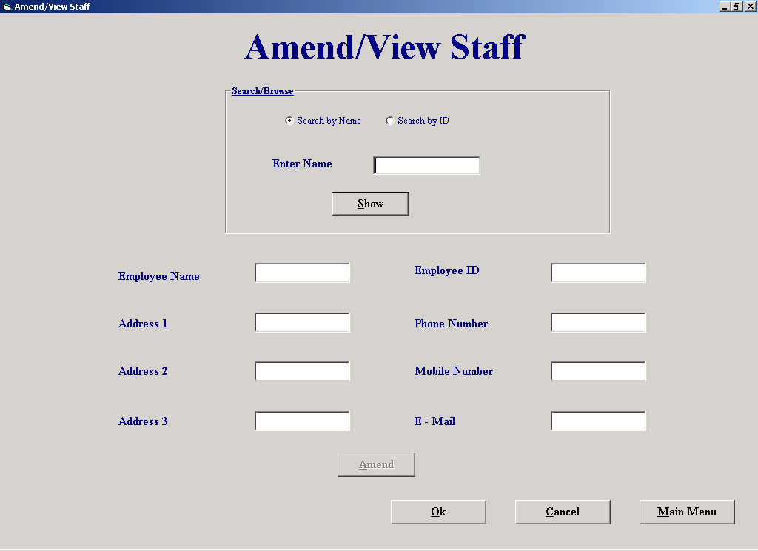

Code:
'The purpose of this screen is to make changes to an employees details

'It allows the user to search for the employee and show their details.
'It then lets the user change some of the fields.
'When user clicks "Amend" and confirms whether to Amend, the fields are updated
'using the data control "datAmendView". The original details are stored in their
'respective text boxes tag property. This method implies parallel arrays
'If the user clicks cancel at the bottom of the screen the system ignores the amendments and restores
'the staffs details to their original values that are stored in the text boxes tag.

'Author Fergal Purcell
'Date 06/03/2002

'Variables used
'strSql : String; This variable holds the SQL statement
'strID : String; Holds the Primary key of a customer
'intTab : Integer; Stores the location of the tab character
'intCounter : Integer; Control variable in for loop

'Objects used
'datAmendView : Data Control; Used to display details of the staff

Option Explicit

Private Sub cmdAmend_Click()
datAmendView.DatabaseName = strThePath
datAmendView.RecordSource = "Employee"
datAmendView.Refresh
datAmendView.Recordset.FindFirst "Employee_ID = " & txtID.Text
If MsgBox("Are you sure you wish to amend this employee's details?", vbQuestion + vbYesNo, "Confirm deletion") = vbYes Then
With datAmendView.Recordset
cmdAmend.Tag = cmdAmend.Tag & txtID.Text & Chr(9) 'Store the ID's of every employee that’s amended
txtName.Tag = txtName.Tag & .Fields("Employee Name") & Chr(9) 'Store the original details of the employee
txtAdd1.Tag = txtAdd1.Tag & .Fields("Address 1") & Chr(9)
txtAdd2.Tag = txtAdd2.Tag & .Fields("Address 2") & Chr(9)
txtAdd3.Tag = txtAdd3.Tag & .Fields("Address 3") & Chr(9)
txtPhone.Tag = txtPhone.Tag & .Fields("Phone No") & Chr(9)
txtMob.Tag = txtMob.Tag & .Fields("Mobile No") & Chr(9)
txtMail.Tag = txtMail.Tag & .Fields("E-Mail") & Chr(9)
.Edit
.Fields("Employee Name") = txtName.Text 'Amend the fields
.Fields("Address 1") = txtAdd1.Text
.Fields("Address 2") = txtAdd2.Text
.Fields("Address 3") = txtAdd3.Text
.Fields("Phone No") = txtPhone.Text
.Fields("Mobile No") = txtMob.Text
.Fields("E-Mail") = txtMail.Text
.Update
End With
Else
AssignFields 'Change the text boxes
End If
End Sub

Private Sub cmdCancel_Click()
If cmdAmend.Tag <> "" Then 'Only display this message if the user has made amendments
If MsgBox("Do you want to save changes?", vbQuestion + vbYesNo, "Save changes") = vbNo Then
CancelAmends
End If
End If
End Sub

Private Sub cmdMM_Click()
If cmdAmend.Tag <> "" Then 'Only display this message if the user has made amendments
If MsgBox("Do you wish to save amendments?", vbQuestion + vbYesNo, "Save Amendments") = vbNo Then
CancelAmends
End If
End If
frmMainMenu.Show
Unload Me
End Sub

Private Sub cmdNext_Click()
datAmendView.Recordset.MoveNext 'Move to the next match
If datAmendView.Recordset.EOF Then
datAmendView.Recordset.MoveFirst
End If
AssignFields
End Sub

Private Sub cmdOk_Click()
Unload Me
End Sub

Private Sub cmdPrevious_Click()
datAmendView.Recordset.MovePrevious 'Move to the previous match
If datAmendView.Recordset.BOF Then
datAmendView.Recordset.MoveLast
End If
AssignFields
End Sub

Private Sub cmdShow_Click()
Dim strSql As String
cmdNext.Visible = False
cmdPrevious.Visible = False
datAmendView.DatabaseName = strThePath
datAmendView.RecordSource = "Employee"
datAmendView.Refresh
If OptName = True Then 'Search for matching name
strSql = "Select Count([Employee.Employee Name]) AS CountOfEmp From Employee Where Employee.[Employee Name] Like '" & txtSearch.Text & "*'" & _
"And Employee.Deletion = False"
datAmendView.RecordSource = strSql
datAmendView.Refresh
If datAmendView.Recordset.Fields("CountOfEmp") = 0 Or txtSearch = "" Then
MsgBox "There is no match.", vbExclamation, "No Match"
txtSearch.SetFocus
txtSearch.Text = ""
ElseIf datAmendView.Recordset.Fields("CountOfEmp") = 1 Then
strSql = "Select * From Employee Where Employee.[Employee Name] Like '" & txtSearch.Text & "*'" & _
"And Employee.Deletion = False"
datAmendView.RecordSource = strSql
datAmendView.Refresh
AssignFields
Else
cmdNext.Visible = True 'Make the movenext and moveprevious buttons visible
cmdPrevious.Visible = True
strSql = "Select * From Employee Where Employee.[Employee Name] Like '" & txtSearch.Text & "*'" & _
"And Employee.Deletion = False"
datAmendView.RecordSource = strSql
datAmendView.Refresh
AssignFields
End If
Else 'Search for primary keys
If CheckNum = True Or txtSearch.Text = "" Then
MsgBox "Invalid data.", vbExclamation, "Invalid data"
txtSearch.SetFocus
txtSearch.Text = ""
Else
datAmendView.Recordset.FindFirst "Employee_ID = " & txtSearch.Text
If datAmendView.Recordset.NoMatch = True Or datAmendView.Recordset.Fields("Deletion") = True Then
MsgBox "There is no match.", vbExclamation, "No Match"
txtSearch.SetFocus
txtSearch.Text = ""
Else
AssignFields
End If
End If
End If
End Sub

Private Sub Form_activate()
txtSearch.SetFocus
End Sub

Private Sub OptID_Click()
lblSearch.Caption = "Enter ID" 'Change the labels
txtSearch.Text = ""
txtSearch.SetFocus
End Sub

Private Sub OptName_Click()
lblSearch.Caption = "Enter Name"
txtSearch.Text = ""
txtSearch.SetFocus
End Sub

Private Sub txtAdd1_Validate(Cancel As Boolean)
If Len(txtAdd1.Text) = 0 Then
MsgBox "This field cannot be empty.", vbExclamation, "Empty field"
Cancel = True
End If
End Sub

Private Sub txtAdd2_Validate(Cancel As Boolean)
If Len(txtAdd2.Text) = 0 Then
MsgBox "This field cannot be empty.", vbExclamation, "Empty field"
Cancel = True
End If
End Sub

Private Sub txtAdd3_Validate(Cancel As Boolean)
If Len(txtAdd3.Text) = 0 Then
MsgBox "This field cannot be empty.", vbExclamation, "Empty field"
Cancel = True
End If
End Sub

Private Sub txtName_Validate(Cancel As Boolean)
If Len(txtName.Text) = 0 Then
MsgBox "This field cannot be empty.", vbExclamation, "Empty field"
Cancel = True
End If
End Sub

Private Sub AssignFields()
'This procedure assigns all the text boxes there values

txtName.Text = datAmendView.Recordset.Fields("[Employee Name]")
txtID.Text = datAmendView.Recordset.Fields("Employee_ID")
txtAdd1.Text = datAmendView.Recordset.Fields("[Address 1]")
txtAdd2.Text = datAmendView.Recordset.Fields("[Address 2]")
txtAdd3.Text = datAmendView.Recordset.Fields("[Address 3]")
txtPhone.Text = datAmendView.Recordset.Fields("[Phone No]")
txtMob.Text = "" + datAmendView.Recordset.Fields("[Mobile No]")
txtMail.Text = "" + datAmendView.Recordset.Fields("E-Mail")
cmdAmend.Enabled = True
txtName.CausesValidation = True
txtAdd1.CausesValidation = True
txtAdd2.CausesValidation = True
txtAdd3.CausesValidation = True
txtPhone.CausesValidation = True
End Sub

Private Sub CancelAmends()
Dim strID As String, intTab As Integer
Do Until cmdAmend.Tag = "" 'A loop that restores the original values to the database
intTab = InStr(cmdAmend.Tag, Chr(9)) 'Find the location of the tab because it marks the end of one primary key
strID = Mid(cmdAmend.Tag, 1, intTab - 1) 'Find the primary key
With datAmendView
.DatabaseName = strThePath
.RecordSource = "Employee"
.Refresh
.Recordset.FindFirst "Employee_ID = " & strID
.Recordset.Edit
intTab = InStr(txtName.Tag, Chr(9)) 'Find the position of the first tag
.Recordset.Fields("Employee Name") = Mid(txtName.Tag, 1, intTab - 1) 'Restore fields to original settings
txtName.Tag = Mid(txtName.Tag, intTab + 1, Len(txtName.Tag) - intTab) 'Delete field from tag
intTab = InStr(txtAdd1.Tag, Chr(9))
.Recordset.Fields("Address 1") = Mid(txtAdd1.Tag, 1, intTab - 1)
txtAdd1.Tag = Mid(txtAdd1.Tag, intTab + 1, Len(txtAdd1.Tag) - intTab)

intTab = InStr(txtAdd2.Tag, Chr(9))
.Recordset.Fields("Address 2") = Mid(txtAdd2.Tag, 1, intTab - 1)
txtAdd2.Tag = Mid(txtAdd2.Tag, intTab + 1, Len(txtAdd2.Tag) - intTab)

intTab = InStr(txtAdd3.Tag, Chr(9))
.Recordset.Fields("Address 3") = Mid(txtAdd3.Tag, 1, intTab - 1)
txtAdd3.Tag = Mid(txtAdd3.Tag, intTab + 1, Len(txtAdd3.Tag) - intTab)

intTab = InStr(txtPhone.Tag, Chr(9))
.Recordset.Fields("Phone No") = Mid(txtPhone.Tag, 1, intTab - 1)
txtPhone.Tag = Mid(txtPhone.Tag, intTab + 1, Len(txtPhone.Tag) - intTab)

intTab = InStr(txtMob.Tag, Chr(9))
.Recordset.Fields("Mobile No") = Mid(txtMob.Tag, 1, intTab - 1)
txtMob.Tag = Mid(txtMob.Tag, intTab + 1, Len(txtMob.Tag) - intTab)

intTab = InStr(txtMail.Tag, Chr(9))
.Recordset.Fields("E-Mail") = Mid(txtMail.Tag, 1, intTab - 1)
txtMail.Tag = Mid(txtMail.Tag, intTab + 1, Len(txtMail.Tag) - intTab)

.Recordset.Update
End With
intTab = InStr(cmdAmend.Tag, Chr(9)) 'Remove the first primary key
cmdAmend.Tag = Mid(cmdAmend.Tag, intTab + 1, Len(cmdAmend.Tag) - intTab)
Loop
End Sub

Private Sub txtPhone_Validate(Cancel As Boolean)
If Len(txtPhone.Text) = 0 Then
MsgBox "This field cannot be empty.", vbExclamation, "Empty field"
Cancel = True
End If
End Sub

Private Function CheckNum() As Boolean
'Bug in IsNumeric says that 6d6 is numeric
Dim intCounter As Integer
For intCounter = 1 To Len(txtSearch.Text)
If Not IsNumeric(Mid(txtSearch, intCounter, 1)) Then 'Check each character
CheckNum = True
End If
Next
End Function

Property Settings

Student Name: Fergal Purcell
Form Name: frmAmendViewStaff
Form Purpose: Allow the user to make changes to staff details

Object | Property | Setting
datAmend/View | DatabaseName | strThePath
 | RecordSource | Employee

Delete Supplier

Screen Shot:

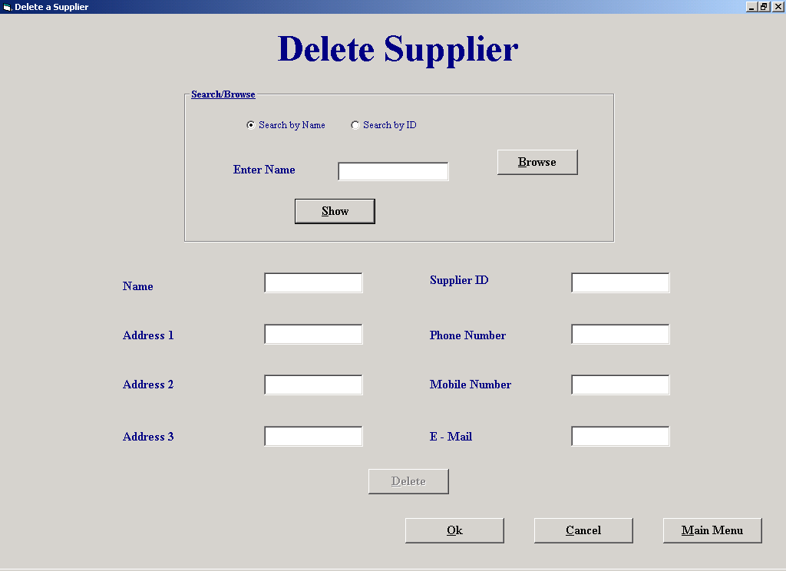

Code:
'The purpose of this screen is to allow the user to mark a supplier for deletion.

'The user enters either the suppliers name or primary key, or they can browse for the
'supplier.
'When the user clicks "Show" the system finds the matching criteria in the supplier
'table and prints the suppliers details into text boxes.
'When user then clicks on "Delete", the supplier is marked for deletion and his
'primary key is concatenated into the tag property of cmdDelete followed by a space.
'If the user clicks "Cancel" the system undeletes the supplier by getting the primary
'key from the cmdDelete tag.

'Author Fergal Purcell
'Date 06/03/2002

'Variables used
'strSql : String ; This variable stores the Sql statement.
'intSpace : Integer; Holds the position of the space as it marks the end of one primary key.
'intCounter : Integer; Control variable in for loop

'Objects used
'datSupplier : Data Control; This data control is used to query the "Supplier" table and mark it for deletion

Option Explicit

Private Function CheckNum() As Boolean
'Bug in IsNumeric says that 6d6 is numeric
Dim intCounter As Integer
For intCounter = 1 To Len(txtSearch.Text)
If Not IsNumeric(Mid(txtSearch, intCounter, 1)) Then 'Check each character
CheckNum = True
End If
Next
End Function

Private Sub cmdCancel_Click()
If cmdDelete.Tag <> "" Then 'Display this message only if the user has deleted suppliers
If MsgBox("Do you want to save deletions?", vbQuestion + vbYesNo, "Save deletions") = vbNo Then
CancelDel
End If
End If
frmSupplierMaintenanceMenu.Show
Unload Me
End Sub

Private Sub cmdDelete_Click()
Dim strSql As String
If MsgBox("Are you sure you wish to delete this supplier?", vbQuestion + vbYesNo, "Confirm deletion") = vbYes Then
datSupplier.DatabaseName = strThePath
strSql = "SELECT Count(Order.Supplier_ID) As CountOfSupp " & _
"From [Order] " & _
"WHERE (((Order.Supplier_ID)= " & txtID.Text & ") AND ((Order.Delivered)<>True)); "
datSupplier.RecordSource = strSql
datSupplier.Refresh
If datSupplier.Recordset.Fields("CountOfSupp") > 0 Then 'if CountOfSupp is greater than zero then the supplier has delivered orders
If MsgBox("This supplier has an undelivered order, are you sure you wish to delete?", vbExclamation + vbYesNo, "Undelivered order") = vbYes Then
DeleteSup
End If
Else
DeleteSup
End If
End If
cmdDelete.Enabled = False 'Disable the delete button
End Sub

Private Sub cmdMM_Click()
If cmdDelete.Tag <> "" Then 'Display this message only if the user has deleted suppliers
If MsgBox("Do you wish to save deletions?", vbQuestion + vbYesNo, "Save Deletions") = vbNo Then
CancelDel
End If
End If
Unload Me
frmMainMenu.Show
End Sub

Private Sub cmdNext_Click()
datSupplier.Recordset.MoveNext 'Move to the next match
If datSupplier.Recordset.EOF Then
datSupplier.Recordset.MoveFirst
End If
AssignFields
End Sub

Private Sub cmdOk_Click()
frmSupplierMaintenanceMenu.Show
Unload Me
End Sub

Private Sub cmdPrevious_Click()
datSupplier.Recordset.MovePrevious 'Move to the previous match
If datSupplier.Recordset.BOF Then
datSupplier.Recordset.MoveLast
End If
AssignFields
End Sub

Private Sub cmdShow_Click()
Dim strSql As String
cmdNext.Visible = False
cmdPrevious.Visible = False
datSupplier.DatabaseName = strThePath
datSupplier.RecordSource = "Supplier"
datSupplier.Refresh
If OptName = True Then 'Search for matching name
strSql = "Select Count([Supplier.Supplier Name]) AS CountOfSup From Supplier Where Supplier.[Supplier Name] Like '" & txtSearch.Text & "*'" & _
"And Supplier.Deletion = false"
datSupplier.RecordSource = strSql
datSupplier.Refresh
If datSupplier.Recordset.Fields("CountOfSup") = 0 Or txtSearch = "" Then
MsgBox "There is no match.", vbExclamation, "No match"
txtSearch.SetFocus
txtSearch.Text = ""
ElseIf datSupplier.Recordset.Fields("CountOfSup") = 1 Then
strSql = "Select * From Supplier Where Supplier.[Supplier Name] Like '" & txtSearch.Text & "*'" & _
"And Supplier.Deletion = False"
datSupplier.RecordSource = strSql
datSupplier.Refresh
AssignFields
Else
cmdNext.Visible = True 'Display these buttons if more than one match is found
cmdPrevious.Visible = True
strSql = "Select * From Supplier Where Supplier.[Supplier Name] Like '" & txtSearch.Text & "*'" & _
"And Supplier.Deletion = False"
datSupplier.RecordSource = strSql
datSupplier.Refresh
AssignFields
End If
Else 'Search for primary keys
If CheckNum = True Or txtSearch.Text = "" Then 'Function CheckNum returns True if the ID entered is not numeric
MsgBox "Invalid data.", vbExclamation, "Invalid data"
txtSearch.SetFocus
txtSearch.Text = ""
Else
datSupplier.Recordset.FindFirst "Supplier_ID = " & txtSearch.Text
If datSupplier.Recordset.NoMatch = True Or datSupplier.Recordset.Fields("Deletion") = True Then
MsgBox "There is no match.", vbExclamation, "No match"
txtSearch.SetFocus
txtSearch.Text = ""
Else
AssignFields
End If
End If
End If
End Sub

Private Sub cmdBrowse_Click()
optID.Value = True 'Set the search type to ID search since browse returns the primary key
OptName.Value = False
lblSearch.Caption = "Enter ID" 'Change the labels
frmBrowse.Tag = "Supplier"
frmBrowse.Show
End Sub

Private Sub Form_activate()
txtSearch.SetFocus
End Sub

Private Sub OptID_Click()
lblSearch.Caption = "Enter ID" 'Change the labels
txtSearch.SetFocus
txtSearch.Text = ""
End Sub

Private Sub OptName_Click()
lblSearch.Caption = "Enter Name"
txtSearch.Text = ""
txtSearch.SetFocus
End Sub

Private Sub AssignFields()
'Assign all the text fields
txtName.Text = datSupplier.Recordset.Fields("[Supplier Name]")
txtID.Text = datSupplier.Recordset.Fields("Supplier_ID")
txtAdd1.Text = datSupplier.Recordset.Fields("[Address 1]")
txtAdd2.Text = datSupplier.Recordset.Fields("[Address 2]")
txtAdd3.Text = datSupplier.Recordset.Fields("[Address 3]")
txtPhone.Text = datSupplier.Recordset.Fields("[Phone No]")
txtMob.Text = "" + datSupplier.Recordset.Fields("[Mobile No]")
txtMail.Text = "" + datSupplier.Recordset.Fields("E-Mail")
cmdDelete.Enabled = True
End Sub

Private Sub AssignBlank()
'Assign all the text fields blank
txtSearch.Text = ""
txtName.Text = ""
txtID.Text = ""
txtAdd1.Text = ""
txtAdd2.Text = ""
txtAdd3.Text = ""
txtPhone.Text = ""
txtMob.Text = ""
txtMail.Text = ""
End Sub

Private Sub CancelDel()
'This procedure returns the suppliers deletions fields to false
Dim intSpace As Integer
intSpace = 1
Do Until cmdDelete.Tag = "" 'Do until all suppliers ID's have been processed
intSpace = InStr(cmdDelete.Tag, " ") 'Find the location of the space because it marks the end of one primary key
txtID.Text = Mid(cmdDelete.Tag, 1, intSpace - 1) 'Find the primary key
datSupplier.DatabaseName = strThePath
datSupplier.RecordSource = "Supplier"
datSupplier.Refresh
datSupplier.Recordset.FindFirst "Supplier_ID = " & txtID.Text 'Find matching key field
datSupplier.Recordset.Edit
datSupplier.Recordset.Fields("Deletion") = False 'Don’t delete supplier
datSupplier.Recordset.Update
If Len(cmdDelete.Tag) <= 2 Then 'No more supplier numbers
cmdDelete.Tag = ""
Else
cmdDelete.Tag = Mid(cmdDelete.Tag, intSpace + 1, (Len(cmdDelete.Tag) - (intSpace - 1))) 'Delete the first supplier number every time
End If
Loop
End Sub

Private Sub DeleteSup()
'This procedure marks a supplier for deletion
cmdDelete.Tag = cmdDelete.Tag + txtID.Text + " " 'Add the ID of the supplier to be deleted to the tag of OK
datSupplier.RecordSource = "Supplier"
datSupplier.Refresh
datSupplier.Recordset.FindFirst "Supplier_ID = " & txtID.Text
datSupplier.Recordset.Edit
datSupplier.Recordset.Fields("Deletion") = True 'Mark the supplier for deletion
datSupplier.Recordset.Update
AssignBlank
End Sub

Property Settings

Student Name: Fergal Purcell
Form Name: frmDeleteaSupplier
Form Purpose: Allow the user to make mark a supplier for deletion

Object | Property | Setting
datSupplier | DatabaseName | strThePath
 | RecordSource | Supplier

Browse

Screen Shot:

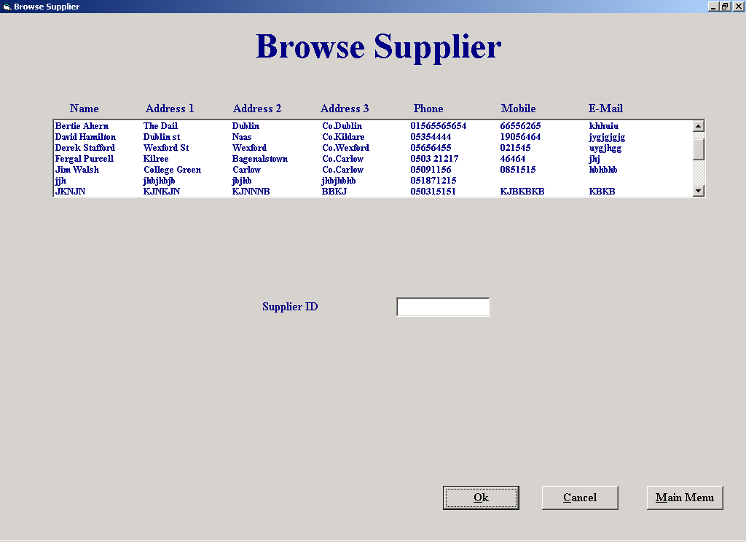

Code:
'The purpose of this screen is to allow the user to browse for a supplier or a customer.

'It allows the user to browse for the supplier or customer by placing all the persons
'details in a list box. The persons primary key is stored in the ItemData property
'of the list box.
'The user then clicks "Ok" and the primary key is passed back to the previous screen.

'Author Fergal Purcell
'Date 06/03/2002

'Variables used
'strTable : String ; This variable stores the name of the table to be browsed,
'e.g., "Customer" or "Supplier"

'Objects used
'datTable : Data Control; This data control fills the list of customers or suppliers
Option Explicit

'Use a DLL to place tab stops in a list box.
'This piece of code is taken from "Programming in Visual Basic 6.0, by Julia Case Bradley"

Private Declare Function SendMessage Lib "user32" Alias "SendMessageA" _
(ByVal hwnd As Long, ByVal wMsg As Long, ByVal wParam As Long, _
lParam As Any) As Long
Const LB_SETTABSTOPS = &H192

Private Sub cmdCancel_Click()
If frmBrowse.Tag = "Supplier" Then 'Tag property set to "Supplier" if coming from DeleteaSupplier screen
frmDeleteaSupplier.Show
ElseIf frmBrowse.Tag = "Customer" Then 'Tag property set to "Customer" if coming from DeleteaSupplier screen
frmMakeaPayment.Show
Else
frmOrdersReport.Show
End If
lstTable.Clear
Unload Me
End Sub

Private Sub cmdOk_Click()
If frmBrowse.Tag = "Supplier" Then 'Tag property set to "Supplier" if coming from DeleteaSupplier screen
frmDeleteaSupplier.txtSearch.Text = txtID.Text
frmDeleteaSupplier.Show
ElseIf frmBrowse.Tag = "Customer" Then 'Tag property set to "Customer" if coming from DeleteaSupplier screen
frmMakeaPayment.txtSearch.Text = txtID.Text
frmMakeaPayment.Show
Else
frmOrdersReport.txtList.Text = txtID.Text
frmOrdersReport.Show
End If
frmBrowse.Tag = ""
Unload Me
End Sub

Private Sub Form_activate()
Dim strTable As String
SetTabs lstTable 'Set the tabs in the list box
If frmBrowse.Tag = "Report" Then
strTable = "Supplier"
Else
strTable = frmBrowse.Tag 'Set which table is to be searched
End If
datTable.DatabaseName = strThePath
datTable.RecordSource = strTable
datTable.Refresh
If strTable = "Supplier" Then
Label1.Caption = "Browse Supplier" 'Search the Supplier table
While Not datTable.Recordset.EOF
If datTable.Recordset.Fields("Deletion") = False Then
lstTable.AddItem (datTable.Recordset("Supplier Name") & Chr(9) & datTable.Recordset("Address 1") & Chr(9) & datTable.Recordset("Address 2") & Chr(9) & datTable.Recordset("Address 3") & Chr(9) & datTable.Recordset("Phone No") & Chr(9) & datTable.Recordset("Mobile No") & Chr(9) & datTable.Recordset("E-Mail"))
lstTable.ItemData(lstTable.NewIndex) = (datTable.Recordset("Supplier_ID")) 'Store the suppliers ID
End If
datTable.Recordset.MoveNext
Wend
Else
Label1.Caption = "Browse Customer" 'Search the Customer table
Label2.Caption = "Customer ID"
While Not datTable.Recordset.EOF
If datTable.Recordset.Fields("Deletion") = False Then
lstTable.AddItem (datTable.Recordset("Name") & Chr(9) & datTable.Recordset("Address 1") & Chr(9) & datTable.Recordset("Address 2") & Chr(9) & datTable.Recordset("Address 3") & Chr(9) & datTable.Recordset("Phone No") & Chr(9) & datTable.Recordset("Mobile No") & Chr(9) & datTable.Recordset("E-Mail"))
lstTable.ItemData(lstTable.NewIndex) = (datTable.Recordset("Cust_ID")) 'Store the Customers ID
End If
datTable.Recordset.MoveNext
Wend
End If
End Sub
Private Sub lstTable_Click()
Dim strTheString As String
txtID.Text = lstTable.ItemData(lstTable.ListIndex) 'Get the Id if the person the user selected
End Sub
Private Sub SetTabs(lst As ListBox)
'Set the tab stops in a listbox
ReDim lngTabs(0 To 7) As Long 'Eight tab stops needed
Dim lngRtn As Long 'DLL function returns a long variable
lngTabs(0) = 70 'Twips measurement for 1st tab stop
lngTabs(1) = 140
lngTabs(2) = 210
lngTabs(3) = 280
lngTabs(4) = 350
lngTabs(5) = 420
lngTabs(6) = 490
lngRtn = SendMessage(lst.hwnd, LB_SETTABSTOPS, 7, lngTabs(0)) 'Set the stops
End Sub
Property Settings

Student Name: Fergal Purcell
Form Name: frmBrowse
Form Purpose: Allow the user to browse for a supplier or customer

Object | Property | Setting
datTable | DatabaseName | strThePath
 | RecordSource | Supplier
 |  | Customer

Make a Payment

Screen Shot:

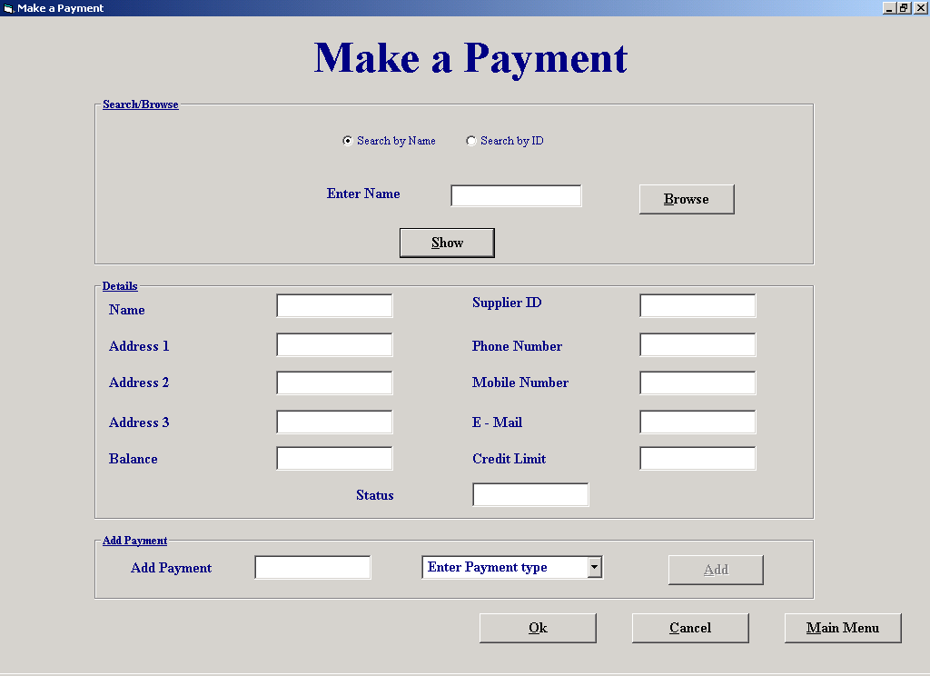

Code:
'The purpose of this screen is to allow the user to make a payment.

'The user enters either the customers name or primary key, or they can browse for the
'customer.
'When the user clicks "Show" the system finds the matching criteria in the customer
'table using the data control "datCustomer" and prints the customers details into text boxes.
'The user then enters the payment amount and selects the payment method from a combo box.
'When the user clicks "Add" the customers balance is updated and the payment details
'are stored in tags.
'If the user clicks "Cancel" the customers balance is stored to its original value.
'If the user clicks "Ok" the payment table is updated

'Author Fergal Purcell
'Date 06/03/2002

'Variables used
'strSql : String ; This variable stores the Sql statement.
'intSpace : Integer; Holds the position of the space as it marks the end of one primary key.
'intCounter : Integer; This variable is used as a control variable in a For Loop
'intPayID : Integer; Stores the system generated payment ID

'Objects used
'datCustomer : Data Control; This data control retrieves information from the "Customer" table and updates their balance owed

Option Explicit

Private Function CheckNum(ByVal strBox) As Boolean
'Bug in IsNumeric says that 6d6 is numeric
Dim intCounter As Integer
For intCounter = 1 To Len(strBox)
If Not IsNumeric(Mid(strBox, intCounter, 1)) Then 'Check each character
CheckNum = True
End If
Next
End Function

Private Sub cmdAdd_Click()
'This procedure updates the customers balance if he/she makes a payment, but it doesnt update the "Payment" table
Dim strSql As String
If txtPay.Text = "" Then
MsgBox "Please enter a payment amount", vbExclamation, "Enter amount"
ElseIf CheckNum(txtPay.Text) = True Then
MsgBox "Please enter a valid payment amount", vbExclamation, "Invalid data"
ElseIf cboType.ListIndex = -1 Then
MsgBox "Please select a payment type", vbExclamation, "Enter type"
Else
datCustomer.DatabaseName = strThePath
datCustomer.RecordSource = "Customer"
datCustomer.Refresh
datCustomer.Recordset.FindFirst "Cust_ID = " & txtID.Text
txtPay.Tag = txtPay.Tag & txtPay.Text & Chr(9) 'Store payments in case the user makes a mistake
cmdAdd.Tag = cmdAdd.Tag & txtID.Text & Chr(9) 'Store the customers ID
cboType.Tag = cboType.Tag & cboType.Text & Chr(9) 'Store the type of payment
txtStatus.Tag = txtStatus.Tag & txtStatus.Text & Chr(9)
datCustomer.Recordset.Edit
datCustomer.Recordset.Fields("Balance Owed") = datCustomer.Recordset.Fields("Balance owed") - txtPay.Text 'Update the Customers balance owed
If datCustomer.Recordset.Fields("Balance owed") <= datCustomer.Recordset.Fields("Credit Limit") Then
datCustomer.Recordset.Fields("Status") = "Normal" 'Change the customers status
txtStatus.Text = "Normal"
End If
datCustomer.Recordset.Update
txtBal.Text = datCustomer.Recordset.Fields("Balance owed")
End If
End Sub

Private Sub cmdCancel_Click()
If cmdAdd.Tag <> "" Then 'Display this message only if the user has added payments
If MsgBox("Do you wish to save payments?", vbQuestion + vbYesNo, "Save payments") = vbNo Then
CancelPay 'Call procedure that cancels the payments that a customer has made
Else
OkPay 'Call procedure that adds payments
End If
End If
If frmMakeaPayment.Tag = "" Then
frmMainMenu.Show
End If
Unload Me
End Sub

Private Sub cmdMM_Click()
If cmdAdd.Tag <> "" Then 'Display this message only if the user has added payments
If MsgBox("Do you wish to save payments?", vbQuestion + vbYesNo, "Save Payments") = vbNo Then
CancelPay
Else
OkPay
End If
End If
frmMainMenu.Show
Unload Me
End Sub

Private Sub cmdNext_Click()
datCustomer.Recordset.MoveNext
If datCustomer.Recordset.EOF Then
datCustomer.Recordset.MoveFirst
End If
AssignFields
End Sub

Private Sub cmdOk_Click()
OkPay
End Sub

Private Sub cmdPrevious_Click()
datCustomer.Recordset.MovePrevious 'Move to the previous match
If datCustomer.Recordset.BOF Then
datCustomer.Recordset.MoveLast
End If
AssignFields
End Sub

Private Sub cmdShow_Click()
ShowDetails
End Sub

Private Sub cmdBrowse_Click()
cmdNext.Visible = False
cmdPrevious.Visible = False
optID.Value = True 'Set the search type to ID search since browse returns the primary key
lblSearch.Caption = "Enter ID" 'Change the labels
frmBrowse.Show 'Display the browse screen
frmBrowse.Tag = "Customer"
End Sub

Private Sub Form_activate()
If frmMakeaPayment.Tag <> "" Then 'Check to see if the form has been activated from "Hiring of Equipment" or "Return of Equipment"
optID.Value = True
cmdMM.Enabled = False
txtSearch.Text = frmMakeaPayment.Tag 'frmMakeaPayment.Tag holds the customers ID
ShowDetails
End If
txtSearch.SetFocus
cboType.Clear
cboType.AddItem ("Cash") 'Add payment methods to the combo box
cboType.AddItem ("Cheque")
cboType.AddItem ("Credit Card")
cboType.Text = "Enter Payment type"
End Sub

Private Sub OptID_Click()
lblSearch.Caption = "Enter ID" 'Change the labels
txtSearch.SetFocus
txtSearch.Text = ""
End SubPrivate Sub OptName_Click()
lblSearch.Caption = "Enter Name"
txtSearch.Text = ""
txtSearch.SetFocus
End Sub

Private Sub AssignFields()
'This procedure assigns the text boxes
txtName.Text = datCustomer.Recordset.Fields("Name")
txtID.Text = datCustomer.Recordset.Fields("Cust_ID")
txtAdd1.Text = datCustomer.Recordset.Fields("[Address 1]")
txtAdd2.Text = datCustomer.Recordset.Fields("[Address 2]")
txtAdd3.Text = datCustomer.Recordset.Fields("[Address 3]")
txtPhone.Text = datCustomer.Recordset.Fields("[Phone No]")
txtMob.Text = "" + datCustomer.Recordset.Fields("[Mobile No]")
txtMail.Text = "" + datCustomer.Recordset.Fields("E-Mail")
txtBal.Text = datCustomer.Recordset.Fields("Balance owed")
txtCredit.Text = datCustomer.Recordset.Fields("Credit limit")
txtStatus.Text = datCustomer.Recordset.Fields("Status")
cmdAdd.Enabled = True
End Sub

Private Sub ShowDetails()
'This procedure searches for the customer and displays there details if found
cmdNext.Visible = False
cmdPrevious.Visible = False
datCustomer.DatabaseName = strThePath
datCustomer.RecordSource = "Customer"
datCustomer.Refresh
If OptName = True Then 'Search for matching name
Dim strSql As String
strSql = "Select Count(Customer.Name) AS CountOfSup From Customer Where Customer.[Name] Like '" & txtSearch.Text & "*'" & _
"And Customer.Deletion = false"
datCustomer.RecordSource = strSql
datCustomer.Refresh
If datCustomer.Recordset.Fields("CountOfSup") = 0 Or txtSearch = "" Then
MsgBox "There is no match.", vbExclamation, "No Match"
txtSearch.SetFocus
txtSearch.Text = ""
ElseIf datCustomer.Recordset.Fields("CountOfSup") = 1 Then
strSql = "Select * From Customer Where Customer.[Name] Like '" & txtSearch.Text & "*'" & _
"And Customer.Deletion = False"
datCustomer.RecordSource = strSql
datCustomer.Refresh
AssignFields
Else
cmdNext.Visible = True 'Display these buttons if there is more than one match
cmdPrevious.Visible = True
strSql = "Select * From Customer Where Customer.[Name] Like '" & txtSearch.Text & "*'" & _
"And Customer.Deletion = False"
datCustomer.RecordSource = strSql
datCustomer.Refresh
AssignFields
End If
Else 'Search for primary keys
If CheckNum(txtSearch.Text) = True Or txtSearch.Text = "" Then
MsgBox "Invalid data.", vbExclamation, "Invalid data"
txtSearch.SetFocus
txtSearch.Text = ""
Else
datCustomer.Recordset.FindFirst "Cust_ID = " & txtSearch.Text
If datCustomer.Recordset.NoMatch = True Or datCustomer.Recordset.Fields("Deletion") = True Then
MsgBox "There is no match.", vbExclamation, "Invalid data"
txtSearch.SetFocus
txtSearch.Text = ""
Else
AssignFields
End If
End If
End If
End Sub

Private Sub CancelPay()
'This procedure cancels all the payments added to the customers balance
Dim intTab As Integer, intTab2 As Integer, intTab3 As Integer
intTab = 1
intTab2 = 1
intTab3 = 1
Do Until cmdAdd.Tag = "" 'Restore the customers balance if the user presses cancel
intTab = InStr(cmdAdd.Tag, vbTab) 'Find the location of the space because it marks the end of one primary key
txtID.Text = Mid(cmdAdd.Tag, 1, intTab - 1) 'Find the primary key
datCustomer.DatabaseName = strThePath
datCustomer.RecordSource = "Customer"
datCustomer.Refresh
datCustomer.Recordset.FindFirst "Cust_ID = " & txtID.Text 'Find matching key field
datCustomer.Recordset.Edit
intTab2 = InStr(txtPay.Tag, vbTab) 'Find the location of the tab because it marks the end of every payment
intTab3 = InStr(txtStatus.Tag, vbTab)
datCustomer.Recordset.Fields("Balance owed") = (datCustomer.Recordset.Fields("Balance owed")) + (Mid(txtPay.Tag, 1, intTab2 - 1)) 'Restore the balance to the original settings
datCustomer.Recordset.Fields("Status") = Mid(txtStatus.Tag, 1, intTab3 - 1)
datCustomer.Recordset.Update
If Len(cmdAdd.Tag) <= 2 Then
cmdAdd.Tag = ""
Else
cmdAdd.Tag = Mid(cmdAdd.Tag, intTab + 1, (Len(cmdAdd.Tag) - (intTab - 1)))
txtPay.Tag = Mid(txtPay.Tag, intTab2 + 1, (Len(txtPay.Tag) - (intTab2 - 1)))
txtStatus.Tag = Mid(txtStatus.Tag, intTab3 + 1, (Len(txtStatus.Tag) - (intTab3 - 1)))
End If
Loop
End Sub

Private Sub OkPay()
'This procedure updates the payment table with all the payments added
Dim intTab As Integer, intTab2 As Integer, intTab3 As Integer, intPayID As Integer
intTab = 1
intTab2 = 1
intTab3 = 1
Do Until cmdAdd.Tag = ""
intTab = InStr(cmdAdd.Tag, vbTab) 'Find the location of the space because it marks the end of one primary key
txtID.Text = Mid(cmdAdd.Tag, 1, intTab - 1) 'Find the primary key
datCustomer.DatabaseName = strThePath
datCustomer.RecordSource = "Payment"
datCustomer.Refresh
If datCustomer.Recordset.RecordCount <> 0 Then
datCustomer.Recordset.MoveLast
intPayID = datCustomer.Recordset.Fields("Payment_ID") + 1 'Create a new payment ID
Else
intPayID = 1
End If
datCustomer.Recordset.AddNew
intTab2 = InStr(txtPay.Tag, vbTab) 'Find the location of the space because it marks the end of one primary key
intTab3 = InStr(cboType.Tag, vbTab)
With datCustomer.Recordset
.Fields("Payment_ID") = intPayID
.Fields("Cust_ID") = txtID.Text
.Fields("Date") = Date
.Fields("Amount") = Mid(txtPay.Tag, 1, intTab2 - 1) 'txtPay.Tag holds the payment amount
.Fields("Payment Method") = Mid(cboType.Tag, 1, intTab3 - 1) 'cboType.Tag holds the payment type
datCustomer.Recordset.Update
End With
If Len(cmdAdd.Tag) <= 2 Then
cmdAdd.Tag = ""
Else
cmdAdd.Tag = Mid(cmdAdd.Tag, intTab + 1, (Len(cmdAdd.Tag) - (intTab - 1))) 'Delete first ID since it has been processed
txtPay.Tag = Mid(txtPay.Tag, intTab2 + 1, (Len(txtPay.Tag) - (intTab2 - 1))) 'Delete first payment amount since it has been processed
cboType.Tag = Mid(cboType.Tag, intTab3 + 1, (Len(cboType.Tag) - (intTab3 - 1))) 'Delete first payment type since it has been processed
End If
Loop
If frmMakeaPayment.Tag = "" Then 'Go back to main menu or else back to rental or return
frmMainMenu.Show
End If
Unload Me
End Sub

Property Settings

Student Name: Fergal Purcell
Form Name: frmMakeaPayment
Form Purpose: Allow the user to enter a payment that the customer has made

Object | Property | Setting
datCustomer | DatabaseName | strThePath
 | RecordSource | Customer

Orders Report

Screen Shot:

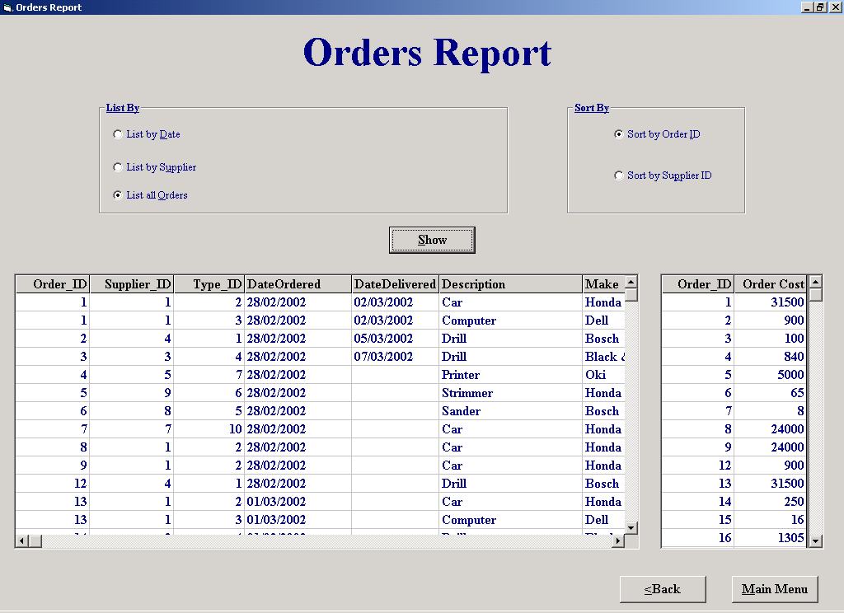

Code:
'The purpose of this screen is to show the user an order report.

'The user has the option of listing orders by date, by supplier, or all the orders.
'The user also has the option of sorting by order ID or supplier ID.
'When the user clicks show the details of every order is shown in one flex grid and each order cost is
'shown in another flex grid.

'Author Fergal Purcell
'Date 13/03/2002

'Variables used
'intCounter : Integer; This variable is used as a control variable in a For Loop
'strSql : String; This string variable is used to store an SQL
'strSort : String; Holds the field by which the user wishes to sort the report
'strSql2 : String; Stores the second SQL which finds the cost of each order

'Objects used
'datOrder : Data Control; Holds the result of the first SQL
'datTotal : Data Control; Holds the result of the second SQL

Option Explicit

Private Function CheckNum() As Boolean
'Bug in IsNumeric says that 6d6 is numeric
Dim intCounter As Integer
For intCounter = 1 To Len(txtList.Text)
If Not IsNumeric(Mid(txtList, intCounter, 1)) Then 'Check each character
CheckNum = True
End If
Next
End Function

Private Sub cmdBrowse_Click()
frmBrowse.Tag = "Report"
frmBrowse.Show
End Sub

Private Sub cmdShow_Click()
Dim strSql As String, strSort As String, strSql2 As String
datOrder.DatabaseName = strThePath
datTotal.DatabaseName = strThePath
If optSortOrder.Value = True Then
strSort = "Order.Order_ID"
Else
strSort = "Order.Supplier_ID"
End If
If optDate.Value = True Then 'List orders by date
If IsDate(txtList.Text) = True Then 'Check to see if user has entered the correct date
'strSql holds the SQL that finds all the order(s) placed since a particular date
strSql = "SELECT Order.Order_ID, Order.Supplier_ID, [Equipment Type].Type_ID, Order.DateOrdered, Order.DateDelivered, [Equipment Type].Description, [Equipment Type].Make, [Equipment Type].Model, [Equipment Type].Details, [Order/Equipment].QuantityOrdered, Equipment.[Purchase Price] " & _
"FROM ([Equipment Type] INNER JOIN ([Order] INNER JOIN [Order/Equipment] ON Order.Order_ID = [Order/Equipment].Order_ID) ON [Equipment Type].Type_ID = [Order/Equipment].Type_ID) INNER JOIN Equipment ON [Equipment Type].Type_ID = Equipment.Type_ID " & _
"GROUP BY Order.Order_ID, Order.Supplier_ID, [Equipment Type].Type_ID, Order.DateOrdered, Order.DateDelivered, [Equipment Type].Description, [Equipment Type].Make, [Equipment Type].Model, [Equipment Type].Details, [Order/Equipment].QuantityOrdered, Equipment.[Purchase Price], Equipment.Supplier_ID, Order.CancelOrder " & _
"Having (((Order.DateOrdered) >= #" & Format(txtList.Text, "MM, DD,YYYY") & "#) And ((Equipment.Supplier_ID) = [Order].[Supplier_ID]) And ((Order.CancelOrder) <> True)) " & _
"ORDER BY " & strSort & ""
'strSql2 holds the SQL that finds the cost of order(s) placed since a particular date
'"OrderReport" is a query table produced from the query that’s in strSql
strSql2 = "SELECT OrderReport.Order_ID, Sum([Purchase Price]*[QuantityOrdered]) AS [Order Cost] " & _
"From OrderReport " & _
"GROUP BY OrderReport.Order_ID, OrderReport.Supplier_ID, OrderReport.DateOrdered " & _
"Having (((OrderReport.DateOrdered) >= #" & Format(txtList.Text, "MM, DD, YYYY") & "#)) " & _
"ORDER BY " & strSort & ""
Else
MsgBox "Please enter a valid date", vbExclamation, "Invalid date"
txtList.Text = ""
End If
txtList.SetFocus
ElseIf optSupplier.Value = True Then 'List by supplier
If CheckNum = True Or txtList.Text = "" Then 'Call procedure CheckNum to see if the ID that the user has entered is numeric
MsgBox "Please enter a valid supplier number", vbExclamation, "Invalid number"
txtList.Text = ""
Else
'strSql holds the SQL that finds all the order(s) placed with a particular supplier
strSql = "SELECT Order.Order_ID, Order.Supplier_ID, [Equipment Type].Type_ID, Order.DateOrdered, Order.DateDelivered, [Equipment Type].Description, [Equipment Type].Make, [Equipment Type].Model, [Equipment Type].Details, [Order/Equipment].QuantityOrdered, Equipment.[Purchase Price] " & _
"FROM ([Equipment Type] INNER JOIN ([Order] INNER JOIN [Order/Equipment] ON Order.Order_ID = [Order/Equipment].Order_ID) ON [Equipment Type].Type_ID = [Order/Equipment].Type_ID) INNER JOIN Equipment ON [Equipment Type].Type_ID = Equipment.Type_ID " & _
"GROUP BY Order.Order_ID, Order.Supplier_ID, [Equipment Type].Type_ID, Order.DateOrdered, Order.DateDelivered, [Equipment Type].Description, [Equipment Type].Make, [Equipment Type].Model, [Equipment Type].Details, [Order/Equipment].QuantityOrdered, Equipment.[Purchase Price], Equipment.Supplier_ID, Order.CancelOrder " & _
"Having (((Order.Supplier_ID) = " & txtList.Text & ") And ((Equipment.Supplier_ID) = [Order].[Supplier_ID]) And ((Order.CancelOrder) <> True)) " & _
"ORDER BY " & strSort & ""
'strSql2 holds the SQL that finds the cost each order placed with a particular supplier
'"OrderReport" is a query table produced from the query that’s in strSql
strSql2 = "SELECT OrderReport.Order_ID, Sum([Purchase Price]*[QuantityOrdered]) AS [Order Cost]" & _
"From OrderReport " & _
"GROUP BY OrderReport.Order_ID, OrderReport.Supplier_ID " & _
"Having (((OrderReport.Supplier_ID) = " & txtList.Text & ")) " & _
"ORDER BY OrderReport.Order_ID;"
datOrder.RecordSource = strSql
datOrder.Refresh
If datOrder.Recordset.RecordCount = 0 Then
MsgBox "There is no match", vbExclamation, "No Match"
End If
End If
txtList.SetFocus
Else
'strSql holds the SQL that finds all the order(s)
strSql = "SELECT Order.Order_ID, Order.Supplier_ID, [Equipment Type].Type_ID, Order.DateOrdered, Order.DateDelivered, [Equipment Type].Description, [Equipment Type].Make, [Equipment Type].Model, [Equipment Type].Details, [Order/Equipment].QuantityOrdered, Equipment.[Purchase Price] " & _
"FROM ([Equipment Type] INNER JOIN ([Order] INNER JOIN [Order/Equipment] ON Order.Order_ID = [Order/Equipment].Order_ID) ON [Equipment Type].Type_ID = [Order/Equipment].Type_ID) INNER JOIN Equipment ON [Equipment Type].Type_ID = Equipment.Type_ID " & _
"GROUP BY Order.Order_ID, Order.Supplier_ID, [Equipment Type].Type_ID, Order.DateOrdered, Order.DateDelivered, [Equipment Type].Description, [Equipment Type].Make, [Equipment Type].Model, [Equipment Type].Details, [Order/Equipment].QuantityOrdered, Equipment.[Purchase Price], Equipment.Supplier_ID, Order.CancelOrder " & _
"Having (((Equipment.Supplier_ID) = [Order].[Supplier_ID]) And ((Order.CancelOrder) <> True)) " & _
"ORDER BY " & strSort & ""
'strSql2 holds the SQL that finds the cost each order
'"OrderReport" is a query table produced from the query that’s in strSql
strSql2 = "SELECT OrderReport.Order_ID, Sum([Purchase Price]*[QuantityOrdered]) AS [Order Cost] " & _
"From OrderReport " & _
"GROUP BY OrderReport.Order_ID " & _
"ORDER BY OrderReport.Order_ID "
End If
datOrder.RecordSource = strSql
datOrder.Refresh
datTotal.RecordSource = strSql2
datTotal.Refresh
End Sub

Private Sub cmdMM_Click()
frmMainMenu.Show
Unload Me
End Sub

Private Sub optAll_Click()
lblList.Visible = False
txtList.Visible = False
cmdBrowse.Visible = False
End Sub

Private Sub optDate_Click()
cmdBrowse.Visible = False
txtList.ToolTipText = "Enter date"
lblList.Visible = True
txtList.Visible = True
txtList.SetFocus
txtList.Text = ""
lblList.Caption = "Enter Date"
End Sub

Private Sub optSupplier_Click()
cmdBrowse.Visible = True
txtList.ToolTipText = "Enter ID"
lblList.Visible = True
txtList.Visible = True
txtList.SetFocus
txtList.Text = ""
lblList.Caption = "Enter ID"
End Sub

Property Settings

Student Name: Fergal Purcell
Form Name: frmOrdersReport
Form Purpose: Displays a report of the orders that the business has made

Object | Property | Setting
datOrder | DatabaseName | strThePath
 | RecordSource | strSQL
datTotal | DatabaseName | strThePath
 | RecordSource | strSQL2
flxOrder | DataSource | datOrder
flxTotal | DataSource | datTotal

Place an Order

Screen Shot:

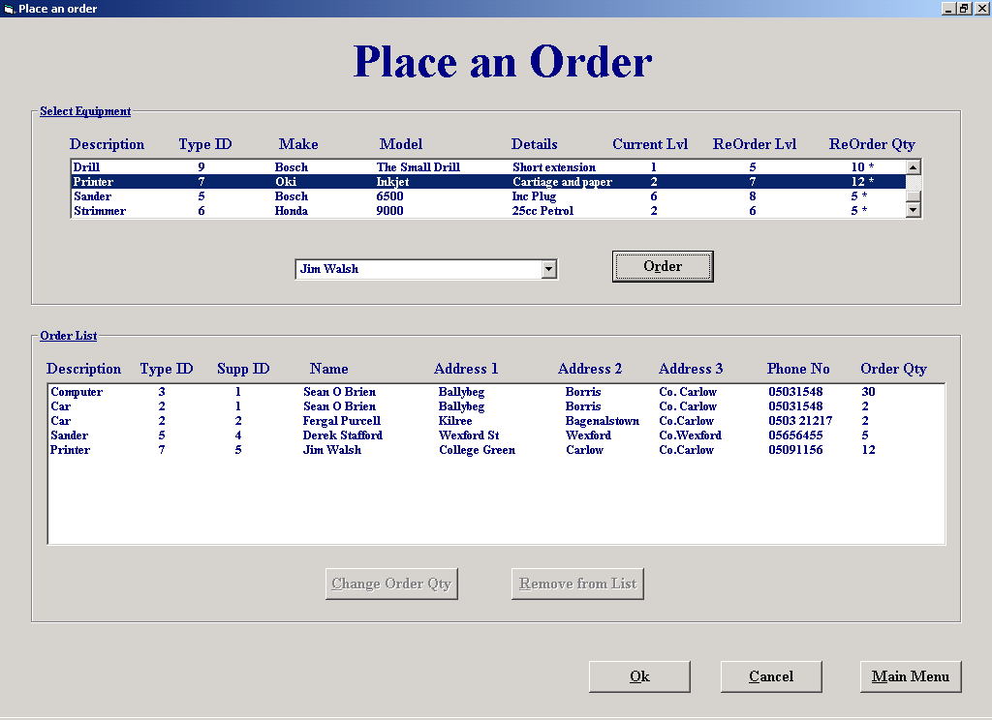

Code:
'The purpose of this screen is to allow orders to be placed with customers.

'When the form is activated the list box "lstEquip" is filled with details of every
'equipment type the business has, the equipment types ID is stored in the list boxes
'ItemData property.
'When the user selects the equipment type he wishes to order, the combo box "cboSupplier"
'is filled with names of every supplier that has supplied the equipment type and who is not
'marked for deletion.
'The user then selects the supplier he wishes to order from and clicks "Order".
'When "Order" is clicked the order is added to the list box "lstOrder".
'If the user wishes to change the order quantity he clicks "Change order Qty" and enters
'the amount required.
'If the user clicks "Remove from List" the order is removed from the list.
'When the user clicks "Ok" an order list is printed for every order and the table "Order" is
'updated with a separate order for every supplier and the table "Order/Equipment" is updated
'with every equipment type ordered.

'Author Fergal Purcell
'Date 06/03/2002

'Variables used
'strSql : String ; This variable stores the Sql statement.
'intSpace : Integer; Holds the position of the space as it marks the end of one primary key.
'intId : Integer; Stores the equipment type Id.
'intOrder_ID : Integer; Holds a concatenation of Suppier ID and Equipment Type ID.
'intIndex : Integer; Control variable.
'blnExist : Boolean; Returns true if an order already exists.
'strRecord : String; Holds the order to be changed.
'intMyPos : Integer; Stores to position of the last tab in strRecord.
'strNewAmt : Integer; The new amount required for a particular order of equipment.
'strSql : String; Holds the SQL statement
'intCounter : Integer; Holds a count an equipment that is in stock.
'intSuppID : Integer; Holds the suppliers ID.
'strSuppName : String; Holds the supplier name.
'strOrder : String; Stores details of an order for processing.
'strOrderID : String; Holds a system generated order ID.
'strSuppID : String; Holds the supplier ID.
'strTemp : Variant; Assigned a split of the order for processing as it goes through the loop.

'Objects used
'datOrder : Data Control; This data control is used to add new record to the "Order" table.
'datEquipment : Data Control; This data control is used to retrieve information from the "Equipment Type" table and the "Supplier" table.
'datSQL : Data Control; This data control is used to view the results of SQL's, its also used to retrieve information from the "Supplier" table.

Option Explicit

'Use a DLL to place tab stops in a list box.
'This piece of code is taken from "Programming in Visual Basic 6.0, by Julia Case Bradley"
Private Declare Function SendMessage Lib "user32" Alias "SendMessageA" _
(ByVal hwnd As Long, ByVal wMsg As Long, ByVal wParam As Long, _
lParam As Any) As Long
Const LB_SETTABSTOPS = &H192

Private Function CheckNum(strMyString) As Boolean
'Bug in IsNumeric says that 6d6 is numeric
Dim intCounter As Integer
For intCounter = 1 To Len(strMyString)
If Not IsNumeric(Mid(strMyString, intCounter, 1)) Then 'Check each character
CheckNum = True
End If
Next
End Function

Private Sub cboSupplier_Click()
cmdAdd.Enabled = True
End Sub

Private Sub cmdAdd_Click()
'This procedure creates an order with the selected supplier
Dim intID As Integer, intOrder_ID As Integer, intIndex As Integer, blnExist As Boolean
If cboSupplier.ListIndex = -1 Then 'Check that the user has selected a supplier
MsgBox "Please select a supplier", vbExclamation, "Select a supplier"
Else
intID = lstEquip.ItemData(lstEquip.ListIndex) 'Get the Type ID of the selected equipment type
SetTabs2 lstOrder 'Set the tabs
datEquipment.DatabaseName = strThePath
datEquipment.RecordSource = "Equipment Type"
datEquipment.Refresh
datSQL.DatabaseName = strThePath
datSQL.RecordSource = "Supplier"
datSQL.Refresh
datEquipment.Recordset.FindFirst "Type_ID = " & intID
datSQL.Recordset.FindFirst "Supplier_ID = " & cboSupplier.ItemData(cboSupplier.ListIndex) 'Find the matching suppliers record for the ID
intOrder_ID = datSQL.Recordset.Fields("Supplier_ID") & intID 'Create an order ID for every order in the list box so that only one specific order can be made
intIndex = 0
blnExist = False
For intIndex = 0 To lstOrder.ListCount - 1 'Check to see if the order already exists
If intOrder_ID = lstOrder.ItemData(intIndex) Then
blnExist = True
End If
Next intIndex
If blnExist = True Then
MsgBox "Order already exists", vbExclamation, "Order exists"
Else
With datEquipment.Recordset
lstOrder.AddItem (.Fields("Description") & Chr(9) & .Fields("Type_ID") & Chr(9) & (datSQL.Recordset.Fields("Supplier_ID")) & Chr(9) & (datSQL.Recordset.Fields("Supplier Name")) & Chr(9) & (datSQL.Recordset.Fields("Address 1")) & Chr(9) & (datSQL.Recordset.Fields("Address 2")) & Chr(9) & (datSQL.Recordset.Fields("Address 3")) & Chr(9) & (datSQL.Recordset.Fields("Phone No")) & Chr(9) & .Fields("ReOrder Quantity")) 'Add details of order
lstOrder.ItemData(lstOrder.NewIndex) = intOrder_ID 'Add order ID
End With
End If
End If
End Sub

Private Sub cmdCancel_Click()
If lstOrder.ListCount <> 0 Then 'Only display this message if there are orders in the list
If MsgBox("Do you wish to save orders?", vbQuestion + vbYesNo, "Save orders") = vbYes Then
OkOrder
End If
End If
frmMainMenu.Show
Unload Me
End Sub

Private Sub cmdCAR_Click()
'This procedure changes the amount required of a particular equipment type
Dim strRecord As String, intMyPos As Integer, strNewAmt As String
strRecord = lstOrder.List(lstOrder.ListIndex) 'Copy order details into string
intMyPos = InStrRev(strRecord, Chr(9)) 'Find the last space in the order details
strNewAmt = InputBox("Please enter the new amount required.", "ReOrder Quantity") 'Get the new amount from the user
If CheckNum(strNewAmt) = True Or strNewAmt = "" Then 'Call function CheckNum to see if inputted value is numeric
MsgBox "Invalid data", vbExclamation, "Invalid data"
ElseIf strNewAmt < 1 Then
MsgBox "Invalid data, no zero or negative amounts", vbExclamation, "Invalid data"
Else
strRecord = Mid(strRecord, 1, intMyPos)
strRecord = strRecord + strNewAmt 'Insert new amount into order details
lstOrder.List(lstOrder.ListIndex) = strRecord
End If
End Sub

Private Sub cmdMM_Click()
If lstOrder.ListCount <> 0 Then
If MsgBox("Save Orders?", vbQuestion + vbYesNo, "Save orders") = vbYes Then
OkOrder
End If
End If
frmMainMenu.Show
Unload Me
End Sub

Private Sub cmdOk_Click()
OkOrder 'Call procedure that prints order(s) and updates "Order" table
frmMainMenu.Show
Unload Me
End Sub

Private Sub cmdRemove_Click()
'This procedure removes an order from the list
If MsgBox("Are you sure you to remove this order from the list?", vbQuestion + vbYesNo, "Remove order") = vbYes Then
lstOrder.RemoveItem (lstOrder.ListIndex) 'Remove order from list
End If
cmdRemove.Enabled = False
cmdCAR.Enabled = False
End Sub

Private Sub Form_Load()
Dim strSql As String, intCounter As Integer, intID As Integer
SetTabs lstEquip 'Set the tabs in the list box
datEquipment.DatabaseName = strThePath
datEquipment.RecordSource = "Equipment Type"
datEquipment.Refresh
datSQL.DatabaseName = strThePath
While Not datEquipment.Recordset.EOF 'Display equipment types in stock
If datEquipment.Recordset.Fields("Deletion") = False Then 'Only display the equipment types that are not deleted
intID = datEquipment.Recordset.Fields("Type_ID")
strSql = "SELECT Count(Equipment.Type_ID) AS CountOfType_ID From Equipment Where Equipment.Type_ID= " & intID & "" 'Find how many equipment types are in stock
datSQL.RecordSource = strSql
datSQL.Refresh
intCounter = datSQL.Recordset.Fields("CountOfType_ID")
If datEquipment.Recordset.Fields("ReOrder Level") > intCounter Then 'Place an "*" at the end of the string to indicate that the stock level is lower than the reorder level
lstEquip.AddItem (datEquipment.Recordset("Description") & Chr(9) & datEquipment.Recordset("Type_ID") & Chr(9) & datEquipment.Recordset("Make") & Chr(9) & datEquipment.Recordset("Model") & Chr(9) & datEquipment.Recordset("Details") & Chr(9) & Str(intCounter) & Chr(9) & datEquipment.Recordset("[ReOrder Level]") & Chr(9) & datEquipment.Recordset("[ReOrder Quantity]") & " *")
Else
lstEquip.AddItem (datEquipment.Recordset("Description") & Chr(9) & datEquipment.Recordset("Type_ID") & Chr(9) & datEquipment.Recordset("Make") & Chr(9) & datEquipment.Recordset("Model") & Chr(9) & datEquipment.Recordset("Details") & Chr(9) & Str(intCounter) & Chr(9) & datEquipment.Recordset("[ReOrder Level]") & Chr(9) & datEquipment.Recordset("[ReOrder Quantity]"))
End If
lstEquip.ItemData(lstEquip.NewIndex) = (datEquipment.Recordset("Type_ID")) 'Store the type id in the ItemData property
End If
datEquipment.Recordset.MoveNext
Wend
End Sub

Private Sub SetTabs(lst As ListBox)
'Set the tab stops in a listbox
ReDim lngTabs(0 To 7) As Long 'Eight tab stops needed
Dim lngRtn As Long 'DLL function returns a long variable
lngTabs(0) = 75 'Twips measurement for 1st tab stop
lngTabs(1) = 120
lngTabs(2) = 180
lngTabs(3) = 260
lngTabs(4) = 340
lngTabs(5) = 400
lngTabs(6) = 460
lngRtn = SendMessage(lst.hwnd, LB_SETTABSTOPS, 7, lngTabs(0))
End Sub

Private Sub SetTabs2(lst As ListBox)
'Set the tab stops in a listbox
ReDim lngTabs(0 To 7) As Long 'Eight tab stops needed
Dim lngRtn As Long 'DLL function returns a long variable
lngTabs(0) = 65 'Twips measurement for 1st tab stop
lngTabs(1) = 110
lngTabs(2) = 150
lngTabs(3) = 230
lngTabs(4) = 305
lngTabs(5) = 360
lngTabs(6) = 425
lngRtn = SendMessage(lst.hwnd, LB_SETTABSTOPS, 7, lngTabs(0))
End Sub

Private Sub lstEquip_Click()
'This procedure finds all suppliers that supply the selected equipment type
Dim intID As Integer, strSql As String, intSuppID As Integer, strSuppName As String
cboSupplier.Clear
cboSupplier.Text = "Select a Supplier"
cmdAdd.Enabled = False
intID = lstEquip.ItemData(lstEquip.ListIndex) 'Get the type ID of the selected equipment type
strSql = "Select [Supplier/Type].Supplier_ID " & _
"From [Supplier/Type] INNER JOIN Supplier ON [Supplier/Type].Supplier_ID = Supplier.Supplier_ID " & _
" Where ((([Supplier/Type].Type_ID = " & intID & " AND ((Supplier.Deletion = False)))));"
datSQL.DatabaseName = strThePath
datEquipment.DatabaseName = strThePath
datEquipment.RecordSource = "Supplier"
datEquipment.Refresh
datSQL.RecordSource = strSql
datSQL.Refresh
While Not datSQL.Recordset.EOF
intSuppID = datSQL.Recordset.Fields("Supplier_ID")
datEquipment.Recordset.FindFirst "Supplier_ID = " & intSuppID 'Find the supplier
cboSupplier.AddItem (datEquipment.Recordset.Fields("[Supplier Name]"))
cboSupplier.ItemData(cboSupplier.NewIndex) = intSuppID 'Store the supplier ID
datSQL.Recordset.MoveNext
Wend
End Sub

Private Sub lstOrder_Click()
cmdCAR.Enabled = True
cmdRemove.Enabled = True
End Sub

Private Sub PrintHeader(ByVal Name As String, ByVal Add1 As String, ByVal Add2 As String, ByVal Add3 As String, ByVal ID As String, ByVal Phone As String, ByVal OrdID As String)
'This procedure prints every header for every page
With Printer 'Set the font
.FontName = "Times New Roman"
.Font.Size = 35
.FontUnderline = True
.ForeColor = &H800000
.FontBold = False
.FontItalic = True
End With
Printer.Print
Printer.Print Tab(9); "Equipment Hire System"
Printer.FontSize = 25
Printer.FontUnderline = False
Printer.Print
Printer.FontItalic = False
Printer.Print Tab(24); "Order List"
Printer.Print
Printer.FontSize = 17
Printer.Print Tab(7); Name
Printer.Print Tab(7); Add1
Printer.Print Tab(7); Add2
Printer.Print Tab(7); Add3
Printer.Print Tab(7); Phone
Printer.Print
Printer.Print Tab(7); "==============================================================="
Printer.Print Tab(7); "Supplier No. : "; ID; Tab(35); "Order No. : "; OrdID; Tab(65); "Date : "; Date
Printer.Print Tab(7); "==============================================================="
Printer.Print
Printer.FontUnderline = True
Printer.Print Tab(7); "ID"; Tab(15); "Make"; Tab(34); "Model"; Tab(50); "Details"; Tab(80); "Qty"
Printer.FontUnderline = False
Printer.Print
End Sub

Private Sub PrintDetails(ID As Integer, Make As String, Model As String, Details As String, ByVal Qty As String)
'This procedure prints the order details for every supplier
With Printer
.FontName = "Times New Roman"
.Font.Size = 15
.FontUnderline = False
.ForeColor = &H800000
End With
Printer.Print Tab(7); ID; Tab(17); Make; Tab(38); Model; Tab(56); Details; Tab(90); Qty
Printer.Print
End Sub

Private Sub OkOrder()
'This procedure prints out the order list and updates the "Order" table
Dim strOrder As String, intIndex As Integer, strOrderID As String, strSuppID As String, strTemp As Variant
Do While lstOrder.ListCount <> 0 'Do until all orders are removed from list and sent to printer
strOrder = lstOrder.List(intIndex)
strTemp = Split(strOrder, Chr(9))
strSuppID = strTemp(2) 'Get the supplier ID
datEquipment.DatabaseName = strThePath
datEquipment.RecordSource = "Equipment Type"
datEquipment.Refresh
datOrder.DatabaseName = strThePath
datOrder.RecordSource = "Order"
datOrder.Refresh
With datOrder.Recordset 'Create a new order for that supplier
If .RecordCount <> 0 Then 'Create order ID
.MoveLast
strOrderID = .Fields("Order_ID") + 1
Else
strOrderID = 1
End If
.AddNew 'Add a new order record
.Fields("Order_ID") = strOrderID
.Fields("Supplier_ID") = strSuppID
.Fields("DateOrdered") = Date
.Update
End With
PrintHeader strTemp(3), strTemp(4), strTemp(5), strTemp(6), strTemp(2), strTemp(7), strOrderID 'Print the header for the order sheet
Do While (intIndex <> lstOrder.ListCount) And (lstOrder.ListCount <> 0) 'Search the order list for matching suppliers ID
strTemp = Split(lstOrder.List(intIndex), Chr(9))
If strTemp(2) = strSuppID Then 'If true then add the current ordered euipment to the order list for that supplier
datOrder.RecordSource = "Order/Equipment"
datOrder.Refresh
With datOrder.Recordset
.AddNew 'Create a new Order/Equipment Record
.Fields("Order_ID") = strOrderID
.Fields("Type_ID") = strTemp(1)
.Fields("QuantityOrdered") = strTemp(8)
.Update
End With
datEquipment.Recordset.FindFirst "Type_ID = " & strTemp(1) 'Find equipment details
With datEquipment.Recordset
PrintDetails .Fields("Type_ID"), .Fields("Make"), .Fields("Model"), .Fields("Details"), strTemp(8) 'Print the description of the equipment that’s on order with the supplier
End With
lstOrder.RemoveItem (intIndex) 'Remove ordered equipment from list since it has been processed
Else
intIndex = intIndex + 1 'Move to next item on the order list
End If
Loop
Printer.NewPage 'Go to a new page for every supplier
intIndex = 0
Loop
Printer.EndDoc 'Start printing
End Sub
Property Settings

Student Name: Fergal Purcell
Form Name: frmPlaceanOrder
Form Purpose: Allows the user to place an order with a supplier

Object | Property | Setting
datOrder | DatabaseName | strThePath
 | RecordSource | Order
 |  | Order/Equipment
datEquipment | DatabaseName | strThePath
 | RecordSource | Equipment Type
 |  | Supplier
datSQL | DatabaseName | StrThePath
 | RecordSource | Supplier
 |  | strSQL

Supplier Maintenance Menu

Screen Shot:

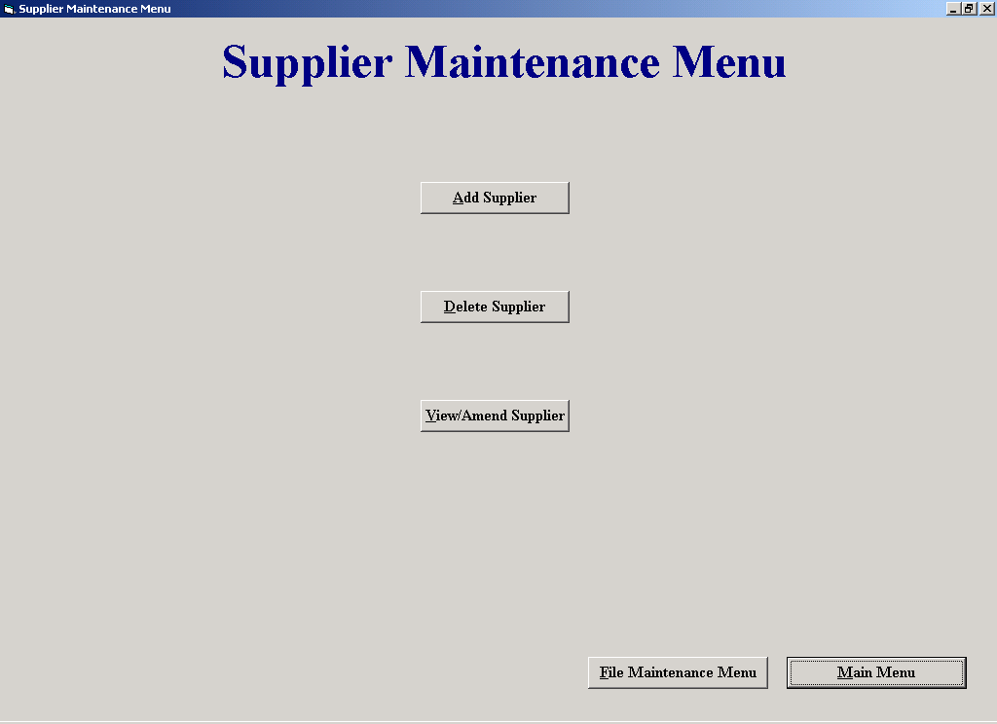

Code:
'The purpose of this screen is to allow the user to access the Add, Amend/View and Delete supplier screens.

'Author Fergal Purcell
'Date 06/03/2002

Option Explicit

Private Sub cmdAdd_Click()
frmAddaSupplier.Show
Unload Me
End Sub

Private Sub cmdDel_Click()
frmDeleteaSupplier.Show 'Display the delete a supplier screen
Unload Me
End Sub

Private Sub cmdFileMaintenance_Click()
frmFileMaintenanceMenu.Show
Unload Me
End Sub

Private Sub cmdMM_Click()
frmMainMenu.Show
Unload Me
End Sub

Private Sub cmdViewAmend_Click()
frmAmendViewaSupplier.Show
Unload Me
End Sub

Property Settings

Student Name: Fergal Purcell
Form Name: frmSupplierMaintenanceMenu
Form Purpose: Allows the user access screens that Add, Amend/View and Delete suppliers

Object | Property | Setting
None

Staff Maintenance Menu

Screen Shot:

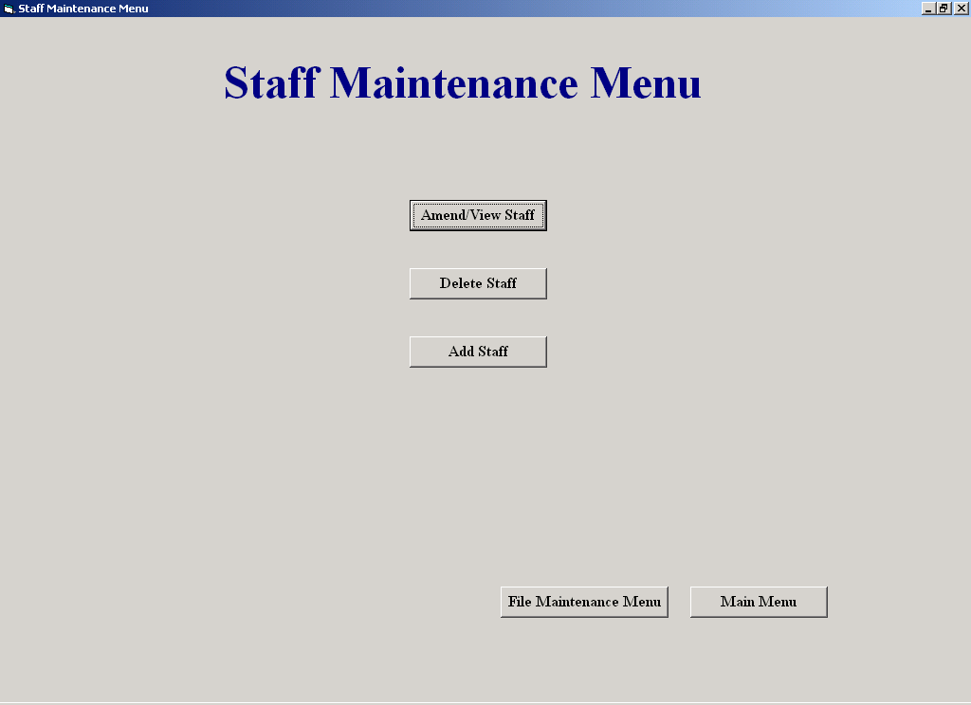

Code:

Allows the user access to staff processing screens such as, Delete a Staff Member and
Amend/View Staff.

Author: Sean O'Brien
Date: 20-03-2002

Variables Used -
None

Objects Used -
None

Option Explicit

Private Sub cmdBack_Click()
(Unloads this screen and shows the File Maintenance Menu)
frmFileMaintenanceMenu.Show
Unload Me
End Sub
Private Sub cmdDelStaff_Click()
(Unloads this screen and shows the Delete Staff screen)
frmDelStaff.Show
Unload Me
End Sub

Private Sub cmdMainMenu_Click()
(Unloads this screen and shows the Main Menu)
frmMainMenu.Show
Unload Me
End Sub

Private Sub cmdViewStaff_Click()
(Unloads this screen and shows the Amend/View Staff screen)
frmAmendViewStaff.Show
Unload Me
End Sub

Clock In Staff

Screen Shot:

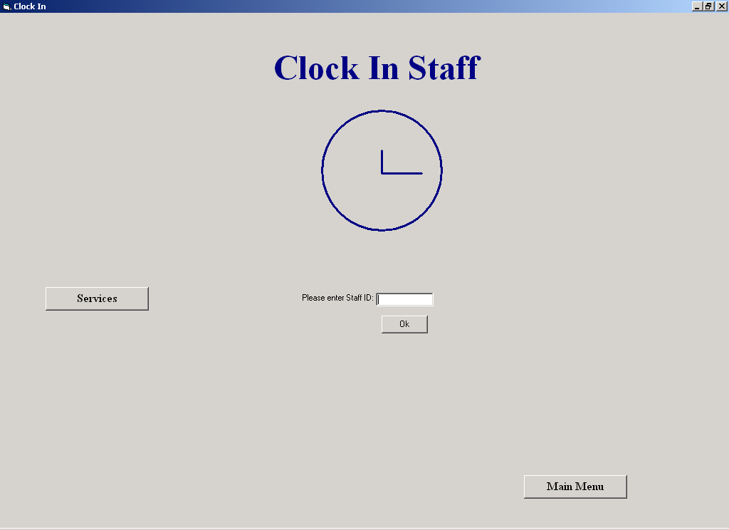

Code:

This screen allows the user to clock in or out, it also allows access to other services such as
Calculating Hours Worked and Clock In Times for the day.
The user enters his or her employee ID and clicks "OK"

Author: Sean O'Brien
Date: 20-03-2002

Variables Used -
TheLastId : Integer (Holds the last primary Clock-In ID in the Clock-In table)
ID : Integer (holds the employee id)
strSQL : String (Holds SQL statements)
Counter : Integer (Control variable in a loop)
CountUp : Integer (indicates whether the value entered was numeric)

Objects Used -
datTime : Data Control (Used to access the Employee and Clock-In tables in the database)
datCount : Data Control (Used to access the Clock-In table in the database)

Option Explicit

Private Sub cmdMainMenu_Click()
(Unloads this screen and shows the Main Menu)
frmMainMenu.Show
Unload Me
End Sub

Private Sub cmdOk_Click()
(Finds out whether the employee wants to clock in or out and then clocks the employee in or out)
Dim TheLastId, ID As Integer
Dim strSQL As String
ID = Val(txtEmpId.Text)
strSQL = "Select * From Employee " & _
"Where Deletion = False " & _
"And Employee_ID = " & ID & ""
datTime.RecordSource = strSQL
datTime.Refresh
If (datTime.Recordset.RecordCount > 0) Then
datTime.RecordSource = "Clock-In"
datTime.Refresh
If datCount.Recordset.RecordCount = 0 Then
TheLastId = -1
Else
datCount.Recordset.MoveLast
TheLastId = datCount.Recordset("ClockIn_ID")
End If
datCount.RecordSource = "SELECT Count(*) AS TheCount From [Clock-In] Where Employee_ID = " & ID & ""
datCount.Refresh
If datCount.Recordset.Fields("TheCount") > 0 Then
datTime.RecordSource = "SELECT * From [Clock-In] Where Employee_ID = " & ID & ""
datTime.Refresh
datTime.Recordset.FindFirst ("[Time Out] Is Null")
If datTime.Recordset.NoMatch Then
PutInTable (TheLastId)
Else
datTime.Recordset.Edit
datTime.Recordset("Time Out") = FormatDateTime(Now, vbShortTime)
datTime.Recordset.Update
datCount.RecordSource = "Clock-In"
datCount.Refresh
End If
Else
PutInTable (TheLastId)
End If
Else
MsgBox "This is not a valid id, please try again", vbExclamation
End If
txtEmpId.SetFocus
End Sub

Private Sub cmdServices_Click()
(Hides this screen and shows the "Services" screen)
frmClockIn.Hide
frmServices.Show
End Sub

Private Sub Form_Activate()
(Puts the focus in the textbox "txtEmpId")
txtEmpId.SetFocus
End Sub

Private Sub Form_Load()
(Sets the data control, "datCount" to access the details of the Clock-In table in the database)
(Sets the data control, "datTime" to access the details of the Clock-In table in the database)
datCount.DatabaseName = strThePath
datCount.RecordSource = "Clock-In"
datCount.Refresh
datTime.DatabaseName = strThePath
datTime.RecordSource = "Clock-In"
datTime.Refresh
End Sub

Public Sub PutInTable(LastId As Integer)
(Enter the details into the Database)
datTime.Recordset.AddNew
datTime.Recordset("Employee_ID") = txtEmpId.Text
datTime.Recordset("Time In") = FormatDateTime(Now, vbShortTime)
datTime.Recordset("Time Out") = Null
datTime.Recordset("Date") = FormatDateTime(Now, vbShortDate)
datTime.Recordset("ClockIn_ID") = LastId + 1
datTime.Recordset.Update
txtEmpId.SetFocus
End Sub

Private Sub txtEmpId_GotFocus()
(makes the screen ready for another clock in)
txtEmpId.Text = ""
cmdOk.Enabled = True
datCount.RecordSource = "Clock-In"
datCount.Refresh
End Sub
Private Sub txtEmpId_Validate(Cancel As Boolean)
(ensures the user enters a valid ID)
Dim counter, CountUp As Integer
If Len(txtEmpId.Text) = 0 Then
Cancel = True
If MsgBox("Please enter employee number", vbOKOnly, "Warning") = vbOK Then
txtEmpId.SetFocus
End If
Else
For counter = 1 To Len(txtEmpId.Text)
If IsNumeric(Mid(txtEmpId, counter, 1)) Then
CountUp = CountUp + 1
End If
Next
If Not (CountUp = Len(txtEmpId.Text)) Then
Cancel = True
Call MsgBox("Supplier ID must be numeric", vbOKOnly, "Warning")
txtEmpId.Text = ""
Else
Cancel = False
End If
End If
End Sub

Services

Screen Shot:

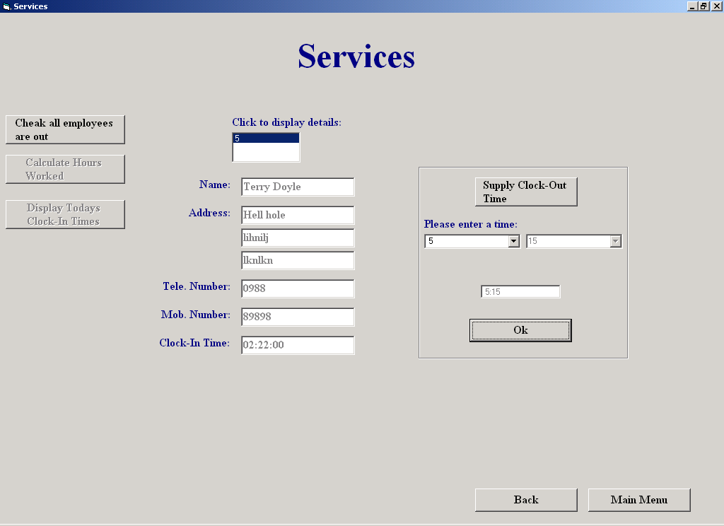

Code:

This screen allows the user to check that all employees are clocked out. Once all employees are clocked out,
the user can then calculate the hours worked for the week for each employee. The user can also get a
listing of clock in times for the day, the system automatically marks those employees
who arrived late and those who left early.

The user must first find out if all employees have clocked out. A listing of those
who haven't clocked out, is displayed. The user clicks on their ID number to view
their details and then has the option of supplying a clock out time for them. To do
this, the user must first choose the hours and then the minutes from two Comboboxes
and then click "OK".
Once all employees are clocked out, hours worked for the week can be calculated by
clicking "Calculate Hours Worked", and also see a list of clock in times for the day
can be displayed by clicking "Display Today’s Clock-In Times"

Author: Sean O'Brien
Date: 20-03-2002

Variables Used -
InTime : String (Holds the last time the employee clocked in)
EnteredTime : String (Holds the clock out time for the employee)
Counter : Integer (Control Variable in a loop)
TheId : Integer (holds the employee's id)
TheDiff : Integer (holds the hours worked for each employee)
Diff : Currency(Holds the total amount of minutes worked for the week for each employee)
strSQL : String (Holds SQL statements)
TheFirstHour : String (Holds the Clock In time)
TheSecHour : String (Holds the Clock Out time)
AllTheId : String (Holds the Id's of all the employees that clocked in today)
Status : String (Indicates whether an employee arrived late)
Left : String (Indicates whether an employee left early)
Temp : String (Stores the variable "Left" temporarily)
TheArray : Variant (An array which holds the Id's from all the employees that clocked in today)
TheDate : Date (Holds today’s date)
ClockID : Integer (Holds the primary Id,"ClockIn_ID" in the Clock-In table)
index : Integer (control variable in a loop)

Objects Used -
datTime : Data Control (Used to access the Clock-In table in the database)
datCount : Data Control (Used to access the Employee and Clock-In tables in the database)

Dim EnteredTime, InTime As String
Option Explicit

Private Sub cmdClockIn_Click()
(Unloads this screen and shows the clock-in screen)
Unload Me
frmClockIn.Show
End Sub

Private Sub cmdMainMenu_Click()
(Unloads this screen and shows the Main Menu)
frmMainMenu.Show
Unload Me
End Sub

Private Sub cmdSupplyTime_Click()
(initializes the "cmbHours" combobox)
Dim counter As Integer
counter = InTime
cmbHours.Enabled = True
While counter <= 23
cmbHours.AddItem (Str(counter))
counter = counter + 1
Wend
cmbHours.AddItem ("00")
lblTime.Enabled = True
End Sub

Private Sub Form_Load()
(Sets both data controls to access the Clock-In table in the database)
datCount.DatabaseName = strThePath
datCount.RecordSource = "Clock-In"
datCount.Refresh
datTime.DatabaseName = strThePath
datTime.RecordSource = "Clock-In"
datTime.Refresh
End Sub

Private Sub lstStaff_Click()
(Finds an employee with a particular ID and then calls a procedure which displays his or her details)
Dim TheId As Integer
datTime.RecordSource = "Clock-In"
datTime.Refresh
TheId = lstStaff.ItemData(lstStaff.ListIndex)
datTime.Recordset.FindLast "Employee_ID = " & TheId & ""
txtClockInTime.Text = datTime.Recordset("Time In")
InTime = Val(datTime.Recordset("Time In"))
TheId = lstStaff.ItemData(lstStaff.ListIndex)
datTime.RecordSource = "Employee"
datTime.Refresh
datTime.Recordset.FindFirst "Employee_ID = " & TheId & ""
Call DisplayDetails
End Sub

Private Sub cmdOk_Click()
(Enters the clock out time for the employee, resets the screen)
txtTheTime.Text = EnteredTime
Dim TheId As Integer
If IsDate(EnteredTime) Then
TheId = lstStaff.ItemData(lstStaff.ListIndex)
datCount.Recordset.FindFirst "Employee_ID = " & TheId & ""
datCount.Recordset.Edit
datCount.Recordset("Time Out") = EnteredTime
datCount.Recordset.Update
cmdOk.Enabled = False
cmdSupplyTime.Enabled = False
cmbHours.Text = "Please choose Hour"
cmbHours.Enabled = False
cmbMinutes.Text = "Please choose minute"
cmbMinutes.Enabled = False
lblTime.Enabled = False
EnteredTime = 0
txtTheTime.Text = ""
lstStaff.RemoveItem (lstStaff.ListIndex)
txtEmpName.Text = ""
txtAddress1.Text = ""
txtAddress2.Text = ""
txtAddress3.Text = ""
txtTelNum.Text = ""
txtMobNum.Text = ""
txtClockInTime.Text = ""
If lstStaff.ListCount = 0 Then
lstStaff.Visible = False
lblDisplay.Visible = False
cmdDisplayTimes.Enabled = True
cmdGetDiff.Enabled = True
End If
Reset1
Else
MsgBox "Please enter a valid time in the format hh:mm", vbExclamation
cmbHours.SetFocus
End If
End Sub

Private Sub cmdGetDiff_Click()
(Calculates the hours worked for each employee and displays it on the screen)
Dim TheId, TheDiff As Integer
Dim Diff As Currency
Dim strSQL, TheFirstHour, TheSecHour As String
datCount.RecordSource = "Employee"
datCount.Refresh
datTime.RecordSource = "Clock-In"
datTime.Refresh
lblHours.Visible = True
lstDisplay.Visible = True
lstDisplay.Clear
lstDisplay.AddItem ("Employee ID" & Chr(9) & "Employee Name" & Chr(9) & "Hours Worked")
While Not datCount.Recordset.EOF
TheId = datCount.Recordset("Employee_ID")
strSQL = "Select * From [Clock-In] where Employee_ID = " & TheId & ""
datTime.RecordSource = strSQL
datTime.Refresh
Diff = 0
While Not datTime.Recordset.EOF
TheFirstHour = datTime.Recordset("Time In")
TheSecHour = datTime.Recordset("Time Out")
Diff = Diff + DateDiff("n", TheFirstHour, TheSecHour) 'gets the total amount of minutes worked for the week
datTime.Recordset.MoveNext
Wend
TheDiff = Round(Diff / 60) 'gets the hours worked for the week
datCount.Recordset.Edit
datCount.Recordset("HoursWorked") = TheDiff
datCount.Recordset.Update
lstDisplay.AddItem (datCount.Recordset("Employee_ID") & Chr(9) & Chr(9) & datCount.Recordset("Employee Name") & Chr(9) & Chr(9) & datCount.Recordset("HoursWorked"))
datCount.Recordset.MoveNext
Wend
lstDisplay.Visible = True
End Sub

Private Sub cmdDisplayTimes_Click()
(Displays the clock in times for today)
Dim strSQL, AllTheId, Status, Left, Temp As String
Dim TheArray
Dim TheDate As Date
Dim TheId, ClockID, index As Integer
AllTheId = ""
cmdDisplayTimes.Tag = "0"
TheDate = FormatDateTime(Now, vbShortDate)
strSQL = "SELECT [Clock-In].[ClockIn_ID], [Clock-In].[Employee_ID], [Employee].[Employee Name], [Clock-In].[Time In]," & _
"[Clock-In].[Time Out], [Clock-In].[Date]" & _
"FROM [Clock-In] INNER JOIN Employee ON [Clock-In].[Employee_ID]=[Employee].[Employee_ID]" & _
"Where ((([Clock-In].[Date]) = #" & TheDate & "#" & "))" & _
"ORDER BY [Clock-In].[ClockIn_ID],[Clock-In].[Employee_ID];" 'gets everyone that clocked in today
datTime.RecordSource = strSQL
datTime.Refresh
While Not datTime.Recordset.EOF
If InStr(AllTheId, Str(datTime.Recordset("Employee_ID"))) = False Then
AllTheId = AllTheId + Str(datTime.Recordset("Employee_ID")) + "," 'gets the ID of each employee that clocked in today
cmdDisplayTimes.Tag = Str(Val(cmdDisplayTimes.Tag) + 1) 'stores the number of employees that clocked in today
End If
datTime.Recordset.MoveNext
Wend
datTime.Refresh
TheArray = Split(AllTheId, ",")
index = 0
datCount.RecordSource = strSQL
datCount.Refresh
If datCount.Recordset.RecordCount = 0 Then
Call MsgBox("No employees have clocked in today", vbOKOnly, "No Clock-Ins")
Else
lblTimes.Visible = True
lstDisplayTimes.Visible = True
lstDisplayTimes.Clear
lstDisplayTimes.AddItem ("Employee ID" & Chr(9) & "Employee Name" & Chr(9) & Chr(9) & "Clock In" & Chr(9) & Chr(9) & "Time Out" & Chr(9) & Chr(9) & "Arrived" & Chr(9) & Chr(9) & "Left")
While index < Val(cmdDisplayTimes.Tag)
TheId = TheArray(index)
datCount.Recordset.FindFirst "Employee_ID = " & TheId & ""
datTime.RecordSource = "Select Count(*) as Counter From [Clock-In]" & _
" Where [Employee_ID] = " & TheId & "" & _
" And Date = #" & TheDate & "#"
datTime.Refresh
ClockID = datCount.Recordset("ClockIn_ID")
If (Val(datCount.Recordset("Time In")) >= Val("10:00")) Then
Status = "Late"
Else
Status = "On Time"
End If
Left = ""
datCount.Recordset.FindLast "Employee_ID = " & TheId & ""
If (Val(datCount.Recordset("Time Out")) <= Val("15:30")) Then
Left = "Early"
Else
Left = "On Time"
End If
If datTime.Recordset("Counter") = 1 Then
lstDisplayTimes.AddItem (datCount.Recordset("Employee_ID") & Chr(9) & Chr(9) & datCount.Recordset("Employee Name") & Chr(9) & Chr(9) & datCount.Recordset("Time In") & Chr(9) & Chr(9) & datCount.Recordset("Time Out") & Chr(9) & Chr(9) & Status & Chr(9) & Chr(9) & Left)
Else
datCount.Recordset.FindFirst "Employee_ID = " & TheId & ""
Temp = Left
Left = ""
lstDisplayTimes.AddItem (datCount.Recordset("Employee_ID") & Chr(9) & Chr(9) & datCount.Recordset("Employee Name") & Chr(9) & Chr(9) & datCount.Recordset("Time In") & Chr(9) & Chr(9) & datCount.Recordset("Time Out") & Chr(9) & Chr(9) & Status & Chr(9) & Chr(9) & Left)
datCount.Recordset.FindLast "Employee_ID = " & TheId & ""
Left = Temp
Status = ""
lstDisplayTimes.AddItem (datCount.Recordset("Employee_ID") & Chr(9) & Chr(9) & datCount.Recordset("Employee Name") & Chr(9) & Chr(9) & datCount.Recordset("Time In") & Chr(9) & Chr(9) & datCount.Recordset("Time Out") & Chr(9) & Chr(9) & Status & Chr(9) & Chr(9) & Left)
End If
index = index + 1
datCount.Refresh
Wend
End If
End Sub

Private Sub cmdCheck_Click()
(Checks to see has all employees clocked out)
lstStaff.Clear
datCount.RecordSource = "Select * From [Clock-In] Where [Time Out] Is Null"
datCount.Refresh
If datCount.Recordset.RecordCount = 0 Then
txtEmpName.Text = ""
txtAddress1.Text = ""
txtAddress2.Text = ""
txtAddress3.Text = ""
txtTelNum.Text = ""
txtMobNum.Text = ""
Call MsgBox("There are no employees clocked in", vbOKOnly, "Warning")
cmdGetDiff.Enabled = True
cmdDisplayTimes.Enabled = True
Else
lblDisplay.Visible = True
lstStaff.Visible = True
datCount.Recordset.MoveFirst
While Not datCount.Recordset.EOF
lstStaff.AddItem (datCount.Recordset("Employee_ID"))
lstStaff.ItemData(lstStaff.NewIndex) = datCount.Recordset("Employee_ID")
datCount.Recordset.MoveNext
Wend
End If
End Sub

Public Sub DisplayDetails()
(Displays an employee's details)
txtEmpName.Text = datTime.Recordset("Employee Name")
txtAddress1.Text = datTime.Recordset("Address 1")
txtAddress2.Text = datTime.Recordset("Address 2")
txtAddress3.Text = datTime.Recordset("Address 3")
txtTelNum.Text = datTime.Recordset("Phone No")
txtMobNum.Text = datTime.Recordset("Mobile No")
txtEmpName.Visible = True
txtAddress1.Visible = True
txtAddress2.Visible = True
txtAddress3.Visible = True
txtTelNum.Visible = True
txtMobNum.Visible = True
txtClockInTime.Visible = True
cmdSupplyTime.Enabled = True
lblName.Visible = True
lblAdd.Visible = True
lblTelNum.Visible = True
lblMobNum.Visible = True
lblClock.Visible = True
frSupply.Visible = True
End Sub

Private Sub cmbHours_Click()
(Gets the Hours field of the clock out time)
txtTheTime.Text = ""
EnteredTime = cmbHours.Text
If cmbHours.Text = "00" Then
txtTheTime.Text = "00:00"
cmdOk.Enabled = True
EnteredTime = "00:00"
Else
cmbMinutes.Enabled = True
End If
End Sub

Private Sub cmbMinutes_Click()
(Gets the Minutes field of the clock out time)
EnteredTime = EnteredTime + ":" + cmbMinutes.Text
txtTheTime.Text = EnteredTime
cmdOk.Enabled = True
cmbMinutes.Enabled = False
End Sub

Private Sub Reset1()
(Resets the screen)
txtEmpName.Visible = False
txtAddress1.Visible = False
txtAddress2.Visible = False
txtAddress3.Visible = False
txtTelNum.Visible = False
txtMobNum.Visible = False
txtClockInTime.Visible = False
lblName.Visible = False
lblAdd.Visible = False
lblTelNum.Visible = False
lblMobNum.Visible = False
lblClock.Visible = False
frSupply.Visible = False
End Sub

Add Supplier

Screen Shot:

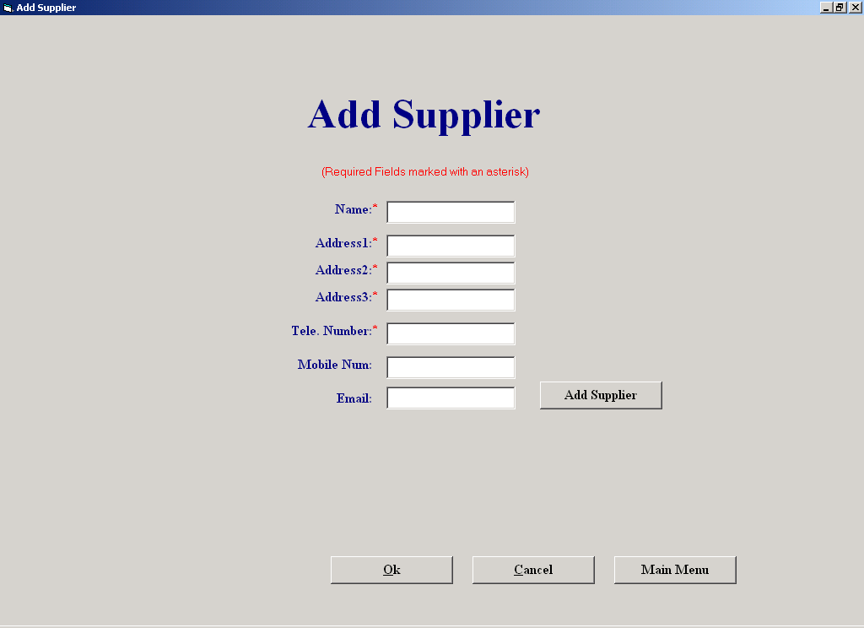

Code:

The purpose of this screen is to allow the user to enter the details of a new supplier.
The user enters the details of the supplier in the relevant textboxes and then clicks
"Add Supplier".
If the user clicks "Cancel", any suppliers that were entered since this screen was last
invoked, are completely deleted from the system.

Author: Sean O'Brien
Date: 20-03-2002

Variables Used -
MyString : String (Holds the telephone number of a supplier)
TheLastId : String (Holds the primary ID of the last record in the current Supplier table)
Counter : Integer (Control variable of a loop)
Answer : Boolean (indicates whether the user wishes to save the details he has just entered)
CountUp : Integer (indicates how many characters in a string are numeric)
Objects Used -
datAddSupplier : Data Control (Used to access the supplier table in the database)

Option Explicit

Private Sub cmdAddSupplier_Click()
(This procedure adds a supplier to the database if the supplier doesn't already exists)
If (Len(txtSuppName.Text) > 0) And (Len(txtAdd1.Text) > 0) And (Len(txtAdd2.Text) > 0) And (Len(txtAdd3.Text) > 0) And (Len(txtTelNum.Text) > 0) Then
Dim MyString, TheLastId As String
datAddSupplier.RecordSource = "Select * From Supplier Order By Supplier_ID"
datAddSupplier.Refresh
datAddSupplier.Recordset.MoveLast
TheLastId = datAddSupplier.Recordset("Supplier_ID")
datAddSupplier.RecordSource = "Select * from Supplier where [Deletion] = False Order By Supplier_ID"
datAddSupplier.Refresh
MyString = txtTelNum.Text
datAddSupplier.Recordset.FindFirst "[Phone No] = '" & MyString & "'"
If datAddSupplier.Recordset.NoMatch Then
datAddSupplier.Recordset.AddNew
datAddSupplier.Recordset("Supplier_ID") = TheLastId + 1
datAddSupplier.Recordset("Supplier Name") = txtSuppName.Text
datAddSupplier.Recordset("Address 1") = txtAdd1.Text
datAddSupplier.Recordset("Address 2") = txtAdd2.Text
datAddSupplier.Recordset("Address 3") = txtAdd3.Text
datAddSupplier.Recordset("Phone No") = txtTelNum.Text
datAddSupplier.Recordset("Mobile No") = txtMobNum.Text
datAddSupplier.Recordset("E-mail") = txtEmail.Text
datAddSupplier.Recordset.Update
cmdNoSave.Tag = Str(Val(cmdNoSave.Tag) + 1)
frmPopUp.Visible = True
cmdNoSave.Enabled = True
Else
Call MsgBox("This supplier already exists in the database, details will not be stored", "Warning")
Reset
End If
Else
frmInCorrect.Visible = True
End If
End Sub

Private Sub cmdBack_Click()
(exits the screen and shows the Supplier Maintenance Menu)
frmSupplierMaintenanceMenu.Show
Unload Me
End Sub

Private Sub cmdNoSave_Click()
(Deletes any suppliers that were entered since the screen was last invoked)
Dim counter As Integer
Dim Answer As Integer
If cmdNoSave.Tag > 0 Then
Answer = MsgBox("Are you sure you want to delete all suppliers you have just entered?", vbYesNo, "Warning")
If Answer = vbYes Then
counter = 0
datAddSupplier.RecordSource = "Select * from Supplier Order By Supplier_ID"
datAddSupplier.Refresh
datAddSupplier.Recordset.MoveLast
While counter < Val(cmdNoSave.Tag)
datAddSupplier.Recordset.Delete
counter = counter + 1
datAddSupplier.Recordset.MovePrevious
Wend
End If
End If
frmSupplierMaintenanceMenu.Show
Unload Me
End Sub

Private Sub cmdExit_Click()
(exits the screen and shows the Main Menu)
frmMainMenu.Show
Unload Me
End Sub

Private Sub Form_Load()
(sets the data control to access the supplier table in the database)
datAddSupplier.DatabaseName = strThePath
datAddSupplier.RecordSource = "Select * From Supplier Order By Supplier_ID"
datAddSupplier.Refresh
cmdNoSave.Tag = "0"
End Sub

Private Sub txtAdd1_Validate(Cancel As Boolean)
(makes sure there was data entered in the textbox, "txtAdd1")
If Len(txtAdd1.Text) = 0 Then
Cancel = True
If MsgBox("Please enter address 1", vbOKOnly, "Warning") = vbOK Then
txtAdd1.SetFocus
End If
Else
Cancel = False
End If
End Sub

Private Sub txtAdd2_Validate(Cancel As Boolean)
(makes sure there was data entered in the textbox, "txtAdd2")
If Len(txtAdd2.Text) = 0 Then
Cancel = True
If MsgBox("Please enter address 2", vbOKOnly, "Warning") = vbOK Then
txtAdd2.SetFocus
End If
Else
Cancel = False
End If
End Sub

Private Sub txtAdd3_Validate(Cancel As Boolean)
(makes sure there was data entered in the textbox, "txtAdd3")
If Len(txtAdd3.Text) = 0 Then
Cancel = True
If MsgBox("Please enter address 3", vbOKOnly, "Warning") = vbOK Then
txtAdd3.SetFocus
End If
Else
Cancel = False
End If
End Sub

Private Sub txtSuppName_Validate(Cancel As Boolean)
(makes sure there was data entered in the textbox, "txtSuppName")
If Len(txtSuppName.Text) = 0 Then
Cancel = True
If MsgBox("Please enter supplier's name", vbOKOnly, "Warning") = vbOK Then
txtSuppName.SetFocus
End If
Else
Cancel = False
End If
End Sub

Public Sub Reset()
(Resets all the forms textboxes to nothing)
txtSuppName.Text = ""
txtAdd1.Text = ""
txtAdd2.Text = ""
txtAdd3.Text = ""
txtTelNum.Text = ""
txtMobNum.Text = ""
txtEmail.Text = ""
End Sub

Private Sub txtTelNum_Validate(Cancel As Boolean)
(Ensures the user enters valid data into this textbox)
Dim counter, CountUp As Integer
CountUp = 0
If Len(txtTelNum.Text) = 0 Then
Cancel = True
MsgBox "Please enter Telephone Number", vbOKOnly, "Warning"
txtTelNum.SetFocus
Else
For counter = 1 To Len(txtTelNum.Text)
If IsNumeric(Mid(txtTelNum, counter, 1)) Then
CountUp = CountUp + 1
End If
Next
If (CountUp = (Len(txtTelNum.Text) - 1)) Or (CountUp = Len(txtTelNum.Text)) Then
Cancel = False
Else
Cancel = True
Call MsgBox("This is not a valid phone number", vbOKOnly, "Warning")
txtTelNum.SetFocus
End If
Cancel = False
End If
End Sub

Private Sub txtMobNum_Validate(Cancel As Boolean)
(Ensures the user enters valid data into this textbox)
Dim counter, CountUp As Integer
CountUp = 0
If (Len(txtMobNum.Text) > 0) Then
For counter = 1 To Len(txtMobNum.Text)
If IsNumeric(Mid(txtMobNum, counter, 1)) Then
CountUp = CountUp + 1
End If
Next
If (CountUp = (Len(txtMobNum.Text) - 1)) Or (CountUp = Len(txtMobNum.Text)) Then
Cancel = False
Else
Cancel = True
Call MsgBox("This is not a valid mobile number", vbOKOnly, "Warning")
txtMobNum.SetFocus
End If
Cancel = False
End If
End Sub

Amend/View Supplier

Screen Shot:

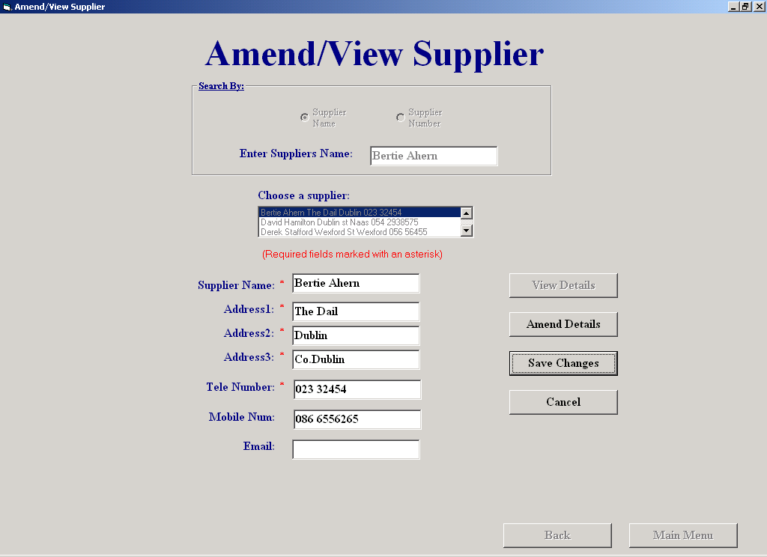

Code:

This screen will allows the user amend or simply view an existing supplier's details
The user enters the supplier's id, name or browses to select a supplier.
When found, the rest of the supplier's details are displayed in view mode. The user can then click
the "Amend" button and amend the details. After clicking "Save Changes", and after confirming to save,
'the changes will be saved. If the user clicks "Cancel", all amendments are cancelled and the previous details
are restored

Author: Sean O'Brien
Date: 20-03-2002

Variables Used -
MyArray : Variant (An array which holds the previous details of the supplier
MyString : String (holds all the previous details)
strSQL : String (holds an SQL statement)
MyString : String (Stores the supplier name)
Answer : Boolean (indicates whether to save amendments)
TheId : Integer (Holds a supplier id)
counter : Integer (Control variable in a loop)
CountUp : Integer (indicates whether the value in a textbox is numeric or not)

Objects used -
TheControl : Data Control (Used to access the supplier table in the database)

Option Explicit

Private Sub cmdAmend_Click()
(Sets the screen to amend mode, saves previous details)
cmdAmend.Tag = TheControl.Recordset("Supplier Name") + "," + _
TheControl.Recordset("Address 1") + "," + TheControl.Recordset("Address 2") + "," + _
TheControl.Recordset("Address 3") + "," + TheControl.Recordset("Phone No") + "," + _
TheControl.Recordset("Mobile No") + "," + TheControl.Recordset("E-mail")
txtSuppName.Enabled = False
optNumber.Enabled = False
optName.Enabled = False
lstSupplier.Enabled = False
cmdSave.Visible = True
Cmdcancel.Visible = True
lblAsterisk.Visible = True
lblAst1.Visible = True
lblAst2.Visible = True
lblAst3.Visible = True
lblAst4.Visible = True
lblAst5.Visible = True
txtSuppNameAm.Text = TheControl.Recordset("Supplier Name")
txtSuppNameAm.Enabled = True
txtAdd1.Enabled = True
txtAdd2.Enabled = True
txtAdd3.Enabled = True
txtTelNum.Enabled = True
txtMobNum.Enabled = True
txtEmail.Enabled = True
cmdBack.Enabled = False
cmdMainMenu.Enabled = False
cmdDisplay.Enabled = False
End Sub

Private Sub DisplayDetails()
(Displays supplier details)
txtSuppNameAm.Text = TheControl.Recordset("Supplier Name")
txtAdd1.Text = TheControl.Recordset("Address 1")
txtAdd2.Text = TheControl.Recordset("Address 2")
txtAdd3.Text = TheControl.Recordset("Address 3")
txtTelNum.Text = TheControl.Recordset("Phone No")
txtMobNum.Text = TheControl.Recordset("Mobile No")
txtEmail.Text = TheControl.Recordset("E-mail")
If optNumber.Value = True Then
txtSuppName.Text = Str(TheControl.Recordset("Supplier_ID"))
Else
txtSuppName.Text = TheControl.Recordset("Supplier Name")
End If
cmdAmend.Enabled = True
End Sub

Private Sub Reset1()
(Resets the screen to view mode)
txtSuppName.Visible = True
lblNamesupp.Visible = True
optNumber.Enabled = True
optName.Enabled = True
lstSupplier.Enabled = True
txtSuppName.Enabled = True
cmdSave.Visible = False
Cmdcancel.Visible = False
cmdBack.Enabled = True
cmdMainMenu.Enabled = True
lblAsterisk.Visible = False
lblAst1.Visible = False
lblAst2.Visible = False
lblAst3.Visible = False
lblAst4.Visible = False
lblAst5.Visible = False
txtAdd1.Enabled = False
txtAdd2.Enabled = False
txtAdd3.Enabled = False
txtSuppNameAm.Enabled = False
txtTelNum.Enabled = False
txtMobNum.Enabled = False
txtEmail.Enabled = False
If optName.Value = True Then
lblNamesupp.Visible = True
lblNumber.Visible = False
Else
lblNamesupp.Visible = False
lblNumber.Visible = True
End If
End Sub
Private Sub cmdBack_Click()
(Unloads this screen and shows the Supplier Maintenance Menu)
frmSupplierMaintenanceMenu.Show
Unload Me
End Sub

Private Sub cmdCancel_Click()
(Cancels any changes to the suppliers details and restores the original details)
Dim MyArray
Dim MyString As String
MyString = cmdAmend.Tag
MyArray = Split(MyString, ",")
txtSuppNameAm.Text = MyArray(0)
txtAdd1.Text = MyArray(1)
txtAdd2.Text = MyArray(2)
txtAdd3.Text = MyArray(3)
txtTelNum.Text = MyArray(4)
txtMobNum.Text = MyArray(5)
txtEmail.Text = MyArray(6)
Call Reset1
End Sub

Private Sub cmdDisplay_Click()
(Finds the first supplier which matches the criteria entered by the user, calls a procedure which displays the details)
Dim strSQL, MyString As String
MyString = txtSuppName.Text
If optName.Value = True Then
strSQL = "Select * From Supplier " & _
"Where Deletion = False " & _
"And [Supplier Name] Like '" & MyString & "'"
txtSuppName.Text = ""
Else
strSQL = "Select * From Supplier " & _
"Where Deletion = False " & _
"And Supplier_ID = " & MyString & ""
End If
TheControl.RecordSource = strSQL
TheControl.Refresh
If optName.Value = True Then
TheControl.Recordset.FindFirst "[Supplier Name] = '" & MyString & "'"
Else
TheControl.Recordset.FindFirst "[Supplier_ID] = " & MyString & ""
End If
If TheControl.Recordset.NoMatch Then
frmNotFound.Visible = True
Else
Call DisplayDetails
End If
End Sub

Private Sub cmdMainMenu_Click()
(Unloads this screen and shows the Main Menu)
frmMainMenu.Show
Unload Me
End Sub

Private Sub cmdSave_Click()
(Saves any amendments to the suppliers details)
Dim Answer As Integer
cmdSave.Tag = TheControl.Recordset("Supplier_ID")
If (Len(txtSuppNameAm.Text) > 0) And (Len(txtAdd1.Text) > 0) And (Len(txtAdd2.Text) > 0) And (Len(txtAdd3.Text) > 0) And (Len(txtTelNum.Text) > 0) Then
Answer = MsgBox("Are you sure?", vbYesNo + vbQuestion, "Warning")
If Answer = vbYes Then
TheControl.Recordset.Edit
TheControl.Recordset("Supplier Name") = txtSuppNameAm.Text
TheControl.Recordset("Address 1") = txtAdd1.Text
TheControl.Recordset("Address 2") = txtAdd2.Text
TheControl.Recordset("Address 3") = txtAdd3.Text
TheControl.Recordset("Phone No") = txtTelNum.Text
TheControl.Recordset("Mobile No") = txtMobNum.Text
TheControl.Recordset("E-mail") = txtEmail.Text
TheControl.Recordset.Update
Call MsgBox("The changes have been saved", , "Save Successful")
If optName.Value = True Then
txtSuppName.Text = TheControl.Recordset("Supplier Name")
Else
txtSuppName.Text = TheControl.Recordset("Supplier_ID")
End If
TheControl.RecordSource = "Select*from Supplier where [Deletion] = False"
TheControl.Refresh
lstSupplier.Clear
While Not TheControl.Recordset.EOF
lstSupplier.AddItem (TheControl.Recordset("Supplier Name") & " " & TheControl.Recordset("Address 1") & " " & TheControl.Recordset("Address 2") & " " & TheControl.Recordset("Phone No"))
lstSupplier.ItemData(lstSupplier.NewIndex) = TheControl.Recordset("Supplier_ID")
TheControl.Recordset.MoveNext
Wend
Call Reset1
End If
Else
Call MsgBox("One or more required fields left empty, details will not be stored", , "Warning")
End If
TheControl.Recordset.FindFirst "Supplier_ID = " & cmdSave.Tag & ""
End Sub

Private Sub Form_Activate()
(Displays every supplier and some of their details in a listbox)
txtSuppName.SetFocus
While Not TheControl.Recordset.EOF
lstSupplier.AddItem (TheControl.Recordset("Supplier Name") & " " & TheControl.Recordset("Address 1") & " " & TheControl.Recordset("Address 2") & " " & TheControl.Recordset("Phone No"))
lstSupplier.ItemData(lstSupplier.NewIndex) = TheControl.Recordset("Supplier_ID")
TheControl.Recordset.MoveNext
Wend
TheControl.Refresh
End Sub

Private Sub Form_Load()
(Sets the data control to access the details of the supplier table in the database)
TheControl.DatabaseName = strThePath
TheControl.RecordSource = "Select*from Supplier where [Deletion] = False"
TheControl.Refresh
End Sub

Private Sub lstSupplier_Click()
(Displays the details of whatever supplier that was chosen by the user from the listbox)
Dim TheId As Integer
TheId = lstSupplier.ItemData(lstSupplier.ListIndex)
TheControl.RecordSource = "Select*from Supplier where [Deletion] = False;"
TheControl.Refresh
TheControl.Recordset.FindFirst "Supplier_ID = " & TheId & ""
txtSuppNameAm.Visible = True
lblName.Visible = True
cmdDisplay.Enabled = False
txtSuppName.Text = ""
Call DisplayDetails
End Sub

Private Sub OptName_Click()
(Shows the label "lblNamesupp")
If optName.Value = True Then
lblNumber.Visible = False
lblNamesupp.Visible = True
txtSuppName.SetFocus
End If
End Sub

Private Sub optNumber_Click()
(Shows the label "lblNumber")
If optNumber.Value = True Then
lblNumber.Visible = True
lblNamesupp.Visible = False
txtSuppName.SetFocus
End If
End Sub

Private Sub txtAdd1_GotFocus()
(Highlights whatever text is in this textbox)
txtAdd1.SelStart = 0
txtAdd1.SelLength = Len(txtAdd1)
End Sub

Private Sub txtAdd2_GotFocus()
(Highlights whatever text is in this textbox)
txtAdd2.SelStart = 0
txtAdd2.SelLength = Len(txtAdd2)
End Sub

Private Sub txtAdd3_GotFocus()
(Highlights whatever text is in this textbox)
txtAdd3.SelStart = 0
txtAdd3.SelLength = Len(txtAdd3)
End Sub

Private Sub txtEmail_GotFocus()
(Highlights whatever text is in this textbox)
txtEmail.SelStart = 0
txtEmail.SelLength = Len(txtEmail)
End Sub

Private Sub txtMobNum_GotFocus()
(Highlights whatever text is in this textbox)
txtMobNum.SelStart = 0
txtMobNum.SelLength = Len(txtMobNum)
End Sub

Private Sub txtMobNum_Validate(Cancel As Boolean)
(Ensures the user enters valid data into this textbox)
Dim counter, CountUp As Integer
CountUp = 0
If (Len(txtMobNum.Text) > 0) Then
For counter = 1 To Len(txtMobNum.Text)
If IsNumeric(Mid(txtMobNum, counter, 1)) Then
CountUp = CountUp + 1
End If
Next
If (CountUp = (Len(txtMobNum.Text) - 1)) Or (CountUp = Len(txtMobNum.Text)) Then
Cancel = False
Else
Cancel = True
Call MsgBox("This is not a valid mobile number", vbOKOnly, "Warning")
txtMobNum.SetFocus
End If
Cancel = False
End If
End Sub

Private Sub txtSuppName_GotFocus()
(Empties all the supplier details out of the textboxes)
txtSuppNameAm.Text = ""
txtSuppName.Text = ""
txtAdd1.Text = ""
txtAdd2.Text = ""
txtAdd3.Text = ""
txtEmail.Text = ""
txtMobNum.Text = ""
txtTelNum.Text = ""
cmdAmend.Enabled = False
cmdDisplay.Enabled = True
End Sub

Private Sub txtSuppName_Validate(Cancel As Boolean)
(Makes sure that valid data is entered into this textbox)
Dim counter, CountUp As Integer
CountUp = 0
If Len(txtSuppName.Text) = 0 Then
Cancel = True
If optName.Value = True Then
Call MsgBox("Please enter supplier name", vbOKOnly, "Warning")
Else
Call MsgBox("Please enter supplier number", vbOKOnly, "Warning")
End If
txtSuppName.SetFocus
Else
If optNumber = True Then
For counter = 1 To Len(txtSuppName.Text)
If IsNumeric(Mid(txtSuppName, counter, 1)) Then
CountUp = CountUp + 1
End If
Next
If Not (CountUp = Len(txtSuppName.Text)) Then
Cancel = True
Call MsgBox("Supplier ID must be numeric", vbOKOnly, "Warning")
txtSuppName.Text = ""
Else
Cancel = False
End If
Else
Cancel = False
End If
End If
End Sub

Private Sub txtSuppNameAm_GotFocus()
(Highlights whatever text is in this textbox)
txtSuppNameAm.SelStart = 0
txtSuppNameAm.SelLength = Len(txtSuppNameAm)
End Sub

Private Sub txtTelNum_GotFocus()
(Highlights whatever text is in this textbox)
txtTelNum.SelStart = 0
txtTelNum.SelLength = Len(txtTelNum)
End Sub
Private Sub txtTelNum_Validate(Cancel As Boolean)
(Ensures the user enters valid data into this textbox)
Dim counter, CountUp As Integer
CountUp = 0
If Len(txtTelNum.Text) = 0 Then
Cancel = True
MsgBox "Please enter Telephone Number", vbOKOnly, "Warning"
txtTelNum.SetFocus
Else
For counter = 1 To Len(txtTelNum.Text)
If IsNumeric(Mid(txtTelNum, counter, 1)) Then
CountUp = CountUp + 1
End If
Next
If (CountUp = (Len(txtTelNum.Text) - 1)) Or (CountUp = Len(txtTelNum.Text)) Then
Cancel = False
Else
Cancel = True
Call MsgBox("This is not a valid phone number", vbOKOnly, "Warning")
txtTelNum.SetFocus
End If
Cancel = False
End If
End Sub

Delete a Staff Member

Screen Shot:

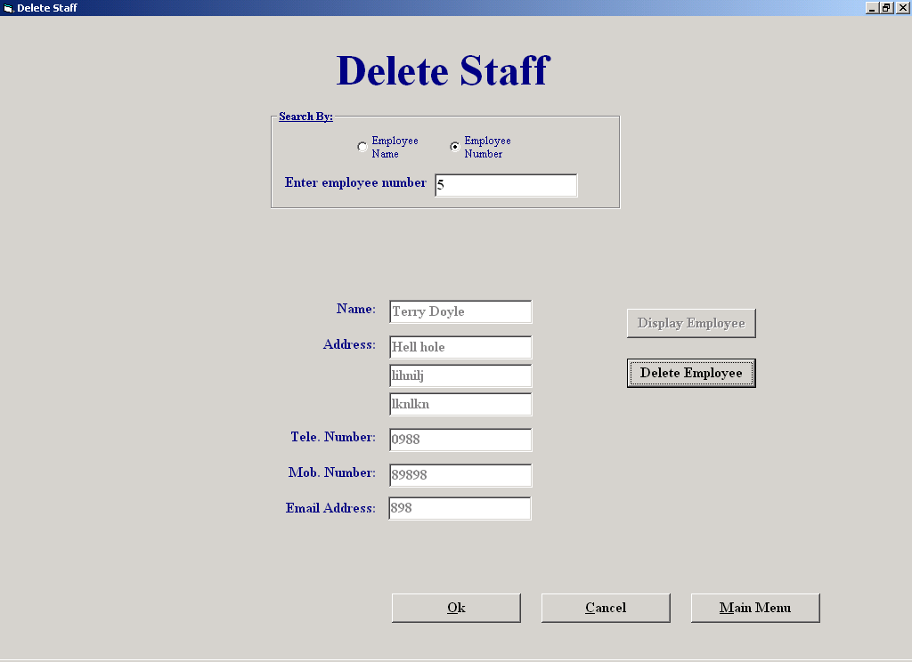

Code:

This screen allows the user to delete an existing staff member's details from the database
The user enters the staff member's ID or name, the system then searches the Staff table for that number or name. When found, the rest of the staff member's details are displayed. The user then has the option of deleting the record from the database by clicking the "Delete Employee" button, repeat the process for another staff member or exit the screen without saving any deletions by clicking the "Cancel" button.

Author: Sean O'Brien
Date: 20-03-2002

Variables Used -
Answer : Integer (indicates whether or not to delete the employee)
MyArray : Variant (An array which holds the ID's of the staff that was deleted)
MyString : String (holds all the id's of the staff that was deleted)
strSQL : String (holds an SQL statement)
Answer : Boolean (indicates whether to save deletions)
TheId : Integer (Holds an employee id)
index : Integer (a control variable in a loop)
MyString : String (holds all the name of the employee)
counter : Integer (Control variable in a loop)
CountUp : Integer (indicates whether the value in a textbox is numeric or not

Objects Used -
datCount : Data Control (Used to access the employee table in the database)
datStaff : Data Control (Used to access the employee table in the database)

Option Explicit

Private Sub cmdBack_Click()
(Unloads this form and shows the Staff Maintenance Menu)
frmStaffMenu.Show
Unload Me
End Sub

Public Sub DisplayDetails()
(Displays the employees details)
cmdDelEmp.Enabled = True
txtEmpName.Text = datStaff.Recordset("Employee Name")
txtAddress1.Text = datStaff.Recordset("Address 1")
txtAddress2.Text = datStaff.Recordset("Address 2")
txtAddress3.Text = datStaff.Recordset("Address 3")
txtTelNum.Text = datStaff.Recordset("Phone No")
txtMobNum.Text = datStaff.Recordset("Mobile No")
txtEmail.Text = datStaff.Recordset("E-mail")
cmdViewEmp.Enabled = False
End Sub

Private Sub Reset1()
(Resets the screen, empties the textboxes)
txtEmpName.Text = ""
txtAddress1.Text = ""
txtAddress2.Text = ""
txtAddress3.Text = ""
txtTelNum.Text = ""
txtMobNum.Text = ""
txtEnteredName.Text = ""
txtEmail.Text = ""
lstStaff.Visible = False
lblMoreThan1.Visible = False
End Sub

Private Sub cmdDelEmp_Click()
(Deletes the employee from the database (marks for deletion))
Dim Answer As Integer
Answer = MsgBox("Are you sure?", vbYesNo + vbQuestion, "Warning")
If Answer = vbYes Then
datStaff.Recordset.Edit
datStaff.Recordset("Deletion") = True
cmdDelEmp.Tag = cmdDelEmp.Tag + Str(datStaff.Recordset("Employee_ID")) + ","
frmDelStaff.Tag = Str(Val(frmDelStaff.Tag) + 1)
datStaff.Recordset.Update
Call MsgBox("The employee has been deleted", vbExclamation, "Deletion Sucessful")
txtEnteredName.SetFocus
End If
End Sub

Private Sub cmdMainMenu_Click()
(Unloads this form and shows the Main Menu)
frmMainMenu.Visible = True
Unload Me
End Sub

Private Sub cmdNoSave_Click()
(Cancels all deletions made by the user since the screen was accessed)
Dim TheArray
Dim MyString As String
Dim TheId, index, Answer As Integer
If Val(frmDelStaff.Tag) > 0 Then
Answer = MsgBox("Are you sure you want to cancel all deletions that you made?", vbYesNo + vbQuestion, "Warning")
If Answer = vbYes Then
MyString = cmdDelEmp.Tag
TheArray = Split(MyString, ",")
datStaff.RecordSource = "Employee"
datStaff.Refresh
index = 0
While index < Val(frmDelStaff.Tag)
TheId = TheArray(index)
datStaff.Recordset.FindFirst "Employee_ID = " & TheId & ""
datStaff.Recordset.Edit
datStaff.Recordset("Deletion") = False
datStaff.Recordset.Update
index = index + 1
Wend
Call MsgBox("The deletions that you made were not saved", vbOKOnly, "Deletions Cancelled")
Else
Call MsgBox("The changes that you made will be saved", vbOKOnly, "Deletions Saved")
End If
End If
frmStaffMenu.Show
Unload Me
End Sub

Private Sub cmdViewEmp_Click()
(Searches for the employee and when found, calls a procedure which displays the employees details)
Dim MyString, strSQL As String
MyString = txtEnteredName.Text
If optName.Value = True Then
strSQL = "Select * From Employee " & _
"Where Deletion = False " & _
"And [Employee Name] = '" & MyString & "'"
Else
strSQL = "Select * From Employee " & _
"Where Deletion = False " & _
"And Employee_ID = " & MyString & ""
End If
datStaff.DatabaseName = strThePath
datStaff.RecordSource = strSQL
datStaff.Refresh
datCount.RecordSource = "SELECT Count(*) AS TheCount From Employee Where Deletion = False And [Employee Name] = '" & MyString & "'"
datCount.Refresh
If datCount.Recordset.Fields("TheCount") > 1 Then
While Not datStaff.Recordset.EOF
lstStaff.AddItem (datStaff.Recordset("Employee Name") & " " & datStaff.Recordset("Address 1"))
lstStaff.ItemData(lstStaff.NewIndex) = datStaff.Recordset("Employee_ID")
datStaff.Recordset.MoveNext
Wend
lblMoreThan1.Visible = True
lstStaff.Visible = True
Else
If optName.Value = True Then
datStaff.Recordset.FindFirst "[Employee Name] = '" & MyString & "'"
Else
datStaff.Recordset.FindFirst "Employee_ID = " & MyString & ""
End If
If datStaff.Recordset.NoMatch Then
txtEnteredName.SetFocus
txtEnteredName.Text = ""
If optName.Value = True Then
Call MsgBox("Employee not found, please make sure you have the name spelled correctly and that the employee exists", vbOKOnly, "Search Failed")
Else
Call MsgBox("Employee not found, please make sure that the employee exists", vbOKOnly, "Search Failed")
End If
Else
Call DisplayDetails
End If
End If
datStaff.Refresh
End Sub

Private Sub Form_Activate()
(Puts focus in a textbox called "txtEnteredName")
txtEnteredName.SetFocus
End Sub

Private Sub Form_Load()
(Sets the data control to access the details of the employee table in the database)
datCount.DatabaseName = strThePath
datCount.RecordSource = "Employee"
datCount.Refresh
cmdDelEmp.Tag = ""
frmDelStaff.Tag = "0"
End Sub

Private Sub lstStaff_Click()
(Finds the employee and then calls a procedure to display its details)
Dim TheId As Integer
TheId = lstStaff.ItemData(lstStaff.ListIndex)
datStaff.Recordset.FindFirst "Employee_ID = " & TheId & ""
If optNumber.Value = True Then
txtEnteredName.Text = Str(TheId)
End If
Call DisplayDetails
End Sub

Private Sub OptName_Click()
If optName.Value = True Then
lblNumber.Visible = False
lblName.Visible = True
txtEnteredName.SetFocus
End If
End Sub

Private Sub optNumber_Click()
If optNumber.Value = True Then
lblNumber.Visible = True
lblName.Visible = False
txtEnteredName.SetFocus
End If
End Sub

Private Sub txtEnteredName_GotFocus()
cmdDelEmp.Enabled = False
cmdViewEmp.Enabled = True
Reset1
End Sub

Private Sub txtEnteredName_Validate(Cancel As Boolean)
(Ensures valid data is entered in this textbox)
Dim CountUp, counter As Integer
CountUp = 0
If Len(txtEnteredName.Text) = 0 Then
If optName.Value = True Then
Cancel = True
If MsgBox("Please enter employee name", vbOKOnly, "Warning") = vbOK Then
txtEnteredName.SetFocus
End If
Else
Cancel = True
If MsgBox("Please enter employee number", vbOKOnly, "Warning") = vbOK Then
txtEnteredName.SetFocus
End If
End If
Else
If optName.Value = True Then
If IsNumeric(txtEnteredName.Text) Then
Cancel = True
txtEnteredName.SetFocus
txtEnteredName.Text = ""
Call MsgBox("Please enter a valid name", vbOKOnly, "Warning")
Else
Cancel = False
End If
Else
For counter = 1 To Len(txtEnteredName.Text)
If IsNumeric(Mid(txtEnteredName, counter, 1)) Then
CountUp = CountUp + 1
End If
Next
If (CountUp = Len(txtEnteredName.Text)) Then
Cancel = False
Else
Cancel = True
Call MsgBox("Employee id must be numeric", vbOKOnly, "Warning")
txtEnteredName.SetFocus
txtEnteredName.Text = ""
End If
End If
End Sub

Customer Report

Screen Shot:

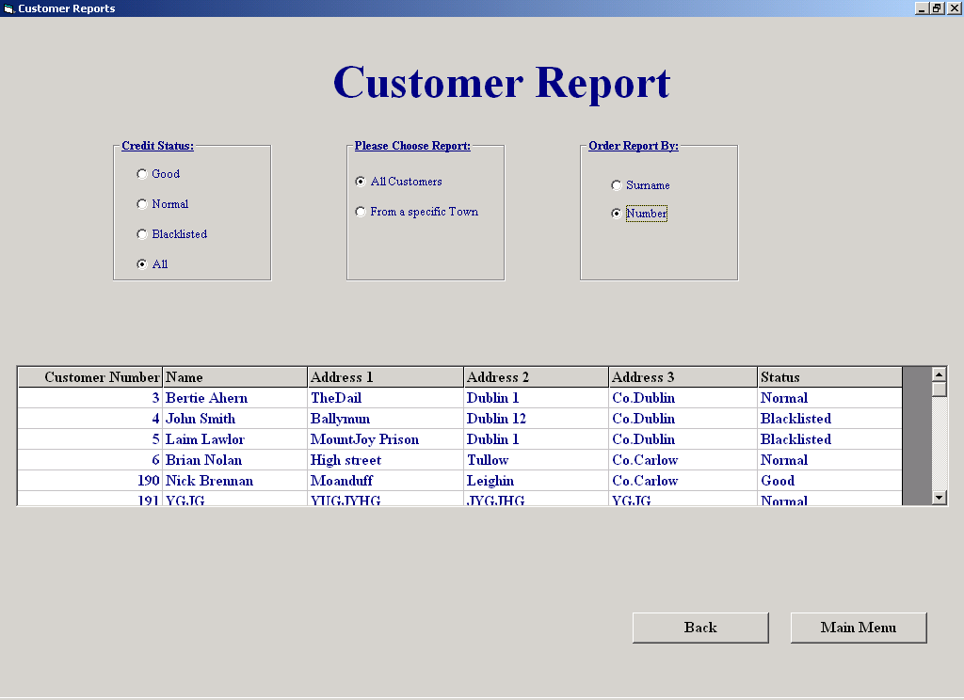

Code:

This screen allows the user to produce reports on customer details.
'The user can select a Credit Status and then get a list of all customers matching it by clicking "All customers", or get a list of all customers from a particular town with the credit status by clicking "From a Specific town". The report can then be sorted by Customer Surname, by clicking "SurName" or, it can be sorted by Customer Number by clicking "Number".

Author: Sean O'Brien
Date: 20-03-2002

Variables Used -
strSQL : String (Holds SQL statements"
MyString : String (Holds credit status)
TheTown : String (holds the town name)
TheName : String (holds customer's full name)
FName : String (holds customer's first name)
LName : String (holds customer's last name)
dbs : Database (opens the database to create a temporary table called “Temp")
Rec : Recordset (Used to access a temporary table called "Temp", in the database)
MyArray : Variant (An array which holds the name the Surname and first name of the customer)
counter : Integer (indicates the amount of spaces in the name of the customer)

Objects Used -
datReport : Data Control (used to access the Customer and Temp tables in the database)

Option Explicit

Private Sub cmdBack_Click()
(Unloads this screen and shows the Reports Menu)
frmReportsMenu.Show
Unload Me
End Sub

Public Sub Sort()
(Displays all customers matching the criteria entered by the user)
Dim strSQL, MyString, TheTown As String
If optGood.Value Then
MyString = "Good"
If optCustNum.Value Then
If optTown.Value Then
strSQL = "Select CustNum as [Customer Number], FName as Name, Add1 as [Address 1]," & _
"Add2 as [Address 2], Add3 as [Address 3], Status From Temp " & _
"Where Status = '" & MyString & "'" & "And Add1 = '" & txtTown.Text & "'" & _
"Order By CustNum"
Else
strSQL = "Select CustNum as [Customer Number], FName as Name, Add1 as [Address 1], Add2 as [Address 2]," & _
"Add3 as [Address 3], Status From Temp " & _
"Where Status = '" & MyString & "'" & " Order By CustNum"
End If
Else
If optTown.Value Then
strSQL = "Select CustNum as [Customer Number], FName as Name, Add1 as [Address 1]," & _
"Add2 as [Address 2], Add3 as [Address 3], Status From Temp " & _
"Where Status = '" & MyString & "'" & "And Add1 = '" & txtTown.Text & "'" & _
"Order By LName"
Else
strSQL = "Select CustNum as [Customer Number], FName as Name, Add1 as [Address 1], Add2 as [Address 2]," & _
"Add3 as [Address 3], Status From Temp " & _
"Where Status = '" & MyString & "'" & " Order By LName"
End If
End If
Else
If optNormal.Value Then
MyString = "Normal"
If optCustNum.Value Then
If optTown.Value Then
strSQL = "Select CustNum as [Customer Number], FName as Name, Add1 as [Address 1]," & _
"Add2 as [Address 2], Add3 as [Address 3], Status From Temp " & _
"Where Status = '" & MyString & "'" & "And Add1 = '" & txtTown.Text & "'" & _
"Order By CustNum"
Else
strSQL = "Select CustNum as [Customer Number], FName as Name, Add1 as [Address 1], Add2 as [Address 2]," & _
"Add3 as [Address 3], Status From Temp " & _
"Where Status = '" & MyString & "'" & " Order By CustNum"
End If
Else
If optTown.Value Then
strSQL = "Select CustNum as [Customer Number], FName as Name, Add1 as [Address 1]," & _
"Add2 as [Address 2], Add3 as [Address 3], Status From Temp " & _
"Where Status = '" & MyString & "'" & "And Add1 = '" & txtTown.Text & "'" & _
"Order By LName"
Else
strSQL = "Select CustNum as [Customer Number], FName as Name, Add1 as [Address 1], Add2 as [Address 2]," & _
"Add3 as [Address 3], Status From Temp " & _
"Where Status = '" & MyString & "'" & " Order By LName"
End If
End If
Else
If optBlack.Value = True Then
MyString = "BlackListed"
If optCustNum.Value Then
If optTown.Value Then
strSQL = "Select CustNum as [Customer Number], FName as Name, Add1 as [Address 1]," & _
"Add2 as [Address 2], Add3 as [Address 3], Status From Temp " & _
"Where Status = '" & MyString & "'" & "And Add1 = '" & txtTown.Text & "'" & _
"Order By CustNum"
Else
strSQL = "Select CustNum as [Customer Number], FName as Name, Add1 as [Address 1], Add2 as [Address 2]," & _
"Add3 as [Address 3], Status From Temp " & _
"Where Status = '" & MyString & "'" & " Order By CustNum"
End If
Else
If optTown.Value = True Then
strSQL = "Select CustNum as [Customer Number], FName as Name, Add1 as [Address 1]," & _
"Add2 as [Address 2], Add3 as [Address 3], Status From Temp " & _
"Where Status = '" & MyString & "'" & "And Add1 = '" & txtTown.Text & "'" & _
"Order By LName"
Else
strSQL = "Select CustNum as [Customer Number], FName as Name, Add1 as [Address 1], Add2 as [Address 2]," & _
"Add3 as [Address 3], Status From Temp " & _
"Where Status = '" & MyString & "'" & " Order By LName"
End If
End If
Else
If optAll.Value = True Then
If optTown.Value Then
If optCustNum.Value = True Then
strSQL = "Select CustNum as [Customer Number], FName as Name, Add1 as [Address 1]," & _
"Add2 as [Address 2], Add3 as [Address 3], Status From Temp Where Add1 = '" & _
txtTown.Text & "'" & "Order By CustNum"
Else
strSQL = "Select CustNum as [Customer Number], FName as Name, Add1 as [Address 1]," & _
"Add2 as [Address 2], Add3 as [Address 3], Status From Temp Where Add1 = '" & _
txtTown.Text & "'" & "Order By LName"
End If
Else
If optCustNum.Value = True Then
strSQL = "Select CustNum as [Customer Number], FName as Name, Add1 as [Address 1]," & _
"Add2 as [Address 2], Add3 as [Address 3], Status From Temp Order By CustNum"
Else
strSQL = "Select CustNum as [Customer Number], FName as Name, Add1 as [Address 1]," & _
"Add2 as [Address 2], Add3 as [Address 3], Status From Temp Order By LName"
End If
End If
End If
End If
End If
End If
datReport.DatabaseName = strThePath
datReport.RecordSource = strSQL
datReport.Refresh
If datReport.Recordset.RecordCount = 0 Then
Call MsgBox("Search is complete, there was no results to display", vbOKOnly, "No Matches")
Else
gridReport.Visible = True
End If
End Sub

Private Sub cmdViewRep_Click()
Sort
End Sub

Private Sub cmdMainMenu_Click()
(Unloads this screen and shows the Main Menu)
frmMainMenu.Show
Unload Me
End Sub

Private Sub Form_Activate()
OrderByNames
End Sub

Private Sub Form_Load()
(Sets the data control, "datReport" to access the details of the Customer table in the database)
datReport.DatabaseName = strThePath
datReport.RecordSource = "Select * from Customer where [Deletion] = False"
datReport.Refresh
gridReport.Clear
End Sub

Private Sub Form_Unload(Cancel As Integer)
(Deletes the temporary table that was created)
datReport.RecordSource = "Customer"
datReport.Refresh
Dim dbs As Database
Set dbs = OpenDatabase(strThePath)
dbs.Execute ("Drop Table Temp")
End Sub

Private Sub optAll_Click()
Reset
optTown.Value = False
optAllCust.Value = False
End Sub

Private Sub optAllCust_Click()
Reset
optTown.Value = False
optSurName.Enabled = True
optCustNum.Enabled = True
End Sub

Private Sub optBlack_Click()
Reset
optTown.Value = False
optAllCust.Value = False
End Sub

Private Sub optCustNum_Click()
Sort
End Sub

Private Sub optGood_Click()
Reset
optTown.Value = False
optAllCust.Value = False
End Sub

Private Sub optNormal_Click()
Reset
optTown.Value = False
optAllCust.Value = False
End Sub

Private Sub optSurName_Click()
Sort
End Sub

Public Sub OrderByNames()
(Creates a temporary table called "Temp",for the purpose of ordering the report by SurName
(The name of the Customer is all in the one field))
Dim strSQL, TheName, FName, LName As String
Dim dbs As Database
Dim Rec As Recordset
Dim MyArray
Dim counter As Integer
counter = 0
Set dbs = OpenDatabase(strThePath)
dbs.Execute ("CREATE TABLE Temp") _
& ("( CustNum NUMBER, FName TEXT, LName TEXT,") _
& ("Add1 TEXT, Add2 TEXT, Add3 TEXT, Status TEXT)") 'creates a temporary table called Temp
Set Rec = dbs.OpenRecordset("Temp", dbOpenDynaset)
strSQL = "Select Cust_ID, Name,[Address 1], [Address 2], [Address 3], Status From Customer " & _
"Where Deletion = False "
datReport.RecordSource = strSQL
datReport.Refresh
While Not datReport.Recordset.EOF
TheName = datReport.Recordset("Name")
MyArray = Split(TheName, " ") 'breaks up the Name of the customer
FName = MyArray(0) 'first name goes into "FName"
If Not (Len(FName) = Len(TheName)) Then 'this is true if there is only one word in the name
LName = MyArray(1)
counter = Len(Replace(TheName, " ", " " & "*")) - Len(TheName) 'finds the number of spaces in the Name
If counter > 1 Then
LName = LName + " " + MyArray(2)
End If
FName = FName & " " & LName
Else
LName = ""
End If
Rec.AddNew
Rec("CustNum") = datReport.Recordset("Cust_ID")
Rec("FName") = FName
Rec("LName") = LName
Rec("Add1") = datReport.Recordset("Address 1")
Rec("Add2") = datReport.Recordset("Address 2")
Rec("Add3") = datReport.Recordset("Address 3")
Rec("Status") = datReport.Recordset("Status")
Rec.Update
datReport.Recordset.MoveNext
Wend
End Sub

Private Sub optTown_Click()
(Allows the user to click the option buttons "optCustNum" and "optSurName")
optCustNum.Enabled = True
optSurName.Enabled = True
optSurName.Value = False
optCustNum.Value = False
gridReport.Visible = False
lblTown.Visible = True
txtTown.Visible = True
txtTown.SetFocus
End Sub

Private Sub txtTown_GotFocus()
txtTown.Text = ""
optCustNum.Value = False
optSurName.Value = False
gridReport.Visible = False
End Sub

Private Sub txtTown_Validate(Cancel As Boolean)
(Ensures the user enters a valid town name)
If Len(txtTown.Text) > 0 Then
If Not IsNumeric(txtTown.Text) Then
Cancel = False
Else
Cancel = True
Call MsgBox("Please enter a valid town name", vbOKOnly, "Warning")
txtTown.SetFocus
End If
Else
Cancel = True
Call MsgBox("Please enter a town", vbOKOnly, "Warning")
txtTown.SetFocus
End If
End Sub

Public Sub Reset()
(Resets the screen)
optSurName.Value = False
optCustNum.Value = False
optSurName.Enabled = False
optCustNum.Enabled = False
gridReport.Visible = False
lblTown.Visible = False
txtTown.Visible = False
End Sub

